# Assessment framework

## Overview

The chapter describes how the potential impacts of the project were assessed, how their assessment influenced the project design, and how the Environmental Management Framework was developed. Chapter 26 – *Environmental management framework* describes how the project’s environmental, social and heritage impacts would be managed, taking into consideration all the assessment work carried out, as outlined in this assessment framework chapter and culminating in this EES.

As described in the *Scoping Requirements for Willatook Wind Farm Environment Effects Statement* (2019) (scoping requirements) issued by the Minister for Planning (the Minister), “the purpose of the EES is to provide a detailed description of the project, assess its potential effects on the environment, and assess alternative project layouts, designs and approaches to avoid and mitigate potential effects”.

The assessment framework for this EES was developed in the context of the final scoping requirements, relevant legislation and policy, and guidance from a Technical Reference Group (appointed by DELWP), which is made up of relevant state government agencies and departments, as well as the Moyne Shire Council.

**Risk** – reflects the potential for negative change, injury or loss with respect to the environment and is a function of the likelihood and consequences of such an event occurring. In other words, risk is the “*the effect of uncertainty on objectives*”, as described in the risk management standard AS/NZS ISO 31000:2009 *Risk Management – Principles and guidelines*.

**Impact** – relates to the detrimental outcome of an event in relation to defined sensitive assets, values and uses.

**Effect** – a change brought about by the project that can be either positive or negative. The term ‘adverse effect’ is sometimes used within the EES and supporting documents to describe a negative impact.

The final scoping requirements were informed by public comments on the draft version and set out the specialist studies required and the matters to be investigated as part of the EES. The scope of the specialist studies was also informed by issues raised during stakeholder engagement activities, including feedback from the Technical Reference Group before and during EES preparation, and by issues identified as the project design was refined.

‘Risk’, ‘impact’ and ‘effect’ are important terms referred to throughout the EES and supporting documents. The EES has taken a ‘risk-based’ approach to guide the scope of environmental, social and cultural studies conducted for the project (see Section 7.4.2). The assessment approach has focussed on the evaluation of impacts, not risks (except where required by regulations). The approach aims to avoid, minimise, and manage impacts as much as possible, thereby reducing the risk of significant impacts.

## Overview of the EES assessment framework

The key components of the EES assessment framework are:

* Evaluation framework – Commonwealth and State Government policies and procedures and the final scoping requirements set by the Minister provide the foundation for the EES assessment. These were used to work out what needed to be investigated and the scope of specialist technical assessments to be carried out.
* Assessment approach – Included investigating and characterising the environment (i.e., existing conditions of the project site and surrounding area), focussing on key sensitivities. This provided the basis for an initial risk assessment that guided the direction of subsequent impact assessments, leading to refinements to the project design and the development of specific mitigation measures. This project refinement process is detailed in Chapter 4 – *Project alternatives and design development*.
* Consultation – Comprehensive stakeholder consultation was an important part of the project design development process and for the preparation of this EES. The consultation process and outcomes are detailed in Chapter 6 – *Stakeholder consultation*.
* Environment Effects Statement – The outputs from the specialist studies are brought together in this EES. At the conclusion of the EES assessment process the Minister’s assessment will inform the statutory approvals decisions.

The relationships between the components of the EES assessment framework are shown in Figure 7.1.

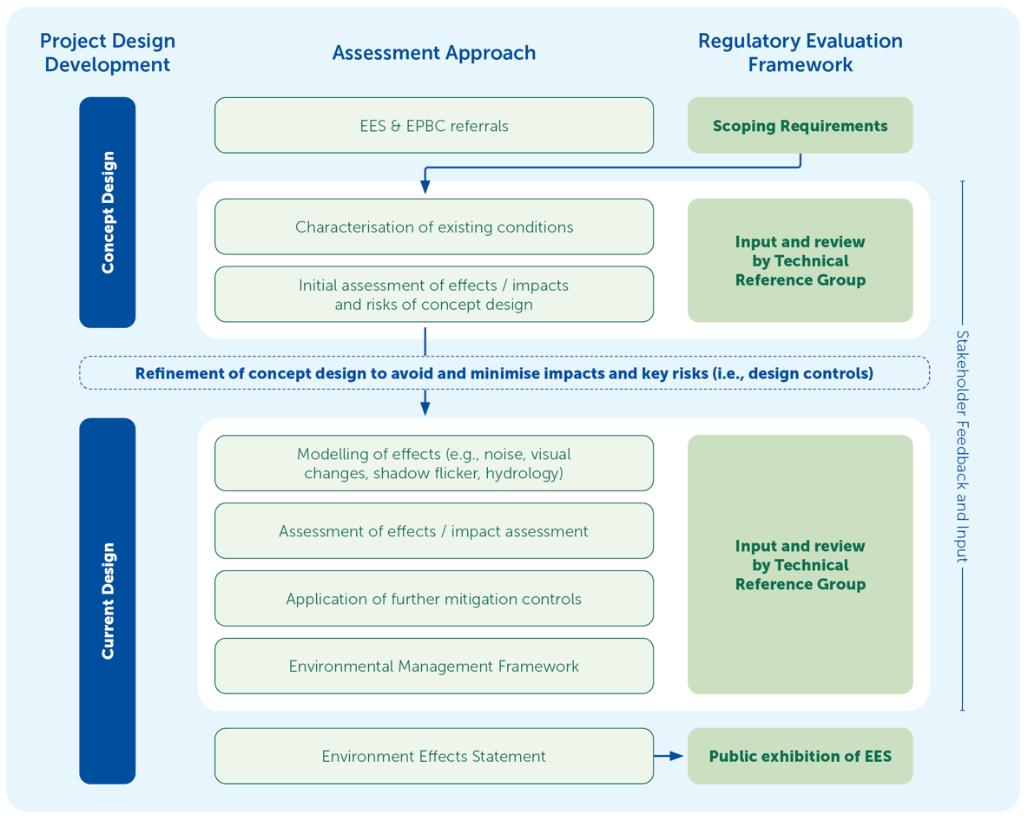

Figure . EES assessment framework

Note, during the impact identification process some disciplines used the risk assessment framework to identify key risks and potential impacts/effects. The variability of risk assessment methodology between technical disciplines is described in Section 7.4.2.

## Evaluation framework

The evaluation framework details the desired outcomes for the project in the context of key legislative and statutory policies, as well as the principles and objectives of ecologically sustainable development and environmental protection. Details of the overarching regulatory framework (i.e., the laws, regulations and policies) and how these interact are detailed in Chapter 3 – *Legislation and policy framework*.

The final scoping requirements, issued in August 2019, outline the draft evaluation objectives for the project. They also guide the integrated assessment of environmental effects in accordance with the *Ministerial Guidelines for the assessment of environmental effects under the EE Act 1978* (Department of Sustainability and Environment, 2006), and evaluation of the overall implications of the project.

There are eight draft evaluation objectives for the project (see Table 7.1). The table includes an overview of the corresponding key legislation and statutory guidelines, and the location of where each evaluation objective is addressed within the EES.

The project must also address the requirements, as applicable, of the Planning Policy Framework, which is incorporated into local planning schemes. The use and development of land in Victoria is guided by the Planning Policy Framework, as well as local planning policy.

Table . EES draft evaluation objectives and relevant EES chapters

| Aspect | Draft evaluation objective from scoping requirements | Assessment focus | Relevant EES chapter(s) | Relevant supporting technical study |
| --- | --- | --- | --- | --- |
| Biodiversity and habitat | To avoid or minimise potential adverse effects on biodiversity values within and near the site including native vegetation, listed threatened species and ecological communities, and habitat for these species. Where relevant, offset requirements are to be addressed consistent with state and Commonwealth policies. | Remnant native vegetation and flora surveys  Brolga breeding, flocking and habitat surveys  Bat echo-location surveys  Bird utilisation surveys  Migratory bird surveys  Terrestrial and aquatic habitat surveys  Targeted threatened species surveys  Assessment of potential impacts on species and communities. | Chapter 11 – *Brolga*  Chapter 12 – *Biodiversity and habitat*  Chapter 24 – *Cumulative effects*  Chapter 25 – *Matters of national environmental significance* | Appendix C1 – *Brolga*  Appendix C2 – *Ecological independent peer review*  Appendix D – *Biodiversity* |
| Catchment values and hydrology | To maintain the functions and values of aquatic environments, surface water and groundwater quality and stream flows and avoid adverse effects on protected beneficial uses. | Hydrological modelling to determine wetland habitat (for Brolga)  Characterisation of surface water and groundwater based on a review of existing data  Groundwater drawdown and water management from the on-site quarry  Assessment of effects on environmental values. | Chapter 9 – *Groundwater*  Chapter 10 – *Surface water* | Appendix B – *Hydrology and hydrogeology* |
| Landscape and visual | To minimise and manage potential adverse effects for the community with regard to landscape and visual amenity. | Geospatial and 3D modelling of visual changes  Creation of visual photomontages of the project from key locations  Assessment of visual impacts from representative locations based on relevant guidelines  Modelling of shadow flicker effects from rotating wind turbine blades. | Chapter 14 – *Landscape and visual*  Chapter 21 – *Shadow flicker and blade glint*  Chapter 24 – *Cumulative effects* | Appendix F1 – *Landscape and visual*  Appendix F2 – *Landscape and visual independent peer review*  Appendix M – *Shadow Flicker* |
| Geoheritage values | To minimise and manage potential adverse effects to geoheritage values. | Assessment of geological and landform features based on geospatial analysis and aerial imagery. | Chapter 8 – *Geoheritage* | Appendix A – *Geoheritage* |
| Amenity | To minimise and manage adverse air quality and noise and vibration effects on residents and local communities as far as practicable during construction, operation and decommissioning having regard to applicable limits, targets or standards. | Mapping of sensitive receptors (e.g., dwellings)  Predictive modelling of project-generated noise, vibration and air quality, based on the current design  Verification by an EPA accredited environmental auditor that the pre-construction (predictive) noise assessment has been conducted in accordance with the New Zealand Standard NZS6808:2010. | Chapter 13 – *Noise and vibration*  Chapter 20 – *Air quality*  Chapter 24 – *Cumulative effects* | Appendix E1 – *Noise and vibration*  Appendix E2 – *Pre-construction noise assessment report verification*  Appendix E3 – Noise and vibration independent peer review  Appendix E4 – *Quarry* *blasting*  Appendix L – *Air quality* |
| Cultural heritage | To avoid or minimise adverse effects on Aboriginal and historic cultural heritage and associated values. | Desktop review of previous studies and registers  Field investigations of the project site including both standard visual field surveys and complex surveys for Aboriginal cultural heritage involving subsurface excavation. | Chapter 18 – *Aboriginal cultural heritage*  Chapter 19 – *Historical cultural heritage* | Appendix J – *Aboriginal cultural heritage*  Appendix K – *Historical heritage* |
| Land use and socioeconomic | To avoid and minimise adverse effects on land use (including agricultural and residential), social fabric of the community (with regard to wellbeing, community cohesion), local infrastructure, electromagnetic interference, aviation safety and to neighbouring landowners during construction, operation and decommissioning of the project. | Desktop data collection and analysis of stakeholder consultation  Economic modelling  Qualitative study of effects on socio-economic values  Specialist study of aviation safety  Specialist study of electromagnetic interference  Specialist study on land use and planning. | Chapter 16 – *Land use and planning*  Chapter 17 – *Socio-economic*  Chapter 22 – *Electromagnetic interference*  Chapter 23 – *Aviation* | Appendix H – *Land use and planning*  Appendix I – *Economic and social*  Appendix N – *Electromagnetic interference*  Appendix O – *Aviation* |
| Traffic and roads | To avoid and minimise adverse effects on roads and road users during construction, operation and decommissioning of the project. | Quantitative study of project-generated traffic with and without the on-site quarry  Assessment of project access points  Assessment of route planned for oversized loads. | Chapter 15 – *Traffic and transport* | Appendix G – *Traffic and transport* |

## Assessment approach

An assessment framework was developed for the project to ensure a consistent and transparent approach to the evaluation of potential impacts on people and the environment.

The overarching assessment approach is shown in Figure 7.2.

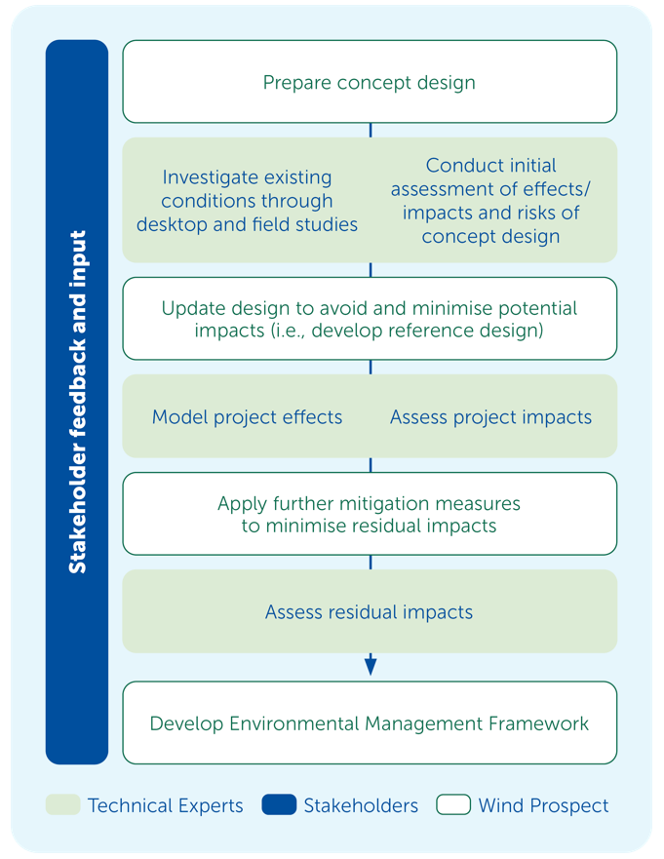

Figure . Assessment approach

The assessment approach commenced with an initial concept design, which enabled the scoping of technical studies to assess potential impacts of the project. Findings from these studies, further feasibility investigations and input from stakeholders resulted in the refinement of the project design, termed the current design. Detailed studies including predictive modelling and impact assessments were then conducted resulting in specific measures to avoid and minimise impacts.

Where there is potential for the project to give rise to risks of harm to human health or the environment from pollution or waste, those risks have been minimised so far as reasonably practicable at this stage of the project. This is required by the general environmental duty within the *Environment Protection Act* 2017 to meet the environmental protection duties and manage environmental risks. Commitments and other standard management controls would be implemented to minimise those risks further, as detailed within Chapter 26 – *Environmental management framework*.

### Project concept design

The project concept design was developed based on a preliminary understanding of the environment, early stakeholder consultation, and experience developing comparable projects in similar environments.

The concept design in the EES and EPBC Act referrals was based on a total of 86 wind turbines with a nominal capacity of 4.8 megawatts with a maximum blade tip height of 220 metres. Referrals identified key potential impacts and risks that required further investigation.

A detailed description of the site selection process and design development is presented in Chapter 4 – *Project alternatives and design development*.

### Scoping impact assessments

A risk-based approach was adopted during the EES studies, prior to the assessment of likely impacts, so that a greater level of effort could be directed at investigating and managing matters that pose a relatively higher risk of adverse effects.

Scoping impact assessments for the project involved:

* addressing the project scoping requirements
* completing technical investigations of the current environmental, social and heritage conditions
* completing a preliminary environmental risk assessment
* considering community and other stakeholder information and concerns.

Chapter 1 – *Introduction* includes the draft evaluation objectives, and each technical chapter   
(Chapters 8–23) includes a list of the issues from the scoping requirements that need to be addressed in the EES.

#### Characterisation of existing conditions

The character of the existing environment and the social context of the project site and surrounding areas was established via desktop and field-based investigations, undertaken by subject matter experts (referred to as ‘technical specialists’). During the field-based investigations, desktop information was verified, and new information was gathered.

Technical specialist studies identified environmental values, sensitivities and land uses that may have the potential to be impacted by the project, with a focus on sensitive receptors. These receptors included people, assets, values, or uses that are protected by legislation and policy, are important to the local community (or broader community), and/or are likely to be susceptible to potential impacts resulting from the project.

The existing conditions investigations informed the design of the project and provided a baseline against which the potential impacts of the project could be assessed. They also allow any residual impacts or positive effects to be predicted, following the implementation of management measures, against the baseline (existing) conditions.

#### Preliminary risk assessment

A risk assessment framework uses a combination of ‘likelihood’ and ‘consequence’ of environmental harm (or damage) to determine the level of overall risk, where:

* **likelihood** is the probability that an environmental, social or heritage value will be impacted by a project activity (creating a hazard)
* **consequence** is the magnitude or severity of the impact on the identified value, which is usually a factor of the geographic extent and/or duration of the predicted change to the value.

The objective of the preliminary risk assessment was to identify potential hazards associated with the project during the construction, operation and decommissioning phases, and to assess the risk of significant impacts on the environment and people. This helped refine the concept design to avoid impacts and minimise risks.

Key technical specialists participated in the risk assessment process as part of the concept design refinement. The purpose was to identify any risks requiring further detailed assessment, and to develop project-specific design controls and management measures to minimise the likelihood and consequences of identified hazards.

The results of the preliminary risk assessment were used to identify potential impacts requiring the greatest attention in this EES. These preliminary risk assessments are described briefly in specialist reports (refer to appendices).

### Project design refinement

The project design has undergone a series of updates and improvements, as described in Chapter 4 – *Project alternatives and design development*. These were informed by the findings of a wide range of technical assessments including flora and fauna (particularly Brolga), heritage, landscape and visual, noise, traffic and geoheritage studies. The design was also refined to include a new landowner that enabled key infrastructure components such as the on-site substation to be moved. An on-site quarry was also included as a way of limiting the number of heavy vehicles on local roads.

The current project design is detailed in Chapter 5 – *Project description*. This proposed design for which planning approvals are sought includes 59 wind turbines, three meteorological masts, internal cables, access tracks, on-site substation, battery energy storage system, associated construction and site maintenance infrastructure, and temporary infrastructure including the on-site quarry.

### Assessment of effects

This EES has adopted two main methods to assess the impacts of project construction, operation and decommissioning activities on identified values. These are:

1. assessment of compliance with regulatory limits or standards from modelled outputs, with the aim of meeting or achieving outcomes better than compliance requirements
2. direct assessment of effects and impacts, with the aim of avoiding or minimising impacts and maximising positive effects.

The overarching assessment methods to address each evaluation objective are outlined in Table 7.2.

Table . Assessment methods used by each technical discipline

| Disciplines | Assessment of residual effects and impacts | Quantitative predictions against standards* |
| --- | --- | --- |
| Geoheritage | ✓ |  |
| Groundwater | ✓ |  |
| Surface water | ✓ |  |
| Biodiversity | ✓ |  |
| Noise and vibration | ✓ | ✓ |
| Landscape and visual | ✓ |  |
| Traffic and transport | ✓ |  |
| Land use and planning | ✓ |  |
| Socio-economic | ✓ |  |
| Aboriginal cultural heritage | ✓ |  |
| Historic heritage | ✓ |  |
| Air quality | ✓ | ✓ |
| Shadow flicker | ✓ | ✓ |
| Electromagnetic interference | ✓ |  |
| Aviation | ✓ | ✓ |

* Disciplines that have quantitative predictions against standards are still required to meet the general environmental duty, where applicable (e.g., air quality, noise and vibration)

The EES provides a detailed analysis of potential project effects and impacts including:

Impacts have the potential to occur both directly and indirectly because of the project, whereby:

1. **direct impacts** are those resulting from direct interaction between the project and the biophysical environment, and there is an immediate cause-and-effect relationship (e.g., land disturbance and removing habitat)
2. **indirect impacts** are those that are at least one step removed from project activities in terms of cause-and-effect links (e.g., upgrade of existing roads has the potential to indirectly increase traffic due to more favourable driving conditions for local road users).

* direct and indirect impact pathways (see info box)
* community expectations around benefits and impacts
* magnitude, extent and duration of impact on assets, values and uses to ensure project effects are maintained within permissible limits
* how changes to one environmental, social or heritage value might affect another value
* how effective measures are to avoid or limit potential adverse effects
* uncertainty associated with each assessment
* benchmarks and requirements set by statutory processes.

This EES needs to describe in detail the effects on the environment and particular defined values in terms of magnitude, extent and duration of change, assuming that design, mitigation and management measures have been applied.

The assessment of residual effects and impacts focuses on understanding and describing the unavoidable changes to the environment and the positive effects brought about by the construction, operation and eventual decommissioning of the project.

The impact assessment process adopted for the EES involved:

* reviewing impact pathways, focusing on the source of the impact, the pathway medium (i.e., land, water, air) and the receiving environment
* establishing the environmental context (i.e., baseline conditions), specifically the sensitivity of the defined assets or values
* assessing all likely impacts in terms of magnitude, geographic extent and duration
* rating the impact significance using defined criteria.

To ensure a consistent assessment approach, a standard impact assessment table was adopted for most technical studies (see Table 7.3). In some instances, specialists used an industry guideline or standard that differed somewhat to the standard impact assessment approach (e.g., the social and economic impact assessment and noise impact assessment).

Table . Standard impact assessment template

| Impact pathway | Asset, value or receptor | Project phase | Likely impact (considering magnitude, extent and duration) | Impact rating and justification |
| --- | --- | --- | --- | --- |
| *Example only*  Quarry excavation leads to groundwater drawdown from the surrounding environment. | Surrounding groundwater uses, including natural wetlands and groundwater bores. | Construction and operation | A peak flow rate of 77 m3/year of groundwater predicted to enter the quarry pit causing drawdown to extend approximately 500 metres from quarry pit, lowering groundwater levels. | Low – no beneficial uses (environmental, economic or social) identified within 500 metres of the quarry. Impact will be temporary. |

#### Impact pathways

An impact pathway is where a project component or activity (i.e., impact source) is likely to have an effect on a defined environmental asset, value or receptor. When an impact pathway was confirmed, an assessment of the significance of the impact was performed. The role of design controls (e.g., infrastructure type and location) were already factored into the assessment process. A potential impact is avoided where a robust and well-proven design control has been applied.

#### Impact magnitude, extent and duration

Key to assessing impacts is determining the scale of impact in terms of extent, duration and magnitude (including intensity/severity). General criteria for magnitude, extent and duration are set out in Table 7.4. These criteria were modified for each technical discipline, where appropriate, to account for intrinsic differences between aspects. For example, social impacts (positive or negative) have the potential to occur over a wider area, as opposed to hydrological impacts that are likely to be experienced within the development footprint. Similarly, the duration of impacts during construction would occur over a shorter timeframe than impacts during operation, but their severity may also differ.

Table . General criteria for impact features – magnitude, extent and duration

| Magnitude | Extent | Duration |
| --- | --- | --- |
| Minor magnitude that does not reduce the viability/capacity of the value. | Highly localised effect | Temporary or transient effect |
| Moderate magnitude effect that reduces the viability (or sustainability) of the value, but recovery is expected. Specific management measures may be required to effectively manage the impact. | Effect may extend beyond the project footprint | Short-term effect |
| High magnitude affecting the future viability or sustainability of the value. | Effect has the potential to extend beyond the project site boundary | Medium- to long-term effect |

Determining the effect, size or severity of impacts alone does not necessarily provide an assessment of the significance of the impact. As outlined in the EPBC Act *Significant impact guidelines 1.2* (Department of Sustainability, Environment, Water, Populations and Communities, 2013):

*“impacts of the action [project] must be considered in the context of the environment in which the action will take place, particularly if the action is likely to impact upon sensitive or valuable components of the environment”*

Impacts that occur within more sensitive environments or nearby vulnerable receptors are more significant. Likewise, impacts with greater magnitude in terms of scale and intensity occurring over a longer duration are also more significant.

Specialists applied their own methods (defined by relevant legislation, policies, standards and guidelines, and their professional judgement and experience) to assess the impact significance, taking into consideration management and mitigation measures where appropriate. Discipline-specific impact criteria (from low to high) were defined by each specialist. The impact assessments for each of the specialist technical assessments are summarised in Chapters 8–23 and detailed in technical reports provided as Appendices A–O.

The impact assessments also identified potential benefits associated with the project during its construction, operation and decommissioning. Ratings were not applied to potential benefits; however, benefits are described in specialist technical assessments where relevant.

The EES has considered the existing conditions and potential impacts relevant to each aspect of the environment both in isolation and together. Some studies have relied on data or results from another study to inform their own assessment. For example, the assessment of wetlands and Brolga habitat has relied on the surface water modelling undertaken as part of the surface water impact assessment.

Modelling, in accordance with best practice methods, was used to determine whether potential noise, shadow flicker and air quality impacts resulting from the project would be within the relevant guideline criteria or levels.

### Consultation

Community and stakeholder consultation is a key element of the EES assessment framework and has occurred at various stages of project development. Consultation activities commenced in 2010 with key community stakeholders and has continued throughout the EES process.

Community consultation provided an understanding of the concerns and preferred outcomes of local residents, businesses and other interested parties, and these were considered in the design and assessment process. Ongoing engagement with Moyne Shire Council and relevant government agencies through the participation in the project Technical Reference Group has enabled key issues and policy priorities of state and local government, as well as community concerns, to be comprehensively addressed in this EES and the project design. The Technical Reference Group provided advice about statutory approvals, policy provisions, methodologies of key specialist technical assessments, and key issues and concerns from their respective areas of interest, experience and expertise.

Details of community and stakeholder consultation undertaken during preparation of this EES and the outcomes of consultation are provided in Chapter 6 – *Stakeholder consultation*.

### Assessing cumulative effects

Although the effects of individual actions may be small or insignificant by themselves, a combination of the effects may be significant. The combination of effects on the existing environment from multiple projects (or activities) occurring in the same area and over similar timeframes are called ‘cumulative impacts’. The project has the potential for cumulative impacts, particularly from other wind farms in operation, development or approved in the region.

The relationship between the project and nearby operating or approved wind farms was assessed by specific impact assessments to determine the cumulative impacts on the existing environment. The assessment of cumulative impacts was completed in accordance with relevant technical guidance, based on publicly available information, and reported in their impact assessment reports. These findings are summarised in Chapter 24 – *Cumulative effects*.

## Environmental management framework

The design approach adopted a hierarchy of controls of firstly avoiding an impact if feasible and practical, then minimising the severity of the impact over space and time, followed by management, and finally offsetting to compensate for residual impacts (e.g., for a loss of biodiversity by protecting similar values elsewhere). The aim of management measures is to protect identified values and meet the evaluation objectives. The hierarchy of controls adopted by the project is presented in Figure 7.3.

**Design controls** are robust measures developed during the project design stage with the intent of avoiding or minimising impacts on defined environmental values or sensitive receptors.

**Management controls** are administrative or procedural controls that will reduce the likelihood and/or consequence of an identified risk event.

Elimination by design has been used across the project, including avoiding areas of native vegetation where possible and applying buffers along waterways to minimise the risk of impact to waterways and the values they support. Abatement or attenuation controls have been applied by increasing separation distances between dwellings and wind turbine locations, minimising potential amenity impacts.

Management controls are those measures that would be implemented during construction, operation and decommissioning of the project with the purpose of reducing the consequence and/or likelihood of an identified impact or the magnitude, extent and/or duration of a known adverse effect.

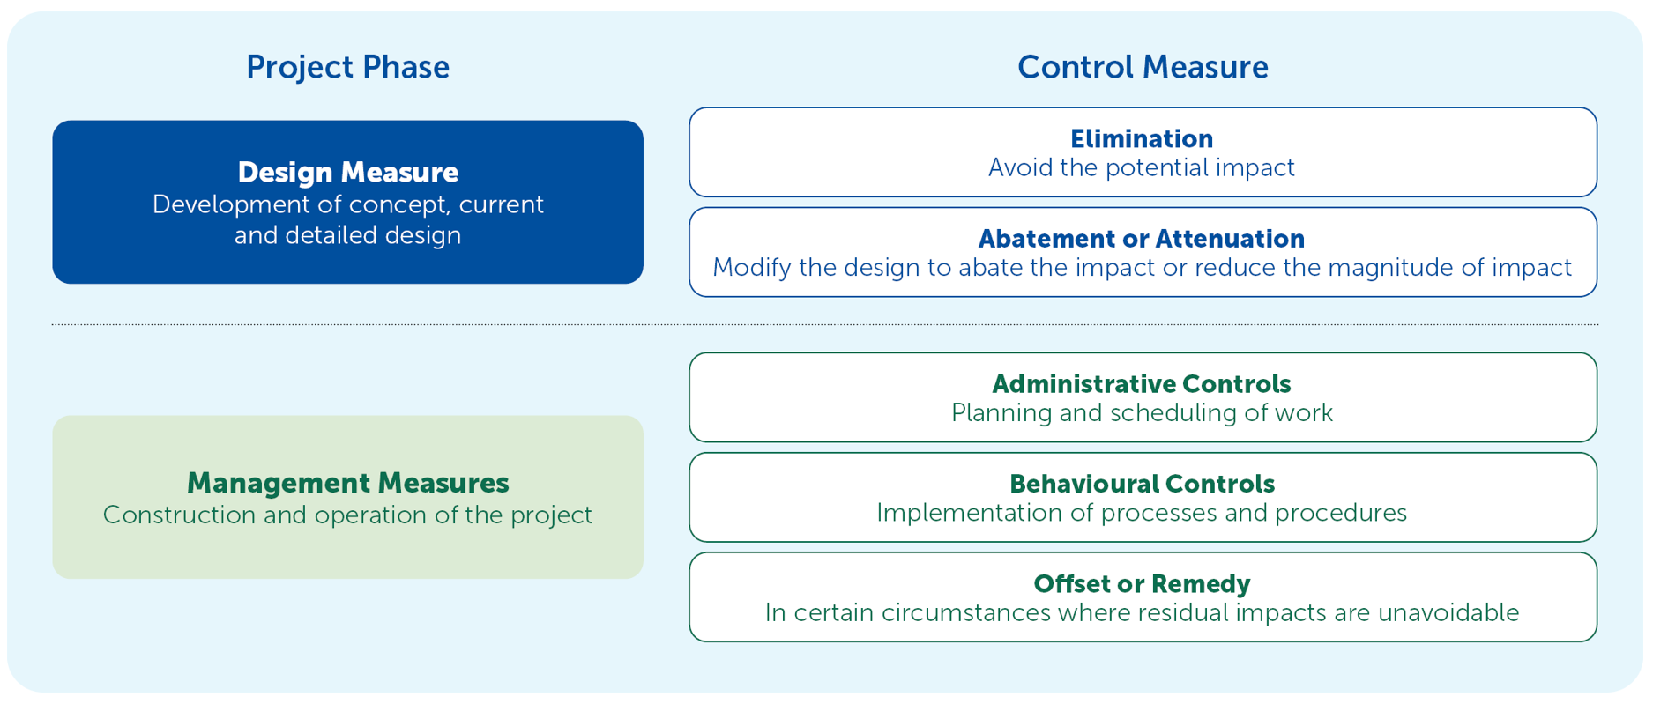

Figure . Project hierarchy of mitigation controls

A full description of the assessment of project alternatives and the changes that have been made to avoid and minimise environmental, social and heritage impacts is provided in Chapter 4 – *Project alternatives and design development*. The current design for assessing project impacts and construction methods, developed from the iterative process, is detailed in Chapter 5 – *Project description*.

Chapter 26 – *Environmental management framework* includes a list of environmental management measures (i.e., mitigation measures), with clear accountabilities for managing environmental effects and hazards associated with construction, operation and decommissioning phases of the project. These management measures assume design measures have already been applied during the current design phase in response to regulations, guidelines and standards, and through an iterative impact assessment process.

Management measures are required to limit the magnitude, extent and duration of any potential negative impacts and enhance the potential positive effects of the project. While management measures typically respond to relevant legislation, policies and guidelines, and would be integrated into statutory approvals, various measures are proposed in response to stakeholder discussions and commitments.

## Assurance

The assessment for this EES is consistent with the *Ministerial guidelines for assessment of environmental effects under the Environment Effects Act* (Department of Sustainability and Environment, 2006) and *Significant Impact Guidelines 1.1 – Matters of National Environmental Significance* (Department of Environment, 2013a). The contents of the EES have also been cross-checked against the scoping requirements.

To provide confirmation that the assessment methodology is robust and consistent with legislated requirements, key supporting studies have been prepared by suitably qualified and independent consultants. As further assurance, assessment of potential impacts to noise and visual amenity and impacts on Brolga and Southern Bent-wing Bat have been subject to an independent peer review by recognised specialists. The reviews are summarised in Chapter 11 – *Brolga*, Chapter 12 – *Biodiversity and habitat*, Chapter 13 – *Noise and vibration* and Chapter 14 – *Landscape and visual* and provided in Appendix C2 – *Ecological independent peer review* (for Brolga and Southern Bent Wing Bat*)*, Appendix E2 – *Pre‑construction noise assessment report verification*, Appendix E3 – *Noise and vibration independent peer review* and Appendix F2 – *Landscape and visual independent peer review*.