# Project rationale and benefits

## Overview

A significant transition is occurring both nationally and internationally from traditional forms of electricity generation that use fossil fuel resources to the use of renewable resources such as wind energy. This transition is occurring in response to several factors including climate change, cost of energy, government policy, and community expectations.

The aim of the project is to deliver affordable and reliable electricity through the conversion of wind energy into electrical energy. The demand for new renewable energy generation is high and is forecast to increase, and the project is well suited to meeting a significant proportion of this demand.

This chapter explains the characteristics that make the project site suitable for a wind farm. It also describes the policy context for renewable energy projects in Victoria, as well as the environmental and economic benefits the project would bring. Finally, the chapter explains how the project’s objectives (as listed in Chapter 1 – *Introduction*) would be achieved, driven by policy and the anticipated environmental and economic benefits.

## Site characteristics

The selection of the Willatook area was the result of an extensive assessment of sites across Victoria in 2009. From an initial list of 30 potential sites, Willatook was found to have the highest ranking of characteristics needed for a successful project. The following characteristics led to the decision to select the Willatook area to develop a wind energy project:

* **Strong, reliable winds**

The Moyne Shire area has a reliable and strong wind resource that has been confirmed for the project site through long-term wind monitoring.

* **Proximity to existing high voltage transmission line and connection infrastructure**

The project is located close to the 500 kilovolt Moorabool to Heywood high voltage transmission line and the existing Tarrone Terminal Station. This provides for a short connection to the National Electricity Market without the need for extensive overhead power lines.

* **Relatively low population density**

The population density of the Moyne Shire local government area is 3.1 people per square kilometre and considerably lower around the project site. The project is located within open farmland and away from larger coastal populations and tourist areas, making it possible for wind turbines to be built at appropriate distances from dwellings.

* **Good vehicle access to, and around, the project site**

The project has good access to a port and a network of existing roads for project construction and operation.

* **Suitable terrain for wind farm construction**

The terrain within the project site is quite flat, providing for a simple and cost-effective construction process compared to more hilly areas (Figure 2.1).

* **Land that is largely cleared and contains few environmental constraints**

The area has been cleared and has been farmed for many years. There are no protected areas such as national or state parks or Ramsar wetland areas close to the site.

* **Appropriate zoning**

The project site is mostly zoned Farming Zone. This zone allows for the development of wind energy projects as long as other planning provisions are met.

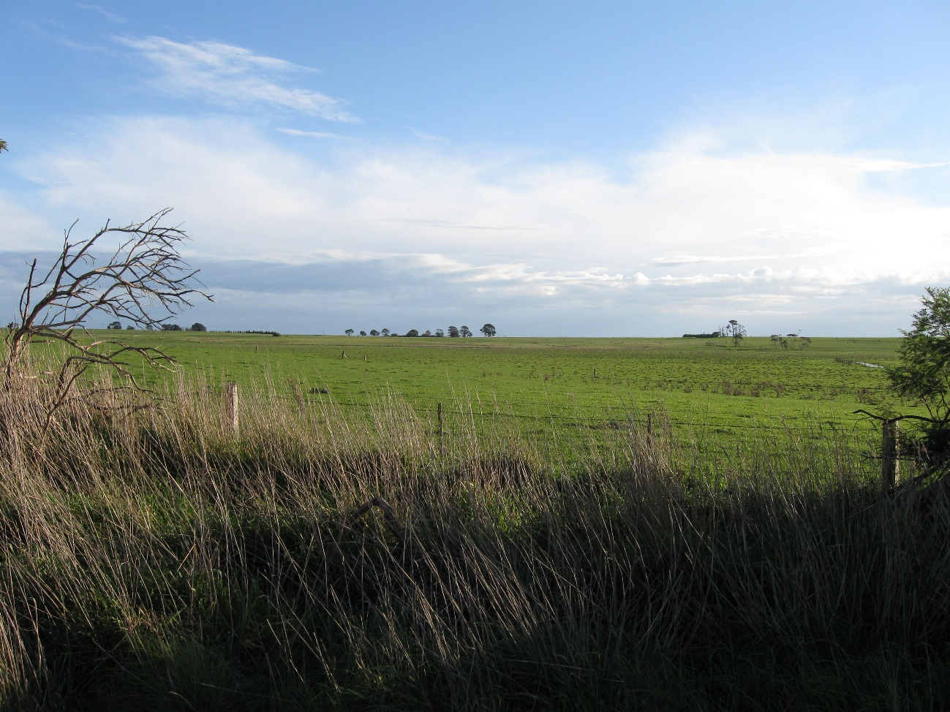

Figure . Typical farmland in the project site

Once the Willatook project site was selected, detailed assessments and community engagement were conducted over the following decade. The process leading to the project design being assessed within the EES is discussed in Chapter 4 – *Project alternatives and design development*.

## Policy context

The rationale for the project is influenced by local, state and national government policies, and international frameworks. Key drivers relate to climate change and the need to reduce greenhouse gas emissions, as well as the economics of reducing the cost of electricity, stimulating the economies of regional areas and maintaining reliable electricity supply. International agreements in relation to the management of climate change impacts has led to commitments at all levels of government to set and achieve greenhouse gas reduction targets, and to implement initiatives to encourage renewable energy development to replace fossil fuels.

The following section describes the policy context at different government levels and how this has provided a key rationale for the project.

### International context

The international community is increasingly calling for accelerated efforts to decarbonise economies to minimise and reduce emissions of carbon dioxide, with electricity generation being a key focus.

#### United Nation Sustainable Development Goals

The United Nations (2015) *Transforming our world: the* *2030 Agenda for Sustainable Development* outlines a set of 17 sustainable development goals and 169 targets to create a more prosperous, sustainable and resilient future. The sustainable development goals seek to end poverty, reduce inequality and improve health and education while tackling climate change and protecting the natural environment.

The project most closely aligns with sustainable development goal no.7:

*Ensure access to affordable, reliable, sustainable and modern energy for all*.

The project would directly contribute to the achievement of this goal through the delivery of low-cost, renewable and reliable electricity to the National Electricity Market.

The **National Electricity Market** involves the wholesale generation of electricity, which is transported via transmission lines (incorporating about 40,000 kilometres of state and private assets) to industrial energy users and local energy distributors in all states and territories except Western Australia and Northern Territory. In total, the National Electricity Market supplies around 10 million customers.

Of the generation resources that make up the National Electricity Market, wind energy comprised of roughly 8% or 15 terawatt-hours (as of 2019/20).

***Source:*** *Fact Sheet – The National Electricity Market (Australian Energy Market Operator (AEMO), 2020a)*

#### Paris Agreement

The outcome of 2016 meeting of the United Nations Framework Convention on Climate Change in Paris was a world-wide commitment to limit global warming to well below 2°C, preferably to 1.5°C, compared to pre-industrial levels, termed the Paris Agreement of 2016. A key component of the Paris Agreement is that countries submit their plans for climate action via ‘nationally determined contributions’ by 2020 and for these contributions to be reviewed and updated (to be increasingly ambitious) on a 5-year cycle.

The Kyoto Protocol was the predecessor of the Paris Agreement. The Kyoto Protocol was adopted in December 1997 and entered into force in 2005. It put into operation the United Nations Framework Convention on Climate Change by committing industrialised countries and economies in transition to limit and reduce greenhouse gas emissions in accordance with agreed individual targets.

Australia is a signatory to both the Kyoto Protocol and the Paris Agreement (see Section 2.3.2).

### Commonwealth context

Australia’s Department of Industry, Science, Energy and Resources is tasked with managing and delivering policies and programs that respond to challenges that climate change poses in Australia. The Department of Agriculture, Water and the Environment (DAWE) is responsible for delivering climate change adaptation and climate science policy and programs. Together with the Department of Foreign Affairs and Trade, these departments negotiate and implement Australia’s obligations under the Paris Agreement and administer other major Commonwealth programs and strategies that relate to climate change.

#### Meeting the Paris Agreement

Under the Paris Agreement, the Australian Government has established the nationally determined contribution of an economy-wide target to reduce greenhouse gas emissions by 26 to 28% below 2005 levels by 2030. Australia’s most recent estimate of the country’s national inventory of greenhouse gas emissions up to the September quarter 2020 showed emissions were 4.4% (or 23.3 million tonnes) lower than in 2019 (Department of Industry, Science, Energy and Resources, 2021a). Emissions were 19% below the level of emissions in 2005 (which is the baseline year for the Paris Agreement). This reduction in emissions is partly due to ongoing reductions in emissions from electricity (down 4.0%), although electricity maintained the highest contribution with 33.4% of total emissions, indicating there is considerable potential for further reductions.

In October 2021, Prime Minister Scott Morrison stated that Australia now has a target to achieve net-zero emissions by 2050. The net-zero emissions by 2050 target has also been committed to by all Australian states and territories.

The project would make a meaningful contribution to Australia’s target to reduce carbon emissions under the agreement, as outlined in Section 2.4 below.

#### Renewable Energy Target

The Renewable Energy Target, administered by the Clean Energy Regulator, is a Commonwealth Government policy designed to ensure at least 33,000 gigawatt hours of Australia’s electricity came from renewable sources by 2020. Under the Renewable Energy Target, the Large-scale Renewable Energy Target scheme requires high-energy users to acquire a fixed proportion of their electricity from renewable sources. This occurs in the form of large-scale generation certificates, which are created by large renewable energy power stations (such as wind farms) and then sold to high-energy users who must surrender them to meet their obligations under the Large-scale Renewable Energy Target (i.e., to meet their renewable energy obligations). One large-scale generation certificate can be created per megawatt hour of eligible electricity generated by a power station, providing a supplement to the generator’s income received for the energy sold on the market.

The Renewable Energy Target’s 33,000-gigawatt hours target (including the Large-scale Renewable Energy Target) was met at the end of January 2021(Clean Energy Regulator, 2021). Large-scale generation certificates will continue to be generated and high-energy users will continue to be required to meet their obligations under the policy until 2030. The large-scale generation certificate price is set by market forces (including supply and demand) and is expected to decrease during the decade to 2030 as oversupply in the market significantly reduces their value.

The project can be expected to create and sell large-scale generation certificates from the time of commissioning up until 2030 when the Large-scale Renewable Energy Target scheme ends. The large-scale generation certificate spot price in Quarter 1 2021 was $33.25 per megawatt hour (Clean Energy Regulator, 2021), however as the supply of renewable energy in the market increases, prices are expected to fall as the Large-scale Renewable Energy Target scheme approaches its end in 2030. The Large-scale Renewable Energy Target scheme is therefore not expected to be pivotal in the financial success of the project.

#### Other Commonwealth initiatives

The recent focus of the Commonwealth Government has been to invest in the National Hydrogen Strategy, emissions abatement strategies, offshore renewable energy and new technologies via its Technology Investment Roadmap. Investment has occurred in large-scale pumped hydro projects like Snowy 2.0 and transmission projects such as Marinus Link, as well as supporting energy efficiency measures and developing a national strategy for electric vehicles.

The Commonwealth Government has policies and programs that provide indirect support for large-scale conventional wind energy projects. For example, the carbon emission reduction benefits of pumped hydro are maximised by using renewable energy, such as wind energy projects, to pump water that can later be used to generate electricity. The environmental benefits of electric vehicles are also maximised when the source of electricity to charge them is from renewable energy such as wind energy projects.

#### Manufacturing and recycling

In 2021, the Commonwealth Government released a *Recycling and Clean Energy National Manufacturing Priority Road Map* (Department of Industry, Science, Energy and Resources, 2021b)as part of its Modern Manufacturing Strategy. The road map highlights opportunities that exist in Australia for manufacturing and recycling of clean energy components such as wind turbines and batteries. The road map signals an expression of the Commonwealth Government’s intentions to support manufacturing and recycling enterprises in the wind energy sector, and sets two-, five- and ten-year goals to achieve its vision to:

*..develop world-leading advanced manufacturers that seize economic opportunities from sustainability, the clean energy transition, and the global effort to create more value from resources and reduced waste*.

An industry-wide approach to recycling would streamline processes, helping to reduce costs and increase the effectiveness of these processes. The project owner and operator would work with the Commonwealth Government, as well as state and local governments and industry associations (e.g., the Clean Energy Council) when preparing and later implementing the project’s detailed decommissioning plan. This will help maximise the recyclability of wind farm infrastructure at the end of its life.

### Victorian context

The Victorian Government’s policies relating to energy, and particularly renewable energy, have changed considerably during the past 20 years. The last six years has seen concerted effort by the Victorian Government to increase the contribution of renewable energy as a means of reducing greenhouse gas emissions from the electricity sector, including providing support to develop socially and environmentally sustainable wind energy projects. Importantly, the project would contribute to the state’s long-term target of net zero emissions by 2050, underpinned by the Victorian *Climate Change Act 2017*.

Other policy objectives include reducing the cost of electricity, stimulating the Victorian economy, and assisting with the evolution of the National Electricity Market currently underway.

#### Victoria’s Renewable Energy Roadmap

In 2015 the Victorian Government released the state’s Renewable Energy Roadmap (Department of Economic Development, Jobs, Transport and Resources, 2015). It was acknowledged at the time that a critical element of delivering a sustainable economy is to increase the supply of renewable energy generation in the National Electricity Market. At that time, only 12% of Victoria’s electricity was sourced from renewable energy (predominantly via wind, solar and hydro power).

The Renewable Energy Roadmap included several initiatives including reinstating a whole-of-Victorian Government facilitation service for renewable energy projects and investigation of new models to enable renewable energy projects. The Renewable Energy Roadmap also flagged the intention of releasing a Renewable Energy Action Plan that would establish targets for renewable energy generation in Victoria.

#### Renewable Energy Action Plan

Victoria’s Renewable Energy Action Plan was released in 2017 by DELWP, setting out long-term actions to drive renewable energy investment in Victoria. Action 1 of the Plan was a commitment to the Victorian Renewable Energy Target for 2020 and 2025. The Victorian Government has since legislated renewable energy targets within the *Renewable Energy (Jobs and Investment) Act 2017*. This legislation sets targets of 25% renewable energy by 2020, 40% by 2025 and 50% by 2030. The Government has met its 2020 target with more than 26% of Victoria’s electricity generated from renewable energy sources (DELWP, 2021a).

Action 6 of the Plan is to streamline renewable energy project processes and approvals. The Government established a ‘one stop shop’ for wind farm planning permit matters “to ensure relevant government agencies can respond promptly to issues for individual applications”. The action also flagged the future introduction of Environment Protection Authority (EPA) Victoria audit of noise assessments and noise management plans (refer to Chapter 3 – *Legislation and policy framework* to see how these apply to the project).

Action 17 of the Plan is to support energy storage that integrates with renewable energy generation. The Plan commits to a minimum of two 20 megawatt batteries in western Victoria, “to support battery storage becoming mainstream”.

#### Victoria’s Climate Change Strategy

Victoria’s Climate Change Strategy (DELWP 2021b) is a roadmap to net-zero emissions and a climate resilient Victoria by 2050. The Government has set targets to reduce the state’s greenhouse gas emissions from 2005 levels by 28–33% by 2025 and 45–50% by 2030. The strategy is linked to the legislated renewable energy targets referred to above under the Renewable Energy Action Plan.

#### Victoria’s energy future

The Australian Energy Market Operator (AEMO) has reported that “a minimum of 13.2 GW [gigawatts] of Victorian renewable generation would be required by 2030 to meet the Victorian Renewable Energy Target (VRET). This means Victoria will need at least an additional 5.4 GW of additional large-scale renewable energy projects and DER [distributed energy resources] investment to meet the VRET” (AEMO, 2020b). This statement was made before the announcement by Energy Australia in March 2021 of the early closure of the Yallourn coal-fired power station in 2028 instead of 2032.

The early closure of Yallourn, along with the potential early closure of other coal-fired power stations within the National Electricity Market, creates additional incentive to add new energy generation before 2028. Given current global and local trends and Victorian Government policies on energy, the replacement for Yallourn’s 1,450 megawatts (~10,500 gigawatt hours) of generation will most likely be from renewable energy sources. The addition of large-scale batteries (and pumped hydro) will also contribute to the energy mix, allowing renewable energy to be stored during periods of low demand and dispatched when demand is higher.

The project’s estimated 1,300 gigawatt hours of renewable energy could replace around 12% of Yallourn’s output, and the battery and synchronous condenser (if built) would provide additional security of supply to the National Electricity Market.

#### Renewable Energy Zones

AEMO’s *2020 Integrated System Plan* (2020c) identified six Victorian Renewable Energy Zones (Figure 2.2). These Renewable Energy Zones are regions with the greatest potential for renewable energy development across the state, and their selection focuses on areas where grid improvements should be carried out to facilitate the transition to a renewables-based National Electricity Market.

The Victorian Government has committed to developing the Renewable Energy Zones to meet the following objectives:

* ensure that communities, including traditional owners, are engaged in the process
* provide for the orderly, planned development of renewable energy resources
* efficiently and effectively expand the grid and connect new generation
* reduce network congestion and costs.

A Renewable Energy Zone Development Plan is currently under development to ensure investments are coordinated, timely, and deliver positive outcomes for Victoria and local communities. This follows the release of the *Victorian Renewable Energy Zones Development Plan Directions Paper* in February 2021 (DELWP, 2021c) which tabled several priority transmission network upgrades “to support existing and future renewable energy generation development in Victoria’s Renewable Energy Zones”.

In early 2021, the Victorian Government announced the establishment of VicGrid to administer a $540 million Renewable Energy Zone fund. This government agency will engage with regional communities to provide for appropriate and beneficial development in each Renewable Energy Zone. Their work will see immediate network investments to upgrade the grid to support the decentralisation of energy generation (i.e., over-reliance on coal fired generation in the Latrobe Valley) and integration of renewables within the Renewable Energy Zones in Victoria.

The strength of the wind resource, access to a transmission network with capacity and the availability of suitable land on which to develop renewable energy projects has led to south-west Victoria being designated a Renewable Energy Zone. This identification of the candidate Renewable Energy Zone was formalised by the Victorian Government in early 2021, and the management of the Renewable Energy Zone will be overseen by VicGrid.

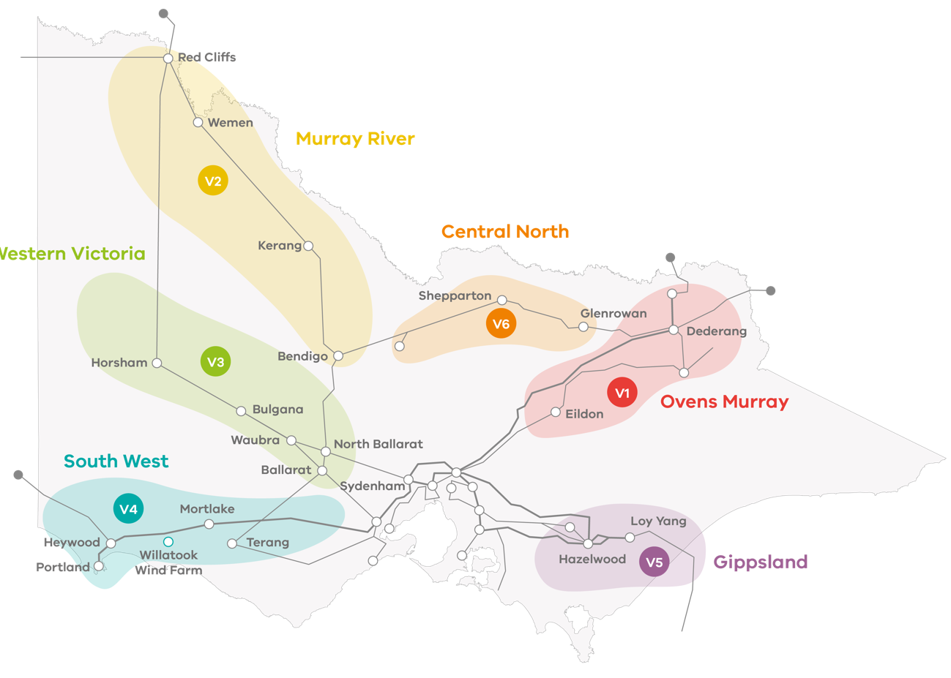

Figure . Renewable Energy Zones in Victoria (source: DELWP, 2021e)

#### Victoria Planning Provisions

State Government plans and strategies for renewable energy are supported through the by the Victoria Planning Provisions contained within all local planning schemes, including the Moyne Planning Scheme. Clause 19.01-2S (Renewable energy) has the objective of promoting the provision of renewable energy in a manner that ensures appropriate siting and design considerations are met. One of the strategies listed in this planning provision is to “consider the economic and environmental benefits to the broader community of renewable energy generation while also considering the need to minimise the effects of a proposal on the local community and environment”.

Clause 52.32 (Wind Energy Facility) provides more specific direction in relation to the use and development of land for a wind farm “to facilitate the establishment and expansion of wind energy facilities, in appropriate locations, with minimal impact on the amenity of the area”. Specifically, the clause includes a description of when a permit is required to use and develop land for a wind energy facility and what a permit application must include.

### Local and regional policies

#### Victoria’s Regional Statement

*Victoria’s Regional Statement* was released in 2015 and set out the next steps and flagged future directions for regional development policy. The statement’s focus is on regional jobs growth and boosting regional economies, with renewable energy identified as a key element of future plans.

In late December 2019, the Barwon South West Renewable Energy Roadmap was released, which incorporates the Moyne Shire (DELWP, 2019). The roadmap articulates the region’s “vision for a renewable energy future, identifying opportunities to attract investment and better understand their community’s engagement and capacity to transition to renewable energy” (from the Minister’s foreword). Collaboration, consultation and engagement with local communities was key to the roadmap’s development. Key themes from the consultation were:

1. Support for renewable energy is strong – very few people (less than 1%) did not support a shift to renewable energy.
2. Take a strategic approach and listen to the community – the community was concerned that renewable energy generation projects were not being planned in a systematic way across Victoria, leading to rushed and ad hoc projects, and that community consultation about proposed renewable energy projects was poor.
3. Share the benefits – it was important that projects created local jobs and an economic boost to local businesses.
4. Wind and solar are the preferred technologies – these technologies were seen by communities as the most appropriate, given the climatic conditions and advantages.
5. Cut down the complexities and costs and make it easier – the community felt that the current rules and regulations are highly complex and preventing community involvement and innovation in the renewable energy space.

Respectful engagement and honest sharing of information has formed a key part of the project’s development for more than ten years. While some of the key themes of the project’s consultation are reflected in those from the Roadmap, community engagement was (and continues to be) carried out in accordance with the Clean Energy Council’s *Best Practice Charter for Renewable Energy Developments*.

#### Moyne Shire Council

Victoria currently has 30 wind farms operating throughout the state, with several others under construction, with planning approval, seeking planning approval or under investigation. The Moyne Shire is home to Victoria’s oldest wind farm, Codrington Wind Farm (near Port Fairy), built in 2001 and still operating today. As of October 2021, the Moyne Shire has seven operating wind farms and a further three with a planning permit. The operating wind farms are Codrington, Yambuck, Mortons Lane, Macarthur, Salt Creek, Dundonnell and Mortlake South. Those wind farms with a planning permit are Ryan Corner, Hawkesdale and Woolsthorpe. The proponent of the Mt Fyans Wind Farm has applied for a planning permit.

In October 2019, Moyne Shire Council declared a climate emergency. The declaration “commits Council to advocating to state and Federal governments to declare a climate emergency and to drive actions to reduce emissions and the impacts on coastal areas. Moyne Shire Council will also incorporate the declaration in all of its relevant strategies and policies and consider the impact of climate change when planning and decision making” (Moyne Shire Council, 2019a).

The Moyne Shire’s *Council Plan 2021–2025* includes strategic objectives relating to renewable energy, including that:

* *”Local communities receive significant benefits from investment and development in renewable energy projects across the Shire*”, and
* *The scale and size of renewable energy projects considers cumulative social, environmental and economic impacts*”.

The project team has worked with Council via Council’s Major Projects team, the EES Technical Reference Group and periodic presentations to councillors.

On 27 November 2018, Council resolved to oppose any further wind farm development or new transmission infrastructure within the shire, pending the implementation of the National Wind Farm Commissioner’s 2017 annual report recommendations within Victoria. The key concern raised by Council was around cumulative impacts of wind farms on the community, including social impacts relating to housing availability, noise and visual amenity, and traffic, as well as environmental impacts such as impacts to Brolga and other threatened fauna, native vegetation and threatened flora (Moyne Shire Council, 2021). These concerns have been addressed through the avoidance of impacts where possible, and mitigation and management measures where needed (as contained within the EES and summarised in Chapter 26 – *Environmental management framework*).

#### Great South Coast Regional Growth Plan

Regional Growth Plans cover eight regions in Victoria and, together with *Plan Melbourne 2017-2050*, provide a land use planning framework for Victoria. Of the regional plans, the *Great South Coast Regional Growth Plan* (2014) covers the project site and Moyne Shire, as well as the municipalities of Corangamite, Glenelg, Southern Grampians and Warrnambool.

The *Great South Coast Regional Growth Plan* outlines opportunities for growth during the next 30 years, with the vision to “create a thriving, multifaceted and resilient economy, while valuing and managing our natural resources and environment”. A key strategic direction of the Plan is to position the Great South Coast for economic growth, with renewable energy (including wind energy) identified as a major opportunity for the region. Land use policies, strategies and actions outlined in the Plan in relation to alternative energy production (i.e., energy generated from renewable sources and natural gas) include:

* “support the development of energy facilities in appropriate locations where they take advantage of existing infrastructure and provide benefits to the regional community
* require the protection and proper maintenance of infrastructure and assets, including local roads, during the development and construction of energy projects
* plan for and sustainably manage the cumulative impacts of alternative energy development
* secure access to key construction material resources in the region, including on-site quarrying”.

## Environmental benefits

The project would provide several environmental benefits from a global to a local level.

The project would contribute significantly to the Victorian Renewable Energy Target of 50% by 2030. In 2020, renewable energy sources were already generating more than 26% of Victoria’s electricity (DELWP, 2020). During the 2019–2020 financial year, wind generation contributed about 12.2% of Victorian electricity generation by source. If the project’s contribution of more than 1,300 gigawatt hours was added to the National Electricity Market at that time, it would have increased the overall contribution from wind (and therefore renewable sources) by more than 2%.

As more renewable energy generation is added to the grid the emissions intensity of the electricity is reduced. The emissions intensity is the amount (in tonnes) of carbon dioxide emitted per megawatt of electricity supplied to the grid from all contributing generators.

Figure 2.3 shows the emissions and emissions intensity within the National Electricity Market. The emission intensity is the amount of carbon dioxide emitted per megawatt generated and the graph indicates that, since 2015 in Australia, electricity has increasingly been supplied by renewable energy sources.

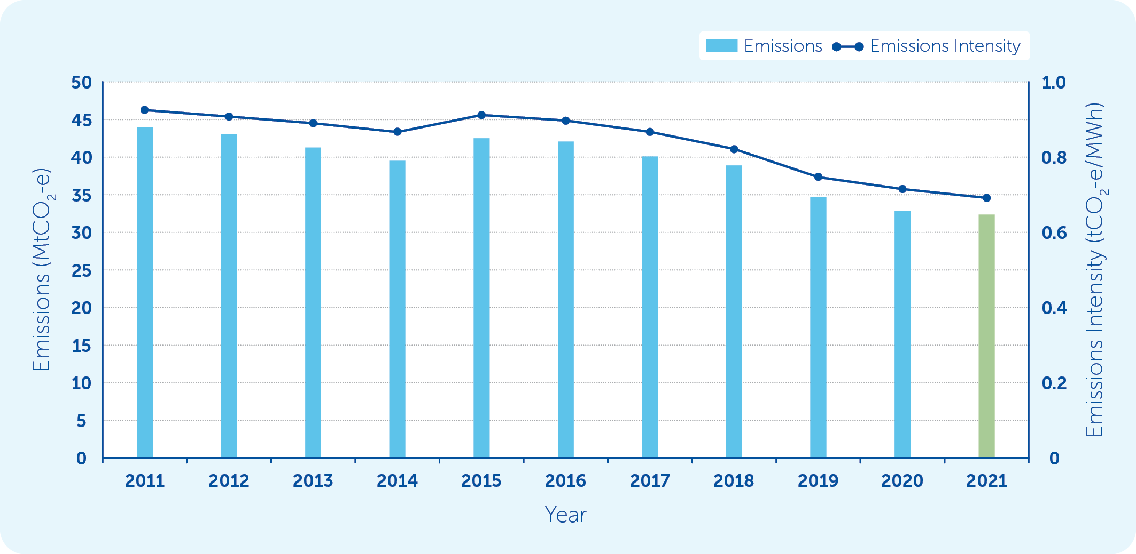

Figure . Quarterly National Electricity Market emissions and emissions intensity (Q4s) (source: Australian Energy Market Operator, 2021)

The key environmental benefit of the project would be contributing to a reduction of emissions intensity of electricity within the National Electricity Market. With a contribution of at least 1,300 gigawatt hours of electricity to the National Electricity Market, that is enough to power more than 200,000 homes with renewable energy. If the project were to directly replace the brown coal generation, this would equate to savings of around 1.3 million tonnes of carbon dioxide equivalent annually.

Australia has one of the highest per capita emissions of carbon dioxide in the world, and our population of more than 25 million people is contributing significantly to human-induced climate change on a per capita basis. Australia ranks higher than other large democracies for emissions, including the United States, Canada and South Korea (Data Commons, August 2021). Australia is also highly exposed to the impacts of climate change, providing a particular imperative that action is taken to reduce carbon emissions as soon as possible (CSIRO, 2020).

## Economic benefits

The main drivers for developing wind energy projects may be environmental, but there are also significant economic drivers. The relative cost of wind energy continues to fall and is predicted to fall further into the future. The key contributors to this fall in cost are:

* improvements in wind turbine, energy storage and electricity grid technologies
* higher costs to produce energy from fossil fuels
* policy certainty, particularly at the state level, that create a more stable market for wind energy technology
* a growing and increasingly skilled local workforce.

### Electricity costs

The CSIRO *GenCost 2020-21 consultation draft* report (Graham et at. 2020) stated that:

*“Variable renewables (wind and solar PV [photovoltaic]) without transmission or storage costs are the lowest cost generation technology by a significant margin. From 2030, the new estimates on additional costs associated with increasing variable renewable generation confirms that they are also competitive when transmission and storage costs are included up to any relevant VRE [Variable Renewable Energy] share”.*

The Australian Energy Market Commission (2020) stated that “Wholesale costs are expected to go down by 37.2 per cent (or $197) over the reporting period [1 July 2020 to 30 June 2022]. This is driven by increases in generation capacity, particularly wind farms”.

### Investment in the wind sector

The Clean Energy Council’s *Clean Energy Australia Report 2021* reported the total investment amount for large-scale renewable energy projects under construction or financially committed in Victoria was $5 billion.

The Moyne Shire *Annual Report 2019-2020* (Moyne Shire Council, 2019b) reported that renewable energy projects worth an estimated $7 billion are in various stages of planning and development across the shire. This includes projects that are not yet financially committed, such as the Willatook Wind Farm project.

It is clear from the growth in installed wind farm generation capacity in Australia that investment has been increasing. Greater energy policy certainty at the state level and estimated closure dates for some of Australia’s biggest coal-fired power stations is fuelling the investment in the renewables sector.

### Employment and economic stimulus

The Clean Energy Council’s *Clean Energy Australia Report 2021* reported the wind energy in Australia directly employs 7,200 people.

The project would support the local and regional economy by providing around 180 direct full time equivalent jobs during construction and an additional 290 indirect full time equivalent jobs through supply chains and local service industries. Around 12 ongoing full time equivalent maintenance jobs and 35 indirect full time equivalent jobs would also be created throughout the operation of the wind farm.

The project would also upgrade several roads to provide access for the oversized project infrastructure components such as wind turbine blades and tower sections. These upgrades would also improve the road conditions for local road users in the longer term.

The project is predicted to generate considerable economic benefits during its 25-year life, including:

* capital expenditure of approximately $800 million
* total rates to the Moyne Shire of more approximately $550,000 each year during the project’s operational life
* ongoing economic stimulus of approximately $158.4 million over 25 years associated with the operation of the wind farm via financial returns to Moyne Shire, host landowners, neighbour benefit program payments and local wages
* the inclusion of local and regional content requirements into key project contracts to maximise employment opportunities in the Moyne Shire and surrounding areas.

Further details about the economic benefits can be found in Chapter 17 – *Social-economic*.

### Neighbour Benefit Sharing Program

The project’s Neighbour Benefit Sharing Program has been developed in consultation with the local community and draws upon recommendations from the Australian Energy Infrastructure Commissioner’s annual reports, the Clean Energy Council’s (2019) *A guide to benefit sharing options for renewable energy projects,* andthe Department of Environment, Land, Water and Planning’s *Community Engagement and Benefit Sharing in Renewable Energy Development in Victoria - A guide for renewable energy developers* (DELWP, 2021d).

The total value of the Neighbour Benefit Sharing Program is dependent on the number and location of constructed wind turbines; however, the current estimate of total value of the program is around $900,000 per year for the life of the project. The injection of this money into the local economy is expected to benefit the region.

The proposed Neighbour Benefit Sharing Program was communicated to project stakeholders in November-December 2020 via a flyer (Attachment V), and via the project website. A summary of the program, including an example of the Neighbour Benefit Program payment calculation, is illustrated in Figure 2.4.

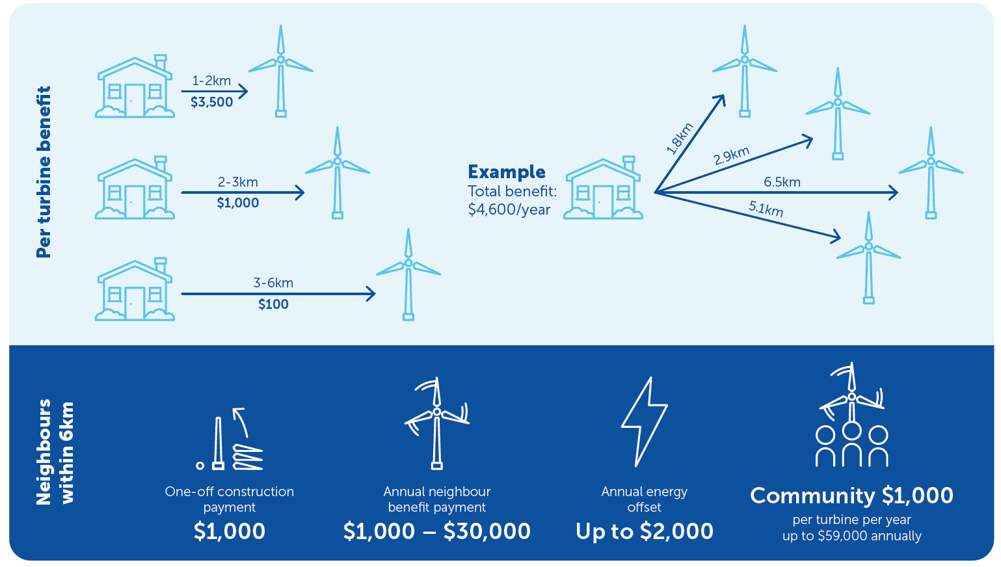

Figure . Neighbour Benefit Sharing Program summary

## Achieving project objectives

Table 2.1 outlines how project objectives would be achieved. Later chapters of this EES explain how some of these project objectives would be achieved in more detail. These chapters are referred to in the table where relevant.

Table 2.1 Project objectives

| Objective | How the project aims to achieve the objective |
| --- | --- |
| Deliver affordable and reliable electricity generated by renewable energy to the electricity grid | The project would provide up to 354 megawatts of wind generation capacity to the National Electricity Market. Large scale wind turbines are proven technology and have been part of Australia’s energy mix for more than 20 years. The project also has provision for around 200 megawatts/400 megawatt hours of battery energy storage and may include synchronous condenser which, along with hydro and pumped hydro projects (developed and operated by others), would ensure variable renewable energy generators (such as wind farms) can deliver reliable electricity to consumers.  Wind energy is considerably cheaper than fossil fuel generation and is expected to remain so into the future. |
| Support Victoria’s Renewable Energy Target | At around 354 megawatts, the project would deliver more than 1,300 gigawatt hours of affordable renewable electricity to the grid annually, replacing electricity sourced from fossil fuels. This would help the Victorian Government reach its renewable energy targets of 40% by 2025 and 50% by 2030. |
| Support the Commonwealth Government’s greenhouse gas emissions reduction target | The project would supply more than 1,300 gigawatt hours of renewable electricity annually. This would help the Commonwealth Government achieve its Paris Agreement greenhouse gas reduction target of 26% to 28% on 2005 levels by 2030, as well as the Commonwealth Government’s target of achieving net-zero emissions by 2050. |
| Improve network strength through the development of a firmed power supply | The project is proposed to include a battery energy storage facility that can provide short-term supply to the National Electricity Market. The project also has provision for a synchronous condenser which can provide network stability services to the National Electricity Market.  Further details about the battery and synchronous condenser can be found in Chapter 5 – *Project description*. |
| Minimise negative, and maximise positive, effects on the environment and communities | The EES process established a mitigation hierarchy whereby potential impacts are firstly avoided or reduced during the design phase, with any remaining potential impacts addressed via management measures in the construction and operational phases of the project in order to achieve the evaluation objectives for the project (as stated in the scoping requirements). This process is explained within Chapter 7 – *Assessment framework*.  A thorough assessment of impacts and opportunities has been carried out via the EES process, committing the project owner to effective avoidance and mitigation measures listed in Chapter 26 – *Environmental management framework*.  Neighbouring landowners and local community organisations would continue to be consulted throughout the design, construction and operational phases to work through any issues and to maximise the benefits from the project.  Government agencies and Council would be expected to maintain a strong involvement in all stages of the project to help achieve the best outcomes for the environment and communities. These stakeholders are expected to help provide an understanding of the various regulatory requirements, review the adequacy of mitigation and management measures, and where required, enforce compliance with project commitments. |
| Support the local community and the local economy | The project would increase development in the region, providing opportunities for local contractors and suppliers of goods and services and opportunities for local employment during construction and operation.  The project would also include a Community Benefit Fund (as part of the Neighbour Benefit Sharing Program), administered by a community-led independent fund committee, comprising $1,000 per operational wind turbine per year indexed annually to the Consumer Price Index from the commencement of the fund.  Further details about how the Community Benefit Fund and the Neighbour Benefit Sharing Program were developed can be found in Chapter 6 – *Stakeholder consultation* and Attachment IV – *Neighbour Benefit Sharing Program*. |
| Support participating and neighbouring landowners | Provide landowners with additional drought resistance income streams complementary to their existing farming operations.  The Neighbour Benefit Sharing Program would offer the following benefits to eligible neighbouring landowners and/or residents with a dwelling within six kilometres of a constructed wind turbine (excluding those hosting infrastructure):  one off construction payment of $1,000  neighbour benefit payment of between $1,000 and $30,000 annually (subject to eligibility criteria, including proximity of dwellings to constructed wind turbines)  energy cost offset plan payment of up to $2,000 annually.  Further details about how the Neighbour Benefit Sharing Program was developed can be found in Chapter 6 – *Stakeholder consultation* and Attachment IV – *Neighbour Benefit Sharing Program*.  The project infrastructure layout has been designed to minimise impacts to the ongoing farm operations of the host landowners, with access tracks following fence lines where appropriate and using existing farm access track layouts.  Construction would be managed in accordance with a stringent Environmental Management Framework and environmental management plans to protect the amenity of, and limit impacts to, neighbouring landowners and the local community. |
| Engage and work with community and stakeholders to identify any potential environmental impacts and implement appropriate mitigation and/or monitoring measures | A consultation plan was formalised at the start of the EES process in early 2019. Considerable community engagement had occurred before that point in time however the plan set out a process to inform the public about the EES, seek targeted input and to respond to that input. Inputs included issues of potential concern, local knowledge on existing conditions, perceptions of potential effects, and feedback on proposed mitigation and management measures.  Consultation would continue in accordance with the commitments made in Chapter 26 – *Environmental management framework*. |