# Electromagnetic interference

## Overview

This chapter identifies the existing radiocommunication licences in the vicinity of the project, as well as other services such as broadcast radio and television, meteorological radars, and wireless and satellite internet, that have the potential to experience electromagnetic interference from operating wind turbines. This chapter is based on the findings of the electromagnetic interference assessment report prepared by DNV Australia Pty Ltd (provided in Appendix N – *Electromagnetic interference*). This chapter also presents the findings of the aviation impact assessment (prepared by Chiron Aviation Consultants and provided in Appendix O – *Aviation*) in relation to potential impacts of the project to aviation communications, navigation and surveillance facilities.

Based on a review of the Australian Communication and Media Authority Register of Radiocommunication Licences database, there are limited radiocommunication services are in the vicinity of the project, with only one point-to-point link (operated by AusNet Services) passing over the project site and three point-to-multipoint stations located within 20 kilometres of the site (operated by Aussie Broadband, Powercor and Wannon Region Water Corporation). Radiocommunications service providers, emergency services, mobile phone providers, NBN, Bureau of Meteorology, operators of fixed point-to-point communications links and radio services were consulted to determine the potential for electromagnetic interference. The operators of these services were asked to assess if the proposed project would interfere with their services and to provide possible mitigation measures where they deemed them necessary. Respondents typically advised that no impacts, or acceptable (negligible) levels of impact were expected. Where they advised of potential impacts, respondents provided a range of feedback on conditions they require the project adopt (e.g., Bureau of Meteorology).

The project has sought to eliminate potential electromagnetic interference impacts from the project, including relocating turbines away from a fixed point-to-point link operated by AusNet Services and the adoption of a buffer to further avoid any potential interference. To ensure mobile phone, NBN, broadcast radio and broadcast television are not negatively impacted, a Signal Strength Survey at neighbouring dwellings would be conducted prior to construction, and then after construction if issues are identified. The proponent would undertake measures necessary to rectify any impacted services.

The assessment of electromagnetic interference concluded that, following the implementation of design and management controls, the project is unlikely or has a low potential to cause interference. Further consultation with the operators of communications and other service providers would occur during detailed design to confirm the avoidance of electromagnetic interference impacts, and to address any impacts identified.

## EES objectives and key issues

The EES scoping requirements specify the draft evaluation objective and key issues, outlined in Table 22.1, relevant to electromagnetic interference that have guided this assessment.

Table .EES draft evaluation objective and key issues

| Draft evaluation objective  Land use and socio-economic: *To avoid and minimise adverse effects on land use (including agricultural and residential), social fabric of the community (with regard to wellbeing, community cohesion), local infrastructure, electromagnetic interference, aviation safety and to neighbouring landowners during construction, operation and decommissioning of the project.* | |
| --- | --- |
| **Key issues** | Potential adverse effects of wind turbines and associated infrastructure from an aviation perspective, including but not limited to impacts on aerial safety, **air traffic control equipment**, obstruction and turbulence.  Potential interference with **communication systems** that use electromagnetic waves as the transmissions medium (e.g., television, radio, mobile reception). |

## Legislation

Key legislation, policies and guidelines relevant to electromagnetic interference are summarised in Table 22.2.

Table 22.2Relevant legislation, policies and guidelines

| Legislation/policy/ guideline | Description | Relevance to project |
| --- | --- | --- |
| **State** | | |
| *Planning and Environment Act 1987* | The purpose of the *Planning and Environment* *Act* is to establish a framework for planning the use, development and protection of land in Victoria. The Act sets out the process for obtaining permits under schemes, settling disputes, enforcing compliance with planning schemes and permits, and other administrative procedures. | The following Clause of the Particular Provisions of the Moyne Planning Scheme is relevant to the project:  Decision Guidelines of Clause 52.32 Wind Energy Facility state that: “*Before deciding on an application, in addition to the decision guidelines of Clause 65, the responsible authority must consider, as appropriate:*   * *The effect of the proposal on the surrounding area in terms of … electromagnetic interference.”* |
| **Guidelines/policies** | | |
| *Policy and planning guidelines for the development of wind energy facilities in Victoria* (Policy and Planning Guidelines) (DELWP, 2021f) | The Policy and Planning Guidelines provide a set of consistent operational performance standards to inform the assessment and operation of a wind energy facility project; and guidance as to how planning permit application requirements might be met. | The Policy and Planning Guidelines recommend the potential for electromagnetic interference from the generation of electricity from a wind energy facility is minimised, if not eliminated, through appropriate turbine design and siting.  These guidelines also recommend that the siting of wind turbines in the ‘line of sight’ between transmitters and receivers is avoided. |
| *National wind farm development guidelines – draft* (Draft National Guidelines) (Environment Protection and Heritage Council, 2010) | The *National wind farm development guidelines – draft* (Draft National Guidelines) outline the best-practice methods for assessing the impacts associated with the development and operation of wind farms. This includes detailed methodologies for the assessment of electromagnetic interference. | The Draft National Guidelines informed the methodology adopted for the project electromagnetic interference assessment. |

## Method

All radiocommunication towers (and radiocommunication licences attached to these towers) within the investigation area were identified and the potential for electromagnetic interference to these towers and licences from the project was assessed. Information on radiocommunication licenses was obtained from the Australian Communication and Media Authority Register of Radiocommunication Licences database, accessed 18 February 2021. This database was used to determine the transmission paths of the licenced links.

Other services with the potential to experience interference from the project were also identified, including meteorological radars, trigonometrical stations, Citizen’s Band (CB) radio and mobile phones, wireless internet, broadcast radio and television, and satellite television and internet.

As per the recommendations of the Draft National Guidelines, consultation was undertaken with relevant radiocommunication operators within 20 kilometres of a wind turbine or within 250 nautical miles of an aeronautical or meteorological radar site. Based on these consultation zones, the following service operators were contacted as part of the project electromagnetic interference assessment:

* AusNet Transmission Group Pty Ltd (AusNet Services)
* Aussie Broadband Pty Ltd. (Aussie Broadband)
* Powercor Australia Pty Ltd. (Powercor)
* Wannon Region Water Corporation
* NBN Co
* BAI Communications
* Geoscience Australia
* Australian Bureau of Meteorology
* Land Use Victoria (DELWP)
* Telecommunication providers Telstra, Optus and Vodafone
* Emergency services including Country Fire Authority, Ambulance Victoria, Victoria State Emergency Service and St John Ambulance Australia
* Department of Justice and Regulation (Regional Mobile Radio and Visionstream Australia (now Ventia)).

## Investigation area

The electromagnetic interference assessment considered all identified dwellings within 5 kilometres of the project site. This area encompasses 136 dwellings, of which 23 are stakeholder dwellings.

A broader investigation area of 75 kilometres from the project site was used to identify mobile phone and NBN fixed wireless towers, and radiocommunication towers and licences listed in the Australian Communication and Media Authority Register of Radiocommunication Licences database.

## Existing conditions

### Radio communication towers

Radiocommunication

The transmission, emission and/or reception of radio waves for specific telecommunication purposes.

Point-to-point links

Point-to-point links are often used for line-of-sight connections for data, voice and video (such as on mobile and television broadcast towers).

Point-to-multipoint links

Point-to-multipoint links provide connections from one location to multiple locations, via multiple paths. Examples of point-to-multipoint links include those used for wireless internet connections.

A review of the Australian Communication and Media Authority Register of Radiocommunications Licences database identified 433 radiocommunication towers within the investigation area, with one tower located within 2 kilometres of the turbine locations (approximately 900 metres) (Figure 22.1). The licences associated with this tower are fixed point-to-point links operated by AusNet Services.

### Fixed point-to-point licences

There is one point-to-point link listed in the Australian Communication and Media Authority Register of Radiocommunication Licences database, operated by AusNet Services, which passes over the project site   
(Figure 22.1). This point-to-point link is associated with the radiocommunication tower located within 2 kilometres of the turbine locations.

### Fixed point-to-multipoint licences

There are 44 point-to-multipoint links listed in the Australian Communication and Media Authority Register of Radiocommunication Licences database within the investigation area, with three stations located within 20 kilometres of the site. These stations are owned by Aussie Broadband, Powercor and Wannon Region Water Corporation.

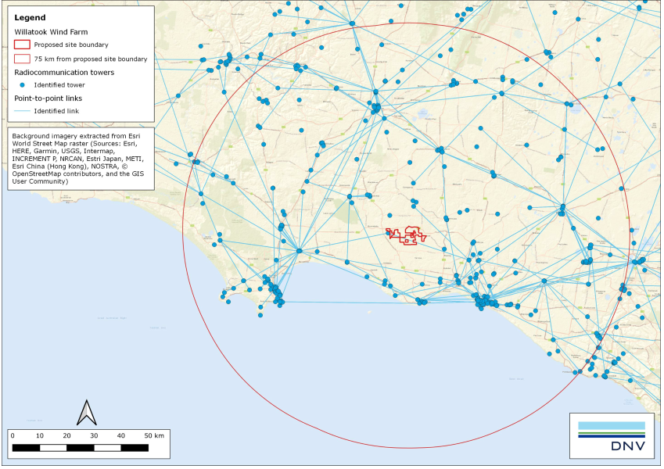

Figure . Location of identified radiocommunication towers and fixed point-to-point links within 75 kilometres of the project site

### Other licence types and services

Weather radar

Standard weather watch radars emit pulsed microwave radiation, which reflects from water particles in the atmosphere to detect rain activity. Doppler radars are able to measure the speed of moving water particles by bouncing a microwave signal off a desired target. This provides information on wind speed and direction.

Trigonometrical stations

Trigonometrical stations (or trig points) are observation marks used for surveying or measuring distance. Trig points may host surveying equipment such as GPS and electronic distance measuring devices, which measure the distance from the trig point to the target object by a reflected beam.

Global navigation satellite system technology is also commonly used for surveying and distance measurements by using positioning and timing information received from satellite signals.

CB radio

CB radio can be used by the general public, and is commonly used in rural areas for emergency communications, road safety information and general conversation. The most common type of CB radio are mobile or handset CB radios (vehicle mounted) and hand-held (walkie‑talkie style) CB radios.

Radio transmission

AM: diffracted by the ground, AM transmissions are able to travel significant distances under the right conditions and can readily propagate around physical obstructions such as wind turbines. However, due to the distances AM transmissions can travel, the signal may be weak and can be susceptible to interference from sources such as changes in atmospheric conditions, electrical power lines and electrical equipment.

FM: better suited to short range broadcasting, FM transmissions may be blocked by significant terrain features.

Other licence types include point-to-area type communications, including those used by emergency services, mobile phones, and radio and television broadcasting. The sections below provide a summary of these licence types within the project investigation area, as well as other services with the potential for electromagnetic interference-related impacts.

#### Emergency services licences

There are no emergency services point-to-point links crossing the project site. The closest licence is approximately 5 kilometres from the project site and is owned by the Country Fire Authority.

#### Meteorological radar

The World Meteorological Organisation guidelines state that wind turbines should not be located within 5 kilometres of a meteorological station due to the potential for the weather radar signal to be blocked by the turbines. Significant impacts are generally not expected for wind farms located more than 45 kilometres from a meteorological radar, however this can depend on the elevations of the radar and wind farm and the terrain.

The Bureau of Meteorology operates eight weather radars within 250 nautical miles of the project, with the closest radar (Mount Gambier) located approximately 122 kilometres north-west of the project site.

#### Trigonometrical stations

The Geoscience Australia *National Geospatial Reference System* database indicates there are two trigonometrical stations within 20 kilometres of the project site.

The closest global navigation satellite system station is located approximately 22 kilometres south of the project at Port Fairy.

#### CB radio and mobile phones

As users of CB radio do not require a licence, there is no record of users of the service and their location.

A review of the mobile phone towers in the project region shows that the closest tower is location approximately 10 kilometres north-east of the project site.

#### Wireless internet (broadband and NBN), and satellite television and internet

Aussie Broadband owns licences in the project site, with the nearest base station located 18 kilometres south-east of the project site. While the location of Aussie Broadband customers is not known, it is possible that these stations may be servicing customers in the vicinity of the project.

NBN is currently available in the region as a fixed wireless services and satellite internet service. The NBN tower servicing the project region is located at Hawkesdale in the north-east. It is likely that some residents are currently accessing the internet via the NBN.

Due to marginal coverage of some communication services, some residents in the vicinity of the project may use satellite television and internet.

#### Broadcast radio

The location of AM and FM radio broadcast transmitters are shown in Figure 22.2 below. The closest FM broadcast transmission tower is located approximately 20 kilometres south-east from the project site.

There is no digital radio coverage currently available in the region.

#### Broadcast television

The main digital television broadcast transmitter used by residents in the region is the Warrnambool transmitter at Tower Hill (Figure 22.2). However, it is also possible that nearby residents are able to receive digital television signals from the Portland transmitter at Narrawong (Mount Clay) or the Western Victoria transmitter at Mount Dundas.

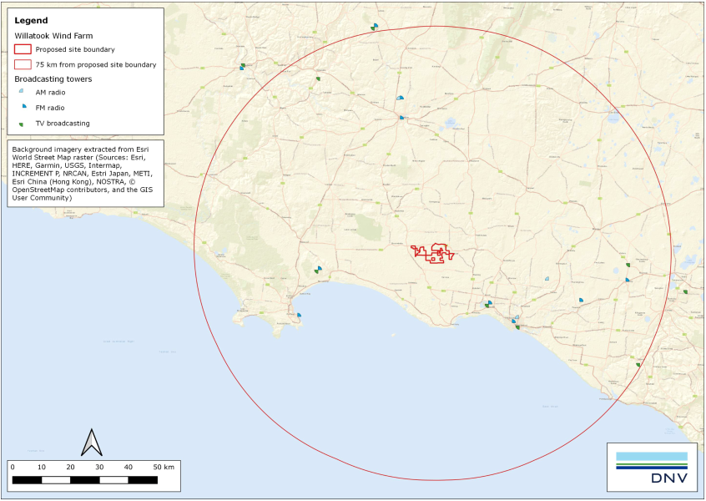

Figure 22.2 Location of radio and television broadcast transmitters within 75 kilometres of the project site (*Source: DNV, Appendix N – Electromagnetic interference*)

#### Aviation communications, navigation and surveillance facilities

The closest Airservices Australia air traffic control communications facility is located at Mount William, approximately 52 nautical miles to the north of the project site.

The non-direction beacon at Hamilton aerodrome is the closest ground-based navigation aid to the project site.

The nearest civil aviation surveillance facility is the secondary surveillance radar location at Mount Macedon, 120 nautical miles northeast of the project site. The closest primary surveillance radar is located at Gellibrand Hill (Tullamarine Airport), 129 nautical miles north-east of the project site.

Primary surveillance radar

Used in air traffic control, the primary surveillance radar system involves the transmission of a radar pulse by antenna located on the ground, which is reflected back by an aircraft. Based on the time taken for the radar pulse to return, this provides information on the distance of the aircraft from the radar.

Secondary surveillance radar

Also used in air traffic control, the secondary surveillance radar is used to obtain information on aircraft identity and altitude.

This radar relies on a transponder (device that receives a radio signal located onboard the aircraft) that transmits a reply signal in response to the pulse received from an antenna located on the ground.

## Impact assessment

### Impact pathways

Operating wind turbines have the potential to interfere with radiocommunication services (i.e., cause electromagnetic interference) to communication signals such as television broadcast signals and fixed point-to-point signals. This can be due to the wind turbines causing:

* complete obstruction of electromagnetic signals
* diffraction (bending), reflection or scattering of electromagnetic signals
* near field effects, where interactions of the turbines with a transmitter or receiver antenna can cause changes to the signal characteristics.

A schematic of the key mechanisms of electromagnetic interference is shown in Figure 22.3.

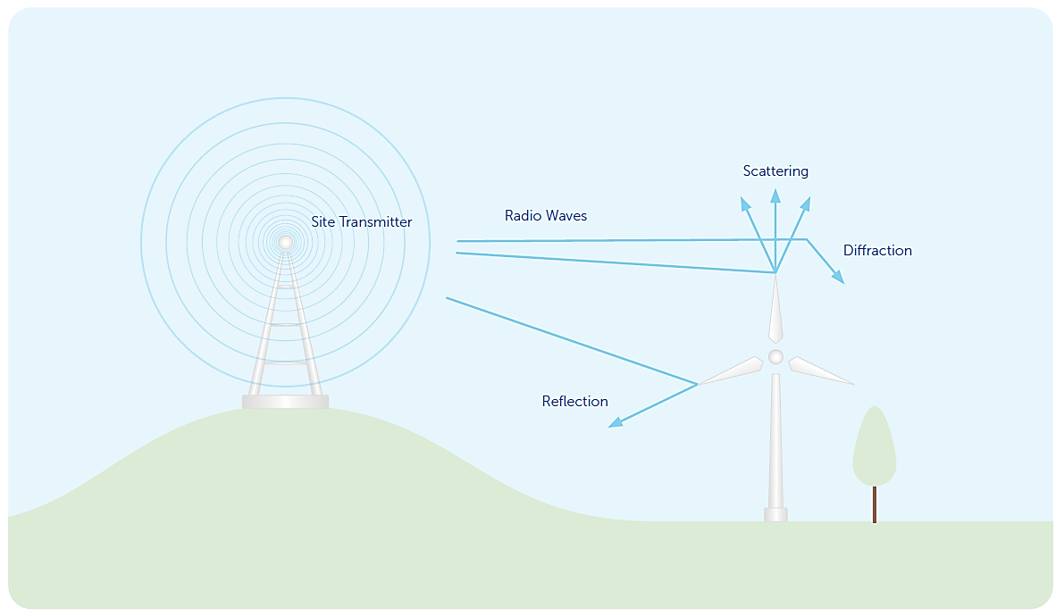

Figure . Schematic of key mechanisms of electromagnetic interference

### Design mitigation

Avoidance by design has been the primary measure to limit electromagnetic interference impacts. This has been an iterative process whereby:

* the specialist engineer assessed potential electromagnetic interference impacts based on the concept design
* the specialist engineer provided recommendations in relation to position of some turbines to minimise or avoid potential electromagnetic interference
* these recommendations were incorporated into the design and assessed by other specialists for their potential to impact other values.

Key measures that were implemented during the design process to minimise electromagnetic interference across the project site and region included:

* identifying a single point-to-point communication link crossing the site and incorporating an appropriate buffer (20 metres plus blade length of 95 metres), into the project design based on consultation with the link operator [EMID01]
* adding an additional uncertainty buffer of 20 metres to the communications link buffer based on recommendations [EMID02]
* relocating several turbines located adjacent to the communications buffer as recommended by the specialist engineer [EMID03].

### Management controls

Where feasible, engineering design measures have been included to avoid potential electromagnetic inference impacts. As summarised in Section 22.7.5 above, electromagnetic related impacts to radiocommunication services and operations in the investigation area are unlikely, or there is low potential for interference to occur as a result of project operation. Where there is low potential for electromagnetic interference, the following management measures outlined in Table 22.3 have been proposed to manage these impacts during project pre-construction, construction and operation.

Table . Electromagnetic interference management measures

| Electromagnetic interference impact | Project phase | Management measures | Number |
| --- | --- | --- | --- |
| Potential for the project to cause electromagnetic interference to point-to-point and point-to-multipoint links | Pre-construction | The proponent would consult with relevant point-to-point and point-to-multipoint service operators to confirm potential effects (or lack thereof) from final project design, prior to construction. | EMI01 |
| Construction, operation | Where interference is not eliminated through turbine design and siting, a mitigation strategy would be developed and implemented in consultation with organisations operating point-to-point and point-to-multipoint services to minimise or avoid interference to communications. These measures could include re-routing of affected services, installing additional towers, or replacing affected links with alternative technologies. | EMI02 |
| Potential for the project to cause electromagnetic interference to other licence types and services:  emergency services (mobile radio systems)  mobile phones  FM radio | Pre-construction | The proponent would consult with relevant radio service operators to confirm potential effects (or lack thereof) from final project design prior to construction. | EMI03 |
| Construction, operation | Where interference is not eliminated through turbine design and siting, a mitigation strategy would be developed and implemented in consultation with organisations operating radio communications sites within 2 kilometres of wind turbines to minimise or avoid interference to radio communications. These measures could include increasing the signal strength from the affected tower or alternative towers, installing a signal repeater or an additional tower. | EMI04 |
| Potential for the project to cause electromagnetic interference to wireless internet signals (NBN) | Pre-construction | The proponent would consult with relevant telecommunications carriers and other parties potentially affected by electromagnetic interference to confirm potential effects (or lack thereof) from final project design, prior to construction. | EMI05 |
| Construction, operation | Where interference is not eliminated through turbine design and siting, a mitigation strategy is to be developed and implemented in consultation with organisations operating telecommunications and NBN services to minimise or avoid interference to communications.  These measures could include re-directing antenna at affected dwelling to alternative tower, changing location of antenna, or installing a new tower. | EMI06 |
| Potential for the project to cause electromagnetic interference to meteorological radar | Design and operation | The project would adhere to the following conditions provided by the Bureau of Meteorology:  inform the Bureau of Meteorology of any changes to the wind farm design, including varying the wind farm layout, changing turbine locations by more than 100 metres or altering the turbine height  notify the Bureau of Meteorology at least two weeks prior to any planned shutdown of the wind farm (for maintenance or any other reason)  collaborate with the Bureau of Meteorology on the event of severe weather condition to assist in endeavours of community safety. | EMI07 |
| Potential for the project to cause electromagnetic interference to services:  television  FM radio  Point to point services  wireless internet signals (NBN) or satellite internet | Pre-construction | The proponent would conduct a Signal Strength Survey, which would be submitted to, approved, and endorsed by the responsible authority, prior to construction. The survey would:  be carried out by a suitably qualified and experienced independent specialist  include testing at selected locations within 5 kilometres of the project site to enable the average signal strength to be determined for television, radio and other point to point services (including GPS autosteer functions used in agricultural operations) that could be impacted by electromagnetic interference from the wind energy facility  identify and consult with organisations operating point to point communication links  include a mitigation strategy for impact to television radio, NBN reception and point to point transmission. | EMI08 |
| Pre-construction | Develop and implement a complaints process for managing complaints relating to radio reception strength at pre-existing dwellings within 5 kilometres of the project site prior to construction. | EMI09 |
| Construction, operation | If a complaint is received regarding the effect of the facility on television or radio reception at an existing dwelling within 5 kilometres of the project site, then:  the complaint would be investigated in accordance with an approved Complaint Investigation and Response Plan  if the investigation indicates that the project has had a detrimental impact on the quality of reception or signal strength, the proponent would restore reception/signal strength to at least the quality determined in the preconstruction Signal Strength Survey. | EMI10 |
| Construction, operation | Where interference to television and satellite internet services is not eliminated through turbine design and siting, a mitigation strategy is to be developed and implemented in consultation with homeowners and service providers to restore the affected service to at least the quality determined in the preconstruction Signal Strength Survey. These measures could include re-directing communication links, re-locating antenna/satellite dishes, and/or upgrading antenna/satellite dishes, installing cable or satellite television, or installing a relay transmitter. | EMI11 |

### Residual effects

Following the implementation of design measures, an assessment of residual effects and impacts was completed describing the changes to the environment brought about by the construction, operation and eventual decommissioning of the project, and rating the significance of these effects.

#### Radiocommunication towers

Through consultation with AusNet Services, no potential interference from the project to their radiocommunication tower services was identified.

#### Fixed point-to-point licences

With the implementation of the design measures outlined in Table 22.3, there is low potential for interference due to diffraction or reflection of the point-to-point link signals.

#### Fixed point-to-multipoint licences

Consultation with Aussie Broadband and Powercor, operators of potentially affected point-to-multipoint base stations within 20 kilometres of the project site, indicates that they do not expect the project to cause interference to their services. No formal response has been received from Wannon Region Water Corporation to date.

#### Other licence types and services

##### Emergency services licences

There is no potential for interference with point-to-point licences operated by emergency services as no links cross the project site. Other licenses operated by emergency services in the region are mobile telephone licences used for mobile radio and paging systems. These systems are generally not affected by the presence of wind turbines any more than other forms of signal obstruction.

##### Meteorological radar

Consultation with the Bureau of Meteorology identified that the project has the potential to impact the Mount Gambier weather radar during normal weather conditions, however the impact is manageable with the implementation of conditions outlined by the Bureau of Meteorology and included as mitigation measures in Section 22.7.3.

##### Trigonometrical stations

It is considered unlikely that the trigonometrical stations within 20 kilometres of the project site host electronic distance measuring devices or other equipment that may be subject to electromagnetic interference. As such, it is unlikely that the project would cause interference to trigonometrical stations or the global navigation satellite system network.

##### CB radio and mobile phones

It is unlikely that the wind turbines would impact CB radio signals passing through the project site, with these signals likely to be intercepted by existing obstructions (e.g., terrain, vegetation).

Within the project site, interference to mobile signals is unlikely where there is existing good mobile phone network coverage. However, in areas in the project site where the reception is marginal, there is the potential for interference where a wind turbine intercepts the signal between the mobile phone and tower.

##### Wireless internet (broadband and NBN)

There is a low potential for interference to wireless broadband services in the project region with marginal reception if a wind turbine intercepts the signal between a receiver and the tower. Consultation received from Aussie Broadband indicates that interference to their services from the project is not anticipated. Consultation with NBN Co indicated that the turbine locations are sufficiently clear of the lines of sight between the Hawkesdale NBN tower and dwellings currently receiving signals from that tower.

##### Satellite television and internet

Based on an analysis of line-of-sight to dwellings in the project vicinity for satellites that provide television or internet services to eastern Australia, the project may intercept signals from 47 satellites to eight nearby dwellings (including five stakeholder dwellings). All eight dwellings have the potential to experience interference to signals that provide television signals intended for international audiences. However, it is considered unlikely that residents would be receiving signals from these satellites due to their low angles of elevation.

One stakeholder dwelling (D482), which is dilapidated, has the potential to experience interference to signals from satellites that provide television and internet services intended for Australian audiences.

##### Broadcast radio

As AM radio signals can propagate around obstructions, it is expected that the project would not cause significant interference for a receiver.

Due to the distance between the FM broadcast transmission tower and the project site, interference from the project to the FM radio signals is not expected.

As there is no digital radio coverage in the region, there is no impact to digital radio signals from the project.

##### Broadcast television

Although digital television signals are unlikely to be susceptible to interference from wind turbines in areas of adequate coverage, signal interference could be experienced in areas where coverage is marginal.

Modelling of digital television interference from the project was undertaken by BAI Communications, who are responsible for broadcasting of national public television services in Australia. This modelling indicates that interference to digital television signals from the Warrnambool Tower are not anticipated, and only minimal impact is expected to signals from the Portland tower. However, modelling (based on a larger 75‑turbine layout) suggested the project would cause signal interference from the Western Victoria tower for 42 dwellings, with 37 of these dwellings at low risk and five at high risk of experiencing interference. Since this modelling was undertaken, turbines have been removed from the project design. As such, it is expected that the areas at risk of experiencing interference would be smaller for the design assessed in this EES, and that the overall impacts would be the same or less. Considering the Warrnambool tower is the primary transmitter for the area and is not expected to be impacted by interference from the project turbines, impacts on digital television broadcasting are likely to be minimal.

##### Aviation communications, navigation and surveillance facilities

Given the distance to closest communications facility, ground-based navigation aid and surveillance radars, the project would not impact on these operations.

### Impact assessment summary

A summary of the electromagnetic interference impact assessment is shown in Table 22.4 below, with the full assessment presented in Appendix N – *Electromagnetic interference*, and Appendix O – *Aviation* for impacts relating to aviation communications, navigation and surveillance facilities.

Table . Electromagnetic interference impact assessment summary

| Impact pathway | Asset, value or receptor | Project phase | Mitigation and management | Likely impact (considering magnitude, extent and duration) | Potential for electromagnetic interference |
| --- | --- | --- | --- | --- | --- |
| Potential for wind turbines to cause electromagnetic interference | Radiocommunication towers | Operation | Consult with relevant radio service operators to confirm potential effects (or lack thereof) from final project design (EMI03).  Where interference occurs, develop and implement a mitigation strategy in consultation with service operators, (EMI04). | Closest radiocommunication tower is located within 2 kilometres of the turbine locations. | **Low** potential for interference.  Consultation with AusNet Services indicates no potential interference from the project. |
| Point-to-point links | Operation | Create wind turbine buffer around communications link based on consultation with link operator [EMID01-02].  Relocate several turbines immediately adjacent to further minimise interference risk to the communications buffer [EMID03].  Consult with relevant point-to-point service operators to confirm potential effects (or lack thereof) from final project design (EMI01).  Where interference is not eliminated through turbine design and siting, a mitigation strategy would be developed (EMI02). | With the application of a buffer either side of the link path and micro-siting several turbines further away from the edge of this clearance zone (as requested by AusNet Services), there is unlikely to be a material impact (e.g., through diffraction or reflection of the signals). | **Low** potential for interference. |
| Point-to-multipoint links | Operation | Consult with relevant point-to-multipoint service operators to confirm potential effects (or lack thereof) from final project design (EMI01).  Where interference is likely to be detected a mitigation strategy would be developed (EMI02). | Three point-to-multipoint base stations located within 20 kilometres of the site, owned by Aussie Broadband, Powercor and Wannon Region Water Corporation. | **Unlikely** to cause interference.  Consultation with Aussie Broadband and Powercor indicates no interference is anticipated.  No response has been received from Wannon Region Water Corporation to date. |
| Emergency services | Operation | Consult with relevant radio service operators to confirm potential effects (or lack thereof) from final project design (EMI03).  Where interference is likely to be detected, develop and implement a mitigation strategy in consultation with service operators (EMI04). | No links cross the project site. | **Unlikely** to cause interference. |
| Meteorological radar | Operation | Adhere to the conditions provided by the Bureau of Meteorology notification of any design changes, and planned shutdowns, and collaborate with the Bureau in the event of severe weather (EMI07). | Potential to impact the Mount Gambier weather radar during normal weather conditions. | **Low** potential for interference.  Impact is manageable with the implementation of conditions outlined by the Bureau of Meteorology. |
| Trigonometrical stations | Operation | NA | Unlikely to cause interference to trigonometrical stations or the global navigation satellite system network. | **Unlikely** to cause interference. |
| CB radio and mobile phones | Operation | Consult with relevant radio service operators to confirm potential effects (or lack thereof) from final project design (EMI03).  Where interference is likely to be detected, develop and implement a mitigation strategy in consultation with service operators (EMI04). | Unlikely that the wind turbines would impact CB radio signals passing through the project site.  Interference to mobile signals is unlikely where there is existing good mobile phone network coverage. However, in marginal coverage areas there is the potential for interference. | **Unlikely** to cause interference to CB radio.  **Low** potential for interference to mobile phone signals. |
| Wireless internet (broadband and NBN) | Operation | Consult with all telecommunications carriers and other potentially affected parties to confirm potential effects (or lack thereof) from final project design (EMI05).  Develop and implement a mitigation strategy in consultation with internet providers where interference is not eliminated through turbine design and siting (EMI06). | Low potential for interference to wireless broadband services in the project region with marginal reception if a wind turbine intercepts the signal between a receiver and the tower. | **Unlikely** to cause interference to broadband services.  Consultation with Aussie Broadband indicates no interference is anticipated.  **Unlikely** to cause interference to NBN services. |
| Satellite television and internet | Operation | Conduct a Signal Strength Survey prior to construction (EMI08).  Develop and implement a complaints process for managing complaints relating to electromagnetic interference (EMI09).  Where interference to satellite television and internet is recorded, a mitigation strategy is to be developed and implemented in consultation with homeowners (EMI11). | For services intended for international audiences, may interfere with television signals to eight nearby dwellings (including five stakeholder dwellings).  For services intended for Australian audiences, may interfere with television signals to one stakeholder dwelling, which is dilapidated. | **Low** potential for interference for services intended for international audiences.  **Low** potential for interference for services intended for Australian audiences. |
| Broadcast radio | Operation | Conduct a Signal Strength Survey prior to construction (EMI08).  Develop and implement a complaints process for managing complaints relating to electromagnetic interference (EMI09).  Where interference to broadcast radio is recorded, a mitigation strategy is to be developed and implemented in consultation with homeowners (EMI11). | No significant inference anticipated for AM radio signals  May experience interference near the wind turbines to FM radio signals. | **Unlikely** to cause interference to AM signals as they can propagate around obstacles.  **Unlikely** to cause interference to FM signals due to the distance between the FM broadcast transmission tower and the project site. |
| Broadcast television | Operation | Conduct a Signal Strength Survey prior to construction (EMI08).  Develop and implement a complaints process for managing complaints relating to electromagnetic interference (EMI09).  Where interference to television is recorded, a mitigation strategy is to be developed and implemented in consultation with homeowners (EMI11). | Signal interference from the Western Victoria tower for 42 dwellings is anticipated (based on the previous 75-turbine layout).  Interference to digital television signals from the Portland tower for one dwelling are anticipated (based on the previous 75-turbine layout).  Since the signal interference modelling was undertaken, turbines have been removed from the project design. It is expected that the overall impacts would be the same or less.  Interference to digital television signals from the Warrnambool tower are not anticipated. | **Low** potential forinterference from the Western Victoria tower based on modelling results as it is likely dwellings would be able to receive signals from Warrnambool tower.  **Low** potential for interference from the Portland tower based on modelling results as it is likely dwellings would be able to receive signals from Warrnambool tower.  **Unlikely** to cause interference from the Warrnambool tower based on modelling results. |
|  | Aviation communication, navigation and surveillance facilities | Operation | NA | No impact to aviation communications, navigation and surveillance facilities is anticipated. | **Unlikely** to cause interference. |

## Conclusions

Wind turbines can cause interference to electromagnetic signals because of the physical disruption of radiocommunication signals by complete obstruction, diffraction, reflection or scattering of signals, or near field effects.

Limited radiocommunication services are in the vicinity of the project, with only one point-to-point link (operated by AusNet Services) passing over the project site and three point-to-multipoint stations located within 20 kilometres of the site (operated by Aussie Broadband, Powercor and Wannon Region Water Corporation).

Where feasible, engineering design measures have been implemented to avoid potential electromagnetic inference impacts to the services identified in the electromagnetic inference assessment as key issues. Management measures have been proposed for the pre-construction, construction and operational phases of the project to further manage potential impacts caused by electromagnetic inference. With the implementation of these design measures and management controls, the potential for electromagnetic interference to impact existing radiocommunication services is either unlikely or low.