# Shadow flicker and blade glint

## Overview

Shadow flicker can occur where the shadow cast by rotating wind turbine blades causes a flickering effect which can cause nuisance, especially inside dwellings. This chapter is based on the findings of the shadow flicker assessment report prepared by DNV Australia Pty Ltd (provided in Appendix M) and includes an assessment of the potential theoretical and actual shadow flicker related impacts on non-stakeholder (neighbouring) and stakeholder dwellings. This chapter also addresses blade glint. This can occur when untreated wind turbine blades reflect sunlight and cause annoyance or cause safety hazard for drivers.

The assessment of shadow flicker impacts took a conservative approach to calculating the potential distance which may be impacted by ‘moderate level of intensity’ shadow flicker, using a calculation from the UK wind industry guidelines (Office of the Deputy Prime Minister, 2004). The DNV shadow flicker assessment used geometrical modelling to predict the ‘theoretical’ worst-case shadow flicker, and ‘actual’ real-world shadow flicker incorporating predictable meteorological mitigating factors.

The project has been designed to avoid unacceptable levels of nuisance from shadow flicker, and the assessment undertaken by DNV confirms that the project satisfies the limits established in the Policy and Planning Guidelines (DELWP, 2021f) at all non-stakeholder dwellings.

While stakeholder dwellings (including dilapidated dwellings) were modelled to experience theoretical shadow flicker above the 30 hours recommended in the *National wind farm development guidelines – draft* (Environment Protection and Heritage Council, 2010), the proponent has committed to meeting a maximum annual shadow flicker duration of 30 hours. Adherence to these limits would be demonstrated through pre-construction modelling and the implementation of a curtailment strategy (or other measures), if required.

## EES objectives and key issues

The EES scoping requirements specify the draft evaluation objective and key issues, outlined in Table 21.1, relevant to shadow flicker and blade glint that have guided this assessment.

Table . EES draft evaluation objective and key issues

| Draft evaluation objective  Landscape and visual: *To minimise and manage potential adverse effects for the community with regard to landscape and visual amenity.* | |
| --- | --- |
| **Key issues** | Potential for nearby residents/communities to be exposed to significant effects to the visual amenity, including blade glint and shadow flicker, from project infrastructure. |

## Legislation

Key legislation, policies and guidelines relevant to shadow flicker and blade glint are summarised in Table 21.2.

Table 21.2 Relevant legislation and guidelines

| Legislation/guideline | Description | Relevance to project |
| --- | --- | --- |
| **Commonwealth** | | |
| *National wind farm development guidelines – draft* (Draft National Guidelines) (Environment Protection and Heritage Council, 2010) | The *National wind farm development guidelines – draft* (Draft National Guidelines) (Environment Protection and Heritage Council 2010) outline the best-practice methods for assessing the impacts associated with the development and operation of wind farms. This includes detailed methodologies for the assessment of shadow flicker. | The Draft National Guidelines informed the methodology adopted for the shadow flicker assessment. |
| **State** | | |
| *Planning and Environment Act 1987* | The purpose of the *Planning and Environment Act 1987* is to establish a framework for planning the use, development and protection of land in Victoria. The Act sets out the process for obtaining permits under schemes, settling disputes, enforcing compliance with planning schemes and permits, and other administrative procedures. | The Moyne Shire Planning Scheme contains the following Victoria Planning Provision within the Particular Provisions relevant to shadow flicker and blade glint:  Clause 52.32 Wind Energy Facility  52.32-6 Decision Guidelines: *“Before deciding on an application, in addition to the decision guidelines of Clause 65, the responsible authority must consider, as appropriate:*  *The effect of the proposal on the surrounding area in terms of … blade glint, shadow flicker…”* |
| *Policy and planning guidelines for the development of wind energy facilities in Victoria* (Policy and Planning Guidelines) (DELWP, 2021f) | The *Policy and Planning Guidelines for Development of Wind Energy Facilities in Victoria* (Policy and Planning Guidelines) provide a set of consistent operational performance standards to inform the assessment and operation of a wind energy facility project; and guidance as to how planning permit application requirements might be met. | Section 5.1.2 *Amenity of the surrounding area* of the Policy and Planning Guidelines establishes the upper limit of shadow flicker duration permissible in the area immediately surround dwellings, stating that:  “*The shadow flicker experienced immediately surrounding the area of a dwelling (garden fenced area) must not exceed 30 hours per year as a result of the operation of the wind energy facility.”* |
| **International** | | |
| *Planning for Renewable Energy – A Companion Guide to PPS22* (UK wind industry guidelines) (Office of the Deputy Prime Minister, 2004) | Presents specific advice on the range of renewable energy technologies that are covered in the guideline. | The shadow flicker assessment adopted the UK wind industry guidelines recommendation for the maximum length of a shadow cast by a wind turbine, which is more conservative than the Draft National Guidelines. |

The Policy and Planning Guidelines establish a shadow flicker limit of 30 hours per year experienced in the area immediately surrounding a dwelling, while the Draft National Guidelines provide more detailed recommendations, with a limit of 30 hours per year of ‘theoretical’ shadow flicker duration and 10 hours per year of ‘actual’ shadow flicker.

The project has been designed to satisfy both the requirement of the Policy and Planning Guidelines and the stricter limits recommended in the Draft National Guidelines.

## Method

The shadow flicker assessment was undertaken using geometrical modelling, which was based on the guidance provided in the Draft National Guidelines.

The Draft National Guidelines outline methodologies for two scenarios:

* a theoretical worst-case scenario, and
* an ‘actual’ real-world scenario incorporating predictable meteorological mitigating factors.

To model shadow flicker, an assumption is required about the maximum shadow length shadow cast by a wind turbine blade that is likely to cause annoyance due to shadow flicker above a ‘moderate level of intensity’. Beyond this distance, the shadow is too diffused and the variation in light levels are unlikely to be sufficient to cause annoyance. The assessment of shadow flicker impacts took a conservative approach to calculating the potential distance that may be impacted by ‘moderate level of intensity’ shadow flicker, using a calculation from the UK wind industry guidelines (Office of the Deputy Prime Minister, 2004). Based on these guidelines, a distance of 1,900 metres (i.e., 10 times the rotor diameter) was used in the modelling for the limit of shadow flicker effects. In comparison, the calculation recommended in the Draft National Guidelines (i.e., 265 times the chord length) provides a distance of 1,325 metres.

**Chord length:** wind turbine blade width along the length of the blade, with the thickest part of the blade (close to the hub) the maximum chord and the thinnest part (at the tip) the minimum chord.

**Rotor diameter:** the span of the circle (i.e., diameter) swept by wind turbine blades as they rotate.

While the distance recommended in the Draft National Guidelines is not considered insufficient (based on publicly available studies), DNV took the more conservative approach by using the UK wind industry guidelines.

In recognition that different people have different levels of sensitivity to shadow flicker, and may therefore be affected by shadow flicker intensities below the ‘moderate level of intensity’ (referred to as ‘low intensity’ shadow flicker), shadow flicker for an increased distance limit of 15 times the rotor diameter, or 2,850 metres (rounded to up 2,900 metres) was also assessed.

Further details on the methodology and assumptions for the shadow flicker assessment are outlined in Appendix M – *Shadow flicker*.

### Theoretical modelled duration

In accordance with the guidance in the Draft National Guidelines, the shadow flicker assessment included an assessment of the theoretical modelled duration that, in theory, could be experienced at non-stakeholder (neighbour) dwellings. The theoretical model shows the ‘worst case scenario’ that is theoretically possible, but it excludes factors that may reduce the impact of shadow flicker (e.g., cloud cover and turbine orientation). These factors are described in Section 21.4.2.

The theoretical modelled duration of shadow flicker on dwellings is calculated using a geometrical model, which incorporates the sun’s path, the topography of the area and wind turbine details, including the rotor diameter and hub height.

The theoretical model simplifies the assessment to identify the maximum duration that shadow flicker could be experienced at a location, and assumes that every day over a one-year period:

* it is always sunny throughout the day, with no cloud cover, and therefore a shadow can be cast
* the wind turbine is always rotating and can therefore cause the flickering effect
* the wind turbine is always facing perpendicular to the dwelling receptor, offering the fullest face of the wind turbine that could cause shadow flicker and affect the dwelling.

### Predicted actual duration

While the theoretical modelled duration assessment is designed to identify the theoretical maximum duration that shadow flicker could occur at a location, the actual duration of shadow flicker experienced at a specific location can be influenced by many factors, including:

* the direction of the property relative to the wind turbine
* the distance from the turbine (the further the observer is from the wind turbine, the less pronounced the effect will be)
* the wind direction (the shape of the shadow is determined by the position of the sun relative to the blades)
* the turbine height and rotor diameter
* the time of year and time of day (the position of the sun in the sky)
* the weather conditions (cloud cover reduces the occurrence of shadow flicker).

Not all these factors can be reliably predicted or assessed without undertaking extensive site assessments. As such, the assessment of ‘actual’ duration of shadow flicker cannot include all these factors in the assessment.

The prediction of ‘actual’ shadow flicker duration undertaken by DNV does, however, account for cloud cover and wind turbine orientation, which can be predicted based on historical records of cloud coverage and wind direction, respectively.

### Blade glint

Blade glint is the reflection of sunlight from wind turbine blades and has the potential to annoy people. Modern wind turbine manufacturers avoid potential blade glint nuisance by finishing their blades with a low-reflectivity treatment. As such, blade glint is not considered an issue for the project.

## Investigation area

The shadow flicker assessment investigated impacts on dwellings located within 2,900 metres of a proposed project wind turbine location. This distance corresponds to 15 times the rotor diameter (plus 50 metres) and captures all dwellings that are likely to experience shadow flicker impacts. This includes shadow flicker impacts of at least a ‘moderate level of intensity’ or above, which is conservatively calculated to be experienced at a distance of 10 times the rotor diameter (i.e., 1,900 metres).

Figure 21.1 shows all dwellings within proximity to the project and the elevation across the region.

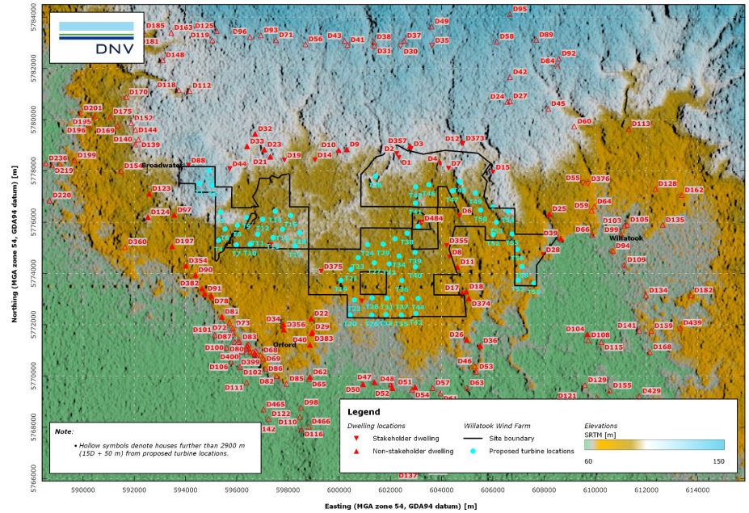

Figure 21.1 Investigation area

## Impact assessment

### Impact pathways

Shadow flicker is caused when the sun passes behind the rotating blades of a wind turbine and casts a moving shadow over the neighbouring areas. This only occurs under certain combinations of geographical position and time of day when the rotating wind turbine is directly between the sun and the viewing receptor.

Figure 21.2 depicts how wind turbines can have differing potential shadow flicker impacts when the sun is in different locations in the sky because of the time of day (and time of year), which cause different shadows, some of which may cause shadow flicker nuisance to nearby dwellings.

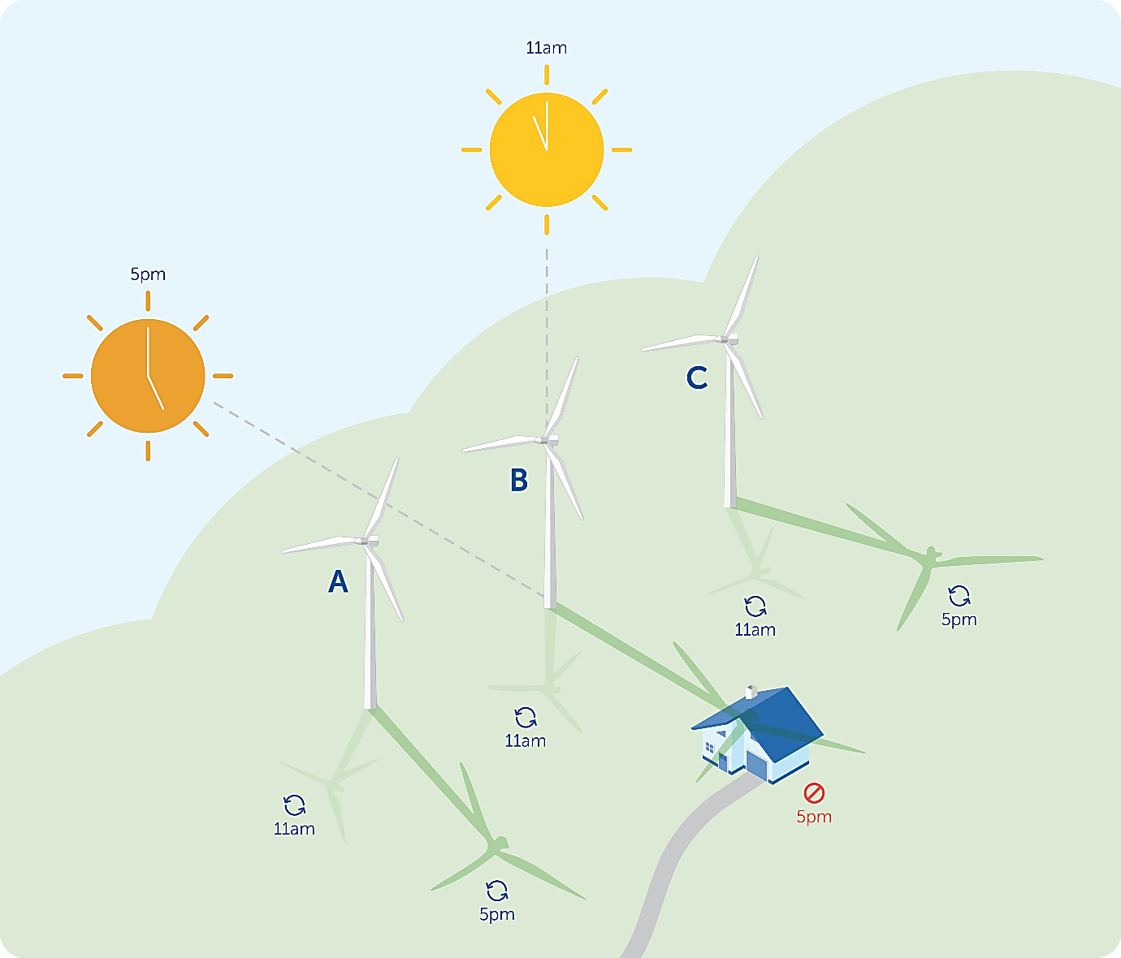

Figure 21.2 Diagram highlighting the different potential for shadows to be created with the sun in different locations in the sky (adapted from: Vestas Wind Systems A/S 2017)

When viewed from a stationary position the moving shadows cause periodic flickering of the light from the sun, giving rise to the phenomenon of ‘shadow flicker’. If a wind farm is not designed properly, shadow flicker can result in unacceptable nuisance on nearby residences. This annoyance is most closely associated with the duration of shadow flicker experienced above a certain intensity (i.e., how long the shadow flicker occurs and how frequently).

Factors influencing the likelihood and duration for the shadow flicker effect include the:

* direction of a property relative to wind turbines
* distance from the wind turbine
* wind direction
* wind turbine height and rotor diameter
* time of year and day
* weather conditions.

The predicted shadow flicker effect of a project wind turbine is depicted in Figure 21.3 where the annual duration of shadow flicker on areas is shown through the ‘butterfly’ image. The different colours show the different annual durations of shadow flicker impacts on that location. A wind rose showing the wind directions and frequency of wind speed at the project site (based on wind measurements recorded by the project meteorological monitoring mast) is overlaid on the figure (grey wedges).

In Figure 21.3, the shadow flicker impacts experienced during the morning are shown on the left of the diagram (as the sun rises in the east), and afternoon impacts shown on the right of the diagram (as the sun sets in the west). Winter impacts are shown in the bottom half of the diagram as the sun is lower in the sky, while the shadow flicker impacts in summer are represented in the top sections of the diagram.

The figure shows the wind is often blowing from the north or the south, yet the theoretical (worst case) model assumes the wind turbine is oriented differently (e.g., towards the rising or setting sun) to cast the ‘worst case’ shadow on a dwelling to the west or east of the wind turbine. This would not occur in real life. As such, the theoretical model is considered very conservative.

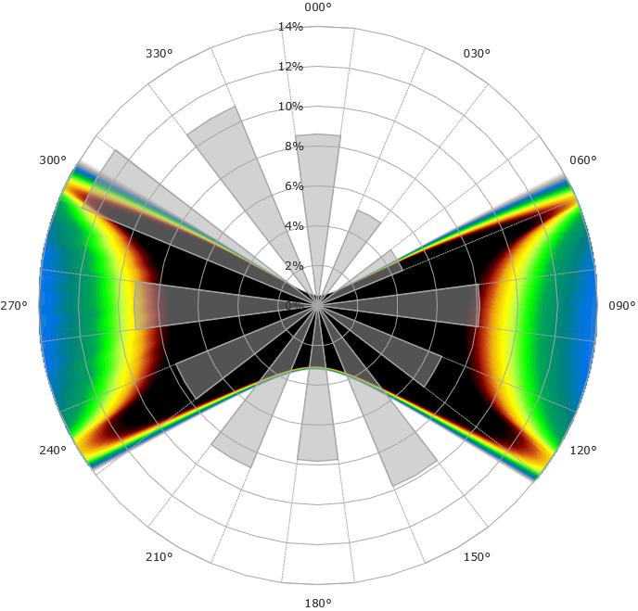

Figure 21.3 Indicative shadow flicker map including wind direction frequency distribution   
(black = high shadow flicker duration; blue = low shadow flicker duration)

### Design mitigation

Avoidance by design has been the primary measure to limit shadow flicker impacts on non-stakeholder (neighbour) dwellings. Following changes to the wind turbine layout during the project design development process to avoid other environmental constraints (e.g., Brolga buffers), the project team reviewed the revised wind turbine layout to ensure there was no excessive shadow flicker nuisance on non-stakeholder (neighbour) dwellings (more than the guidelines).

Following the assessment of shadow flicker impacts, minor adjustments to the layout of the project design were made to move turbines contributing to predicted shadow flicker impacts further from dwellings so that the duration of their predicted impacts would decrease to below the guideline limits.

### Management controls

Where possible, engineering design measures have been included to avoid shadow flicker impacts. To further manage potential shadow flicker impacts, the following management measures outlined in Table 21.3 have been proposed for project construction and operation.

Table 21.3 Shadow flicker management measures

|  |  |  |  |
| --- | --- | --- | --- |
| Shadow flicker impact | Project Phase | Management measures | Number |
| Potential for the project to cause shadow flicker in excess of the Planning and Policy Guidelines or the Draft National Guidelines duration limits | Construction | A pre-construction assessment of the potential effects of shadow flicker from turbines on existing dwellings is to be undertaken for the final turbine layout in accordance with the DELWP (2021f) *Policy and Planning Guidelines for the Development of Wind Energy Facilities in Victoria,* and to the satisfaction of the responsible authority. | SF01 |
| Operation | The project would meet shadow flicker limits (30 hours per annum) at all pre-existing dwellings evidenced through pre-construction modelling. For stakeholder dwellings, shadow flicker limits (30 hours per annum) would be met through the micro siting of turbines in the final design, conducting strategic screen plantings, using smaller wind turbine blades or implementation of a curtailment strategy, if required. | SF02 |

### Residual effects

There are 59 dwellings identified within the 2,900 metre investigation area, including stakeholder dwellings and non-stakeholder dwellings. The shadow flicker assessment identified that 24 dwellings are predicted to experience some high intensity shadow flicker. Of these dwellings, 13 are stakeholder dwellings and 11 are non-stakeholder dwellings.

Figure 21.4 and Figure 21.5 show the modelled outputs of ‘theoretical’ and ‘actual’ shadow flicker duration predicted to be caused by the project.

Table 21.4 outlines the duration of theoretical and actual shadow flicker at a moderate intensity or greater durations (i.e., ‘high intensity’ shadow flicker) predicted at each non-dilapidated non-stakeholder (neighbour) dwelling.

Of the 11 non-stakeholder dwellings predicted to experience some high intensity shadow flicker, none are predicted to exceed the 30 hours of theoretical shadow flicker duration guideline limit per year, or to exceed the 10 hours of actual shadow flicker guideline limit within 50 metres of their dwelling.

Seven non-dilapidated stakeholder dwellings are predicted to experience theoretical shadow flicker above the 30-hour per year recommended limit within 50 metres of their dwelling. When considering the likely reduction in shadow flicker due to cloud cover and rotor orientation, the predicted actual shadow flicker for these stakeholder dwellings is also predicted to be above the recommended limit of 10 hours per year.

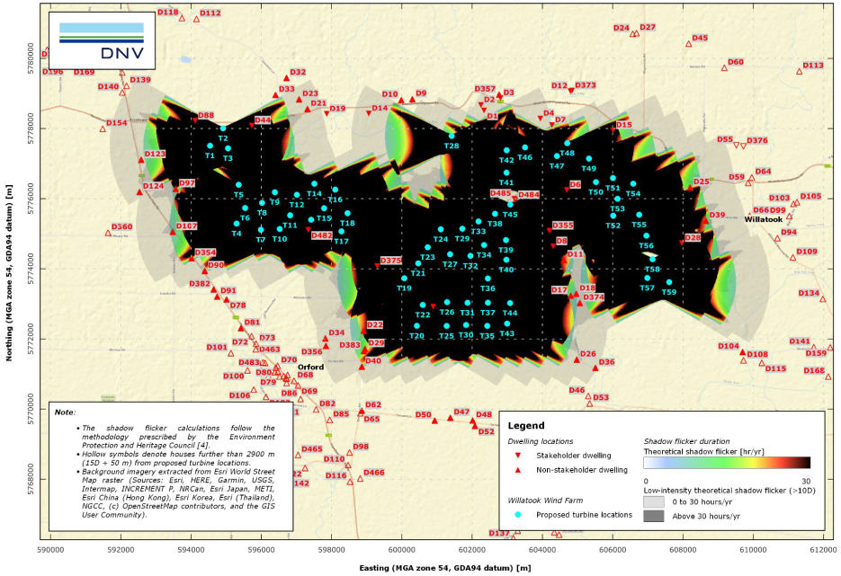

Figure 21.4 Modelled theoretical annual shadow flicker duration

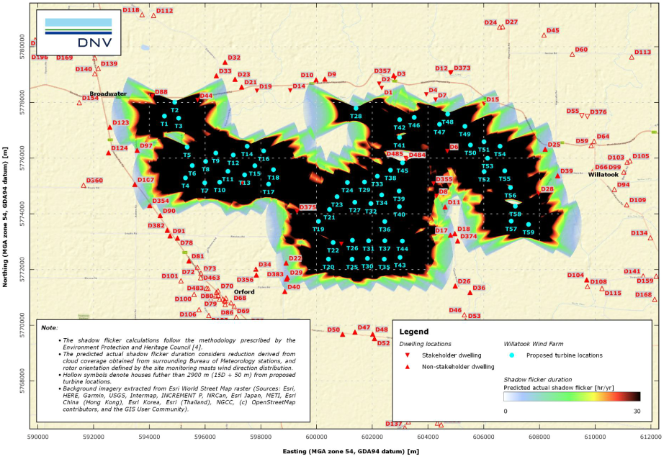

Figure 21.5 Predicted 'actual' annual shadow flicker duration

Table 21.4 High intensity shadow flicker durations within 1,900 metres of a wind turbine

| Shadow flicker duration per year | Stakeholder dwellings | | Number of non-stakeholder dwellings | | Stakeholder dilapidated dwellings | |
| --- | --- | --- | --- | --- | --- | --- |
| **Theoretical** | **Actual** | **Theoretical** | **Actual** | **Theoretical** | **Actual** |
| 0 hours | 4 | 4 | 11 | 11 |  |  |
| 0.01–10 hours |  |  | 1 | 11 | 2 | 2 |
| 10.01–30 hours |  | 7 | 10 |  |  | 2 |
| >30.01 hours | 7 |  |  |  | 4 | 2 |
| **Total dwellings** | 11 | | 22 | | 6 | |

Some dwellings may experience low intensity shadow flicker out to 2,900 metres from a wind turbine. DNV has predicted that four stakeholder dwellings and 11 non-stakeholder dwellings may experience some low intensity shadow flicker.

### Impact assessment summary

There are no non-stakeholder landowners that would experience theoretical or actual shadow flicker impacts in excess of the limits provided in the Policy and Planning Guidelines or the Draft National Guidelines. ‘Actual’ shadow flicker duration experienced within the 50-metre boundary of a non-stakeholder dwelling does not exceed 6.6 hours per year. This, along with the theoretically modelled maximum duration of 28.6 hours per year, demonstrate that no non-stakeholder dwellings would receive unacceptable levels of shadow flicker effects.

Excluding dilapidated dwellings, seven stakeholder dwellings are predicted to experience theoretical shadow flicker greater than the 30-hours per year recommended in the Draft National Guidelines within 50 metres of their dwelling. The predicted ‘actual’ shadow flicker for these stakeholder dwellings is also predicted to be above the 10 hours per year recommended limit, taking into consideration cloud coverage and wind direction. Project stakeholders have agreed to include a maximum annual shadow flicker duration of 30 hours at all dwellings (including dilapidated dwellings) within their agreements with the proponent. For these stakeholders, this limit would be met through the micro siting of wind turbines in the final design, conducting strategic screen plantings, using smaller wind turbine blades or implementing a curtailment strategy, if required. Curtailment involves pausing wind turbine blade rotation at times when shadow flicker may occur to limit the shadow flicker.

Adherence to these agreed limits and the limits of the Policy and Planning Guidelines and the Draft National Guidelines would be demonstrated through pre-construction modelling and (for stakeholder) the design and implementation of a curtailment strategy.

## Conclusions

The project has been designed to avoid unacceptable levels of nuisance from shadow flicker, and the assessment undertaken by DNV confirms that the project satisfies the limits established in the Policy and Planning Guidelines at all non-stakeholder (neighbour) dwellings. Predicted shadow flicker based on worst case design assumptions exceeds the 30-hour annual duration limit established in the Policy and Planning Guidelines at seven dwellings of stakeholder landowners. The proponent has committed to meeting a maximum annual shadow flicker duration of 30 hours at all dwellings of stakeholder landowners, which would be achieved through curtailment or other mitigations strategies. Post-construction assessments of shadow flicker, taking into account the micro-siting of turbines during detailed design, would be undertaken to ensure the limits of the Policy and Planning Guidelines are not exceeded.