# Air quality

## Overview

This chapter provides an overview of the local meteorology and existing air quality environment of the project investigation area, as well as an assessment of potential impacts to local air quality resulting from project construction, operation and decommissioning. The information is based on the impact assessment prepared by Jacobs Group (Australia) Pty Ltd and presented in Appendix L – *Air quality*. Air quality impacts can occur when air pollutant emissions from an industry or activity cause a deterioration in ambient (i.e., outdoor) air quality.

The existing air quality at the project site is good and typical of air quality for rural Australia, which is typically better than the metropolitan areas of Melbourne and Geelong. Emissions of particulate matter during construction and operation of the quarry resulting from activities such as material handling and transport, crushing, drilling and blasting, and wind erosion were assessed to be the main impact pathway with the potential to reduce air quality. There would also be gas emissions at the quarry site, primarily from diesel combustion and blasting of explosives. The construction, operation and decommissioning of other (non-quarry related) project activities would generate dust from civil works, vehicles driving on unsealed roads and wind erosion, the operation of three concrete batching plants and gas emissions from combustion engines.

Construction and operation of the on-site quarry was identified as the most significant source of air emissions, having the greatest potential of all project activities to impact air quality for nearby sensitive receptors. To avoid air quality impacts, the quarry and concrete batch plants have been proposed in areas of the project site away from occupied dwellings. The closest sensitive receptor to the quarry is 1.4 kilometres and to any of the concrete batch plants is approximately 1.2 kilometres, which are greater than the minimum separation distances specified in Environment Protection Authority (EPA) Victoria Publication 1518: *Recommended separation distances for industrial residual air emissions*.

The focus of the air quality impact assessment involved quantitative modelling of quarry emissions and their potential impacts. Emissions modelled were PM10, PM2.5, respirable crystalline silica and dust deposition. A qualitative assessment was also undertaken for the potential impacts on air quality from the construction, operation and decommissioning from all other project activities.

This chapter seeks to explain how the project would meet its general environmental duty relating to air quality. The approach has been to first avoid or limit potential impacts by creating appropriate separation distances between proposed project infrastructure (such as the quarry, concrete batching plants and the wind turbines) and sensitive receptors. The air quality impact assessment (Appendix L) has identified the potential impacts to air quality caused by project activities and provided management controls to mitigate against the risk of air pollution impacts. These take a proactive approach to avoid the generation of dust through the application of dust prevention measures and the monitoring of weather conditions to guide what construction activities can take place, and if additional dust suppression measures (e.g., additional water spraying) are required to permit the activities to continue. Modelling indicates that predicted ground-level concentrations near the quarry site boundary exceed the air quality standard for PM10, PM2.5, respirable crystalline silica and deposited dust during operations. However, at the nearest sensitive receptor site (1.4 kilometres away), the predicted ground-level concentrations do not exceed the project standards for all air pollutants emitted from the quarry operations.

General environmental duty

At the centre of the new *Environment Protection Act 2017* is the ‘general environmental duty’, which requires any person in Victoria (businesses, industry and the community) engaging in an activity that may risk harming human health and the environment from pollution and waste to minimise those risks, so far as reasonably practicable.

Dust emissions from the operation of the project concrete batching plants would be of relatively short duration and small scale (i.e., with low dust generation intensity). Concrete batching is not expected to contribute significantly to the overall air emissions, and it is expected that these emissions can be effectively managed using targeted dust mitigation measures at each site.

Gas emissions from diesel combustion and blasting for the quarry site, as well as combustion emissions from other project activities, are expected to be insignificant and of short duration.

With the implementation of management measures, including a site-specific dust management plan, the potential impact to air quality for nearby sensitive receptors is considered to be low.

## EES objectives and key issues

The EES scoping requirements specify the draft evaluation objective and key issues, outlined in Table 20.1, relevant to air quality that have guided this assessment.

Table . EES draft evaluation objective and key issues

| Draft evaluation objective  Amenity: *To minimise and manage adverse air quality and noise and vibration effects on residents and local communities as far as practicable during construction, operation and decommissioning having regard to applicable limits, targets or standards.* | |
| --- | --- |
| **Key issues** | Potential for adverse effects to air quality at sensitive receptors and on other sensitive land uses during construction of wind turbines, associated infrastructure and use of an on-site quarry. |

## Legislation, policy and guidelines

The project air quality assessment was undertaken during the transitional phase between the introduction of the new *Environment Protection Act 2017* (and Environment Reference Standard) on 1 July 2021 and replacement of the former *Environment Protection Act 1970* (and State Environment Protection Policies). EPA Victoria’s new Publication 1961: *Guideline for assessing and minimising air pollution in Victoria* was also considered in the assessment, which forms a key component of the new legislation. The air quality standards for the project air quality assessment were informed by the legislation that was existing at the time (prior to July 1 2021, and the new legislation that came into effect from July 1 2021), with the lowest (most conservative) assessment standards adopted as the ‘project standard’.

Air pollutants

**Total Suspended Particulates:** mass concentration of particulate matter comprisingparticles with diameters less than or equal to approximately 50 microns.

**Respirable crystalline silica:** created during activities such as cutting, grinding, and drilling of materials such as stone, rock, concrete and mortar that contain silica.Respirable crystalline silica is able enter to lungs and can cause lung damage.

**Particulate Matter (PM):** PM10 are particles with diameters less than or equal to 10 microns that, when inhaled, can enter the lungs. PM10 particles are generated by combustion and non-combustion processes.

Smaller than PM10 particles are those with diameters less than or equal to 2.5 microns (referred to as PM2.5). These particles, typically generated by combustion processes, can pass from the lungs into the bloodstream. Both PM10 and PM2.5 can cause negative health effects when exposed to them over long periods of time.

Key legislation, policies and guidelines relevant to air quality for the project are summarised in Table 20.2.

Table . Relevant legislation and guidelines

| Legislation/ guideline | Description | Relevance to project |
| --- | --- | --- |
| **Commonwealth** | | |
| National Environmental Protection (Ambient Air Quality) Measure | The National Environment Protection (Ambient Air Quality) Measure provides a national framework for monitoring and reporting of ambient air quality. This is achieved through the establishment of air quality standards for measuring six common pollutants. | Key air pollutants relevant to the project include carbon monoxide, sulphur dioxide, nitrogen oxides, and particulates PM10 and PM2.5. |
| National Pollutant Inventory, Department of Sustainability, Environment, Water, Population and Communities (2012) *Emission Estimation Technique Manual for Mining* | The National Pollutant Inventory (2012) *Emission Estimation Technique Manual for Mining* outlines procedures and recommended approaches for estimating emissions from facilities involved in mining of coal and metallic minerals, as well as dust control techniques. | Dust emissions were estimated considering emission factors published in the *Emission Estimation Technique Manual for Mining*. |
| **State** | | |
| *Environment Protection Act 2017* | The *Environment Protection Act 2017* establish the legislative framework for protecting the environment in Victoria. The *Environment Protection Amendment Act 2018* amended the *Environment Protection Act 2017* and introduced the general environmental duty. | The project is being developed under the new environmental regulatory regime, including the general environmental duty. The project is required to demonstrate it is implementing measures so far as ‘reasonably practicable’ to meet the general environmental duty (refer to Chapter 3 – *Legislation and policy framework*, Section 3.3.2). |
| State Environment Protection Policies (SEPPs) | Prior to 1 July 2021, air quality in Victoria was evaluated using processes and criteria set out in Victoria’s State Environment Protection Policy (Ambient Air Quality) (SEPP (AAQ)), which sets out ambient air quality standards for ‘criteria’ air pollutants, including PM10 and PM2.5, based on national standards of the National Environment Protection (Ambient Air Quality) Measure. The new National Environment Protection Measure was registered on 26 May 2021, but with no changes to the standards for particulate matter.  The SEPP (Air Quality Management) (SEPP (AQM)) sets out design criteria for air pollutants for use in modelling assessments. This SEPP identifies beneficial uses of the air environment.  The air quality impact assessment was undertaken in accordance with SEPP (AQM). |
| Environment Reference Standard | The Environment Reference Standard, made under the *Environment Protection Act 2017*, identifies environmental values to be achieved and maintained, and how these values are to be assessed. The Environment Reference Standard is comprised of many ‘reference standards’, including several for the ambient air environment (Part 2 of the Environment Reference Standard).  The Environment Reference Standard, combined with EPA Victoria Publication 1961: *Guideline for assessing and minimising air pollution in Victoria* has replaced the SEPP (AQM) and generally adopts the objectives in the National Environmental Protection (Ambient Air Quality) Measure, with some modifications.  The project design and construction would need to consider and apply the Environment Reference Standard relevant to the project. |
| *Planning and Environment Act 1987* | The Moyne Shire Planning Scheme contains a Victoria Planning Provision within the Planning Policy Framework relevant to air quality. | Victoria Planning Provision 13.06-1S Air quality management objective is “*to assist the protection and improvement of air quality*”.  One of the strategies within the provision is to “ensure, wherever possible, that there is suitable separation between land uses that reduce air amenity and sensitive land uses” and to “consider as relevant” EPA Victoria Publication 1518 (see below). |
| *Mineral Resources (Sustainable Development) Act 1990* | The *Mineral Resources (Sustainable Development) Act 1990* regulates mineral exploration, mining and extractive activities in Victoria including quarrying.  To obtain a work authority from Earth Resources Regulation under section 77I of the *Mineral Resources (Sustainable Development) Act 1990*, the project must prepare a work plan for the proposed quarry that includes a rehabilitation plan and a community consultation plan.  Quarry work plans require statutory endorsement by Earth Resources Regulation, in consultation with relevant agencies, before any quarrying can commence. | A preliminary draft quarry work plan has been prepared for the project quarry site (see Attachment II of this EES). This plan outlines measures for the control of emissions and dust from the work authority area.  The quarry work plan will be submitted to Earth Resources Regulation, separate to this EES process. |
| EPA Victoria (2020d) *Publication 1834: Civil construction, building and demolition guide* | EPA Victoria Publication 1834 outlines controls for civil construction and earthworks to manage risks and obligations under the general environmental duty in relation to air, noise, land and water. This includes controls regarding minimising dust, managing stockpiles and working within waterways. | Measures for the management of dust and potential impacts would be developed in accordance with controls contained in EPA Victoria Publication 1834. |
| EPA Victoria (2007) *Publication 1191:* *Protocol for Environmental Management: Mining and Extractive Industries* | EPA Victoria Publication 1191 is an incorporated document of SEPP (AQM) and provides guidance regarding the assessment of potential emission impacts arising from mining and extractive industries on air quality. | The assessment of potential dust impacts from the project quarry was undertaken in accordance with the requirements of EPA Victoria Publication 1191. |
| EPA Victoria (2022b) *Publication 1961:* *Guideline for assessing and minimising air pollution in Victoria* | EPA Victoria Publication 1961 outlines air quality assessment criteria for the assessment and management of air emissions. The criteria contained in this publication supersedes those in EPA Victoria Publication 1191 and SEPP (AQM). | The air quality impact assessment included consideration of EPA Victoria Publication 1961.  For assessment of dust, the criteria for PM10 and PM2.5 in EPA Victoria Publication 1961 refers to the Environment Reference Standard. These values generally align with those of the National Environmental Protection (Ambient Air Quality) issued in May 2021, except for the annual PM10 standard. For the project air quality assessment, the lowest (most conservative) assessment standards were adopted. |
| EPA Victoria (2019) *Publication 1806: Reducing risk in the premixed concrete industry* | EPA Victoria Publication 1806 provides guidance for concrete batching plant operators on assessing, managing and controlling potential risks to human health and the environment. | The concrete batching plants would be designed and operated to adequately control dust emissions as per guidelines set out in EPA Victoria Publication 1806. |
| EPA Victoria (2013) *Publication 1518: Recommended separation distances for industrial residual air emissions* | EPA Victoria Publication 1518 provides recommendations for separation distance between industrial land uses (e.g., quarries and concrete batch plants) and sensitive land uses to minimise off-site impacts arising from unintended, industry-generated dust emissions. | The project has considered the siting of the quarry and concrete batch plants in accordance with EPA Victoria Publication 1518. The closest sensitive receptor to the quarry is 1.4 kilometres and to any of the concrete batch plants is approximately 1.2 kilometres, which are greater than the minimum separation distance of 500 metres and 100 metres, respectively, under this guideline. |
| EPA Victoria (2021c) *Publication 1823: Mining and quarrying – Guide to preventing harm to people and the environment* | This guide outlines how to manage risks, and requirements under the general environment duty, and addresses managing risks from dust. | The project Construction Environmental Management Plan would align with the four-step risk management process to identify hazards, assess the risk, implement suitable control measures and check controls regularly, as outlined in EPA Victoria Publication 1823. |
| EPA Victoria AERMOD guidelines (2014):  Publication 1550: Construction of input meteorological data files for EPA Victoria's regulatory air pollution model (AERMOD)  Publication 1551: Guidance notes for using the regulatory air model AERMOD in Victoria. | EPA Victoria Publication 1550 outlines the methods to be used when building the meteorological input data files for AERMOD modelling for air impact assessments in Victoria.  This publication specifies that where no measured data is available, required data may be generated by the prognostic meteorological model, The Air Pollution Model (TAPM).  EPA Victoria Publication 1551 provides guidance on the recommended use of AERMOD, in conjunction with SEPP (AQM). | The air dispersion modelling for the project quarry activities was undertaken using AERMOD in accordance with EPA Victoria Publications 1550 and 1551.  As there is no Bureau of Meteorology station within 25 kilometres of the project site, the meteorological model input data was generated by TAPM. |
| Construction Material Processors Association (2016) *Dust Management Guideline* | The *Dust Management Guideline* provides practical guidelines, including various mitigation options, for the effective management of airborne dust arising from extractive industries. | The recommendations outlined in the *Dust Management Guideline* would be considered in the design of dust management controls. |

## Method

The air quality impact assessment was undertaken in accordance with the SEPP (AQM) and is consistent with EPA Victoria Publication 1191: *Protocol for Environmental Management: Mining and Extractive Industries*. EPA Victoria Publication 1961: *Guideline for assessing and minimising air pollution in Victoria* and the Environment Reference Standard were also considered in the establishment of standards suitable for the project air quality assessment. A conservative approach was applied whereby the lowest regulated limits between the two publications were adopted for the assessment.

Air dispersion modelling (a quantitative assessment) was undertaken to quantify the potential air quality impacts from the quarry, with dust emissions being the primary focus of the assessment. In addition to the dispersion modelling, a qualitative assessment was also undertaken for the wider project construction, operation and decommissioning activities (i.e., outside of the quarry activities). Quantitative assessment of the quarry is needed since it would operate throughout the construction phase (of approximately two years), whereas other areas of the site would see shorter periods of excavation and construction.

### Desktop assessment

A desktop review of local meteorology and existing air quality of the project investigation area was undertaken to identify any existing air quality issues and the meteorological conditions that influence local air quality. This information was obtained through a review of:

* topographic maps
* aerial imagery and the proponent’s knowledge of the project site and surrounds to identify existing land uses and the location of sensitive receptors (e.g., dwellings)
* long-term Bureau of Meteorology observations for rainfall, temperature, relative humidity and wind speed
* local wind speed and direction observations collected by the project meteorological monitoring mast (near the project quarry site) from 2018 to 2020 at a height of 11 metres
* historical EPA Victoria monitoring data for ambient air levels of PM10 and PM2.5.

### Meteorological modelling

Meteorological conditions are important for determining the direction and rate at which air pollutant emissions would disperse from a source. Typically, meteorological parameters used for modelling assessments include factors such as wind speed and wind direction, temperature, humidity and rainfall.

Victoria’s regulatory air dispersion model, AERMOD, was used to assess pollutants emitted to the air from quarry activities. To develop this model, site-specific meteorological data (defined as within a 25-kilometre radius of the site) is required. The nearest Bureau of Meteorology stations are the Warrnambool Airport NDB Bureau of Meteorology station (number 090186) located 33 kilometres south-east of the quarry location and Mortlake Racecourse Bureau of Meteorology station (number 090176) located approximately 58 kilometres east north-east of the quarry site. As there is no Bureau of Meteorology station within the 25‑kilometre radius, the meteorological model input data was generated by TAPM, which predicts meteorology and air pollution concentrations. TAPM was used in conjunction with hourly average wind speed and wind direction observation data measured at the project’s temporary meteorological mast located near the proposed project quarry site (refer to Figure 20.1), and incorporated land use and terrain data for the region. This data was compared against the data at each of the Bureau of Meteorology stations to ensure it was valid and suitable for use in the modelling.

Meteorological data from 2018 was selected as the model year as the ambient background air quality data as this year was considered to be most representative of typical conditions[1], and the percentage of strong winds blowing towards the direction of the nearest sensitive receptor site was highest for year 2018. It therefore provided a worst-case scenario out of the three years of available meteorological data   
(2016–2018) recorded at the project’s temporary meteorological mast near the proposed quarry site.

Meteorological conditions are described in more detail in Section 20.6.2.

### Air dispersion modelling

AERMOD was used to predict ground-level concentrations of PM10, PM2.5, respirable crystalline silica and dust deposition resulting from project quarry activities, using the meteorological data generated for the model year 2018. The AERMOD predictions were compared with air quality standards, defined by legislation, to assess the potential impacts of the project on the existing ambient air quality environment. To define the standards, the lowest (i.e., most conservative) assessment standards from the current and new legislation were adopted.

#### Standard pollutant concentrations

The project has adopted a ‘project standard’ for the assessment of air quality performance of the project throughout construction. The project standard has adopted the lowest (i.e., most conservative) assessment standards from the legislation that was in place when the air quality impact assessment was undertaken, and the legislation that has come into effect shortly after the assessment.

The standards used in the air quality modelling to assess compliance for the project are presented in Table 20.3 below. These standards relate to total air pollutant concentrations, meaning they include background (without project) levels.

Table . Air quality standards used in modelling assessment

|  |  |  |  |
| --- | --- | --- | --- |
| Parameter | Averaging time | Project standard (maximum)# | Reference |
| PM10 | 24 hours | 50 µg/m3 | Environment Reference Standard |
| Annual | 20 µg/m3 | Environment Reference Standard |
| PM2.5* | 24 hours | 25 µg/m3 | Environment Reference Standard |
| Annual | 8 µg/m3 | Environment Reference Standard |
| Respirable crystalline silica | Annual | 3 µg/m3 | EPA Victoria Publication 1961*:* *Guideline for assessing and minimising air pollution in Victoria* |
| Deposited dust | Monthly | 2 g/m2/month | EPA Victoria Publication 1191*:* *Protocol for Environmental Management: Mining and Extractive Industries* |
| Monthly | 4 g/m2/month  (including background) | EPA Victoria Publication 1191*:* *Protocol for Environmental Management: Mining and Extractive Industries* |

# ‘Maximum’ means no model-predicted exceedances are allowed

* Modelling assessment based on current values of PM2.5 standards. In 2025 these would be reduced to 20 µg per m3 (maximum 24-hour average) and 7 µg per m3 (annual average).

#### Quarry activities

The dust emission rates were determined using published emission factors for mining operations, including from *Emission Estimation Technique Manual for Mining* (National Pollutant Inventory 2012) and *Compilation of Air Pollutant Emission Factors, AP-42* (US EPA 1985 and updates). Other input information included estimates for expected haul road distances and routes within the quarry work authority area, truck sizes, soil moisture content and activity operating hours.

The key inputs representing the worst-case expected dust emissions (at peak production) are shown in Table 20.4 below.

Table . Quarry dust emission estimate input parameters

| Quarry model parameter | Value |
| --- | --- |
| Quarry lifetime production | 1 million tonnes |
| Peak annual production rate | 600,000 tonnes per year |
| Maximum disturbance area | 20.0 hectares (area subject to wind erosion, that is, excluding footprint area of dams) |
| Crushed rock product stockpile area | 4.0 hectares |
| Topsoil stockpile area | 0.45 hectares |
| Overburden stockpile area | 2.0 hectares |
| Raw product stockpile area | 1.5 hectares |
| Blast frequency | 1 or less per week, 40–50 per year |
| Blast area | 1,000 metres squared (approximately) |
| Holes drilled per blast | 150 |
| Number of crushing/screening trains | 2 |
| Crushing and screening rate | 600,000 tonnes per year |
| Haul route distances | Approximately 1 kilometre |
| Moisture content of excavated material | 2% by mass |
| Operating hours | 7 am – 6 pm Monday to Friday  7 am – 1 pm Saturday  365 days per year (in practice, operating days would be less than this due to no activity on Sundays and holidays) |

## Investigation area

Air dispersion modelling was undertaken for a 12 x 12 kilometre grid area (comprised of 121 x 121 grid points and 14,641 grid receptors, as well as 73 discrete receptors), centred on the quarry centre. The discrete receptors are the closest sensitive receptors to the project quarry site.

The air quality investigation area is shown in Figure 20.1.

## Existing conditions

### Sensitive receptors

The nearest sensitive receptor site to the quarry is located approximately 1.4 kilometres south-east of the quarry site boundary (Figure 20.1). This is an isolated residential dwelling. Other sensitive receptor sites are located along the Hamilton-Port Fairy Road approximately 3 kilometres south-west of the quarry site, and along Woolsthorpe-Heywood Road approximately 3 kilometres north of the quarry site. All of these sensitive receptors are residential properties.

**Sensitive receptors** or **sensitive land use** is defined by EPA Victoria as land uses that require protection of the air environment, such as for human health and wellbeing and local amenity. This includes places such as residential dwellings, education facilities and outdoor recreation sites.

*Source: EPA Victoria (2013) Publication 1518: Recommended separation distances for industrial residual air emissions*

The number of sensitive receptors within 3 kilometres of the quarry site are included in Table 20.5 below.

Table 20.5 Distance of air quality sensitive receptors from quarry work authority boundary

| Distance from quarry work authority boundary | Number of sensitive receptors |
| --- | --- |
| < 500 metres | 0 |
| 501–1,000 metres | 0 |
| 1,001–1,500 metres | 1 |
| 1,501–2,000 metres | 0 |
| 2,001–2,500 metres | 0 |
| 2,501–3,000 metres | 3 |

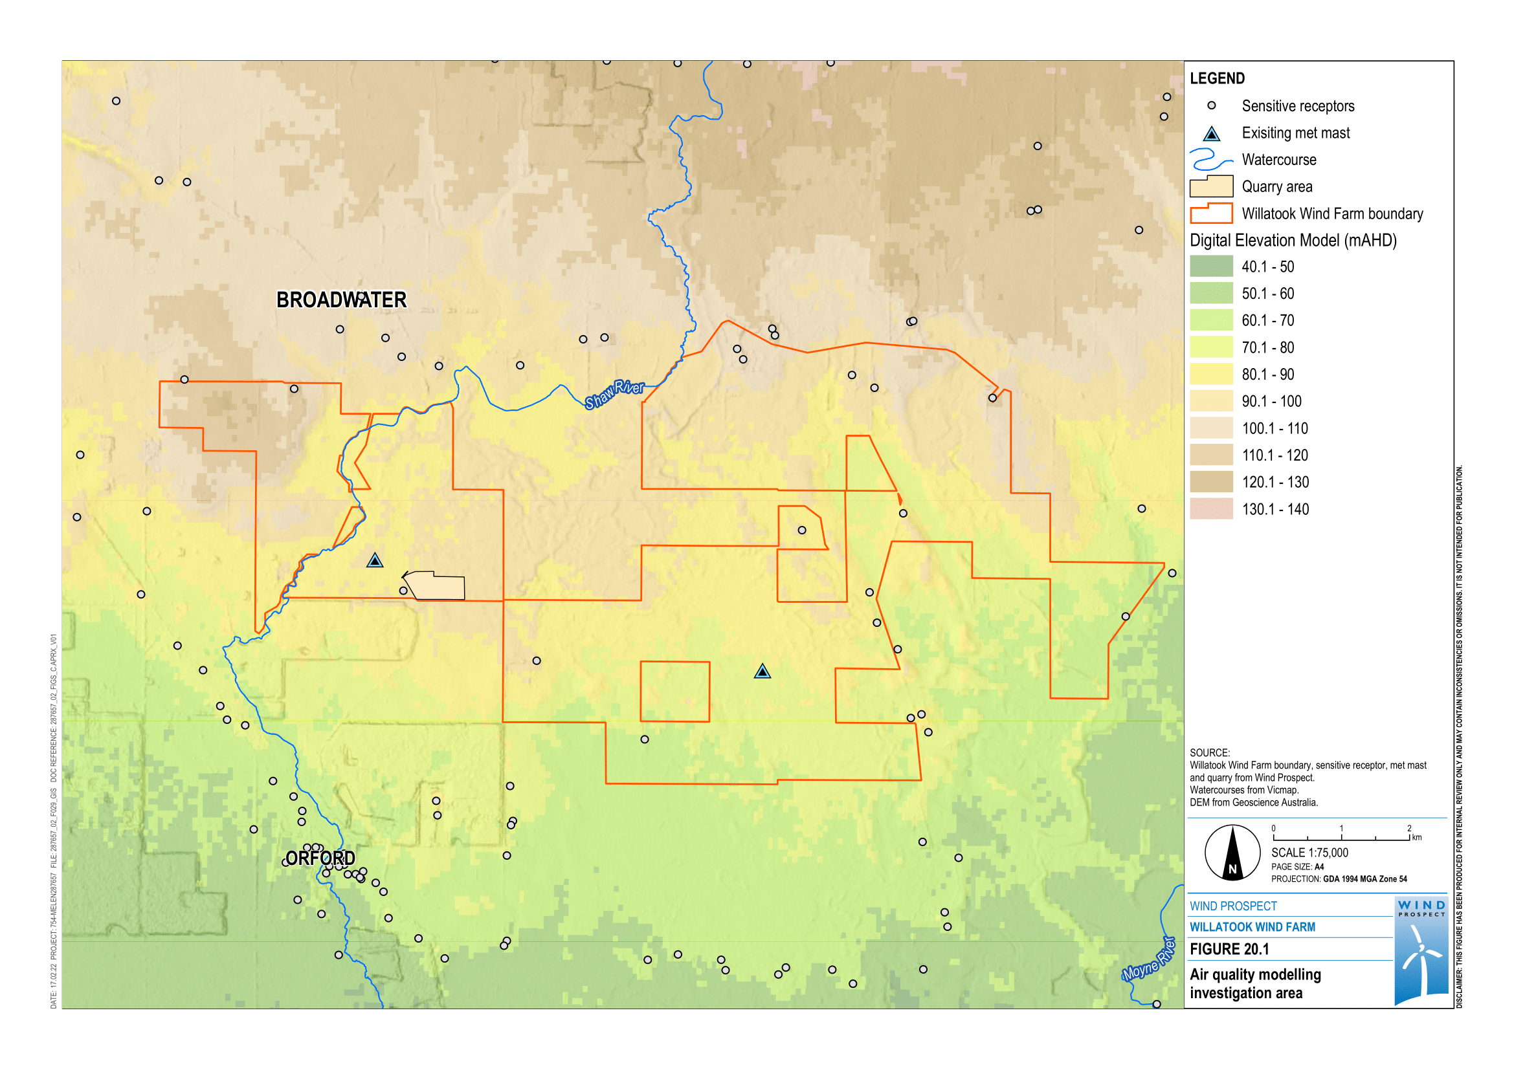

Figure . Air quality modelling investigation area

### Meteorological conditions

Meteorological conditions are important inputs into air quality modelling as they impact the direction and rate at which air pollutant emissions would disperse from a source. This section discusses the meteorological parameters used for modelling the project’s air quality impacts including wind speed and wind direction, temperature, humidity and rainfall.

Temperature, rainfall and humidity were taken from the Mortlake Racecourse Bureau of Meteorology station as it was deemed more similar to the project site than the more coastal Warrnambool Airport NDB Bureau of Meteorology station. Wind speed and direction were taken from the wind monitoring mast installed on the project site.

#### Temperature

Mean monthly minimum and maximum temperatures for the Mortlake Racecourse station, from 1991–2021, are shown in Figure 20.2. These temperature statistics are expected to be similar for the project site.

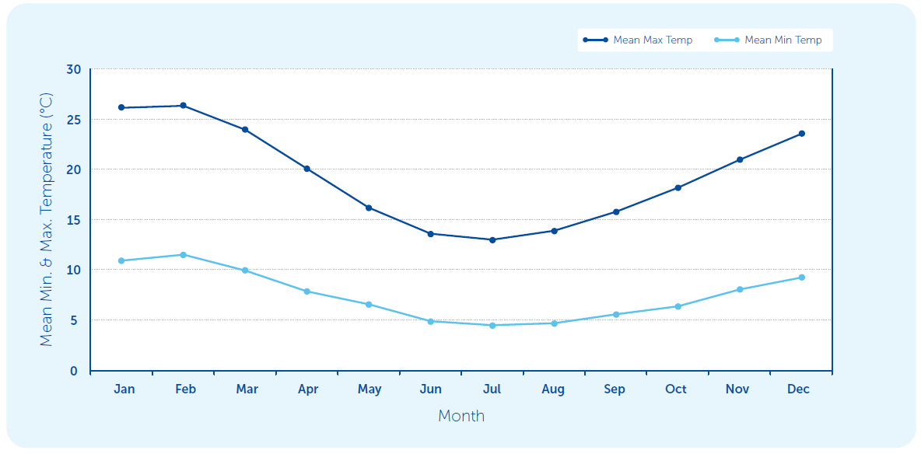

Figure . Mean maximum and minimum daily temperatures for Mortlake Racecourse Bureau of Meteorology station from 1991 to May 2021

#### Rainfall and humidity

Mean monthly relative humidity (%) at 9 am and 3 pm for the Mortlake Racecourse station, from 1991 to 2010, are shown in Figure 20.3. The relative humidity statistics for the project site are expected to be slightly higher than at Mortlake Racecourse station as the project is closer to the coast.

Mean monthly rainfall and the highest monthly rainfall for calendar months between 1994 to 2021, recorded at the Mortlake Racecourse station, are shown in Figure 20.3. That is, the average of all rainfall recorded in each calendar month over the time period (e.g., average of rainfall from all months of January during the time period), and the highest monthly rainfall recorded in each calendar month (e.g., highest monthly rainfall recorded during each of the Januarys throughout the 20-year time period).

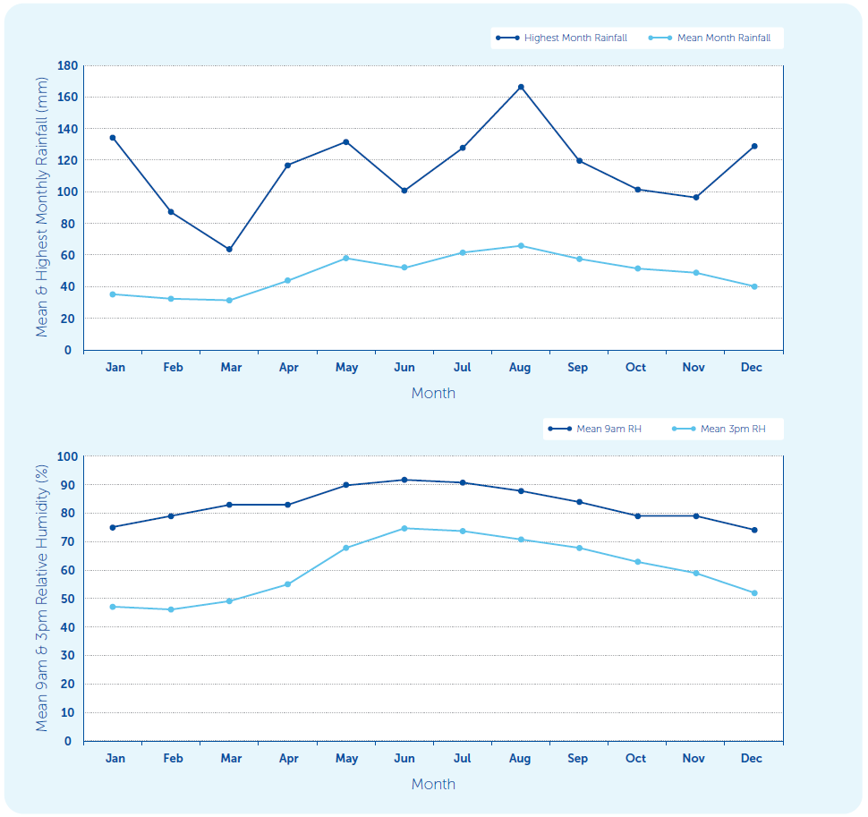

Figure . Monthly rainfall (top) and relative humidity (bottom) at the Mortlake Racecourse Bureau of Meteorology station

#### Wind

The annual average wind speed at the Mortlake Racecourse station, from 2003 to 2021, was 3.9 metres per second. Observations at the local project area for 2018 recorded an annual average wind speed of 5.2 metres per second, with the prevailing wind direction at 9 am typically being from the north-west and from the south-west at 3 pm (Figure 20.4).

To assess the validity of the local observation data collected at the project site for the purposes of meteorological modelling, comparisons were made with the long-term wind parameters for closest Bureau of Meteorology stations (Mortlake Racecourse and Warrnambool Airport NDB) for the model year 2018. It was confirmed that the local observation data could be used for the project meteorological modelling as it is comparable with long-term wind speeds and patterns of the nearby Bureau of Meteorology stations.

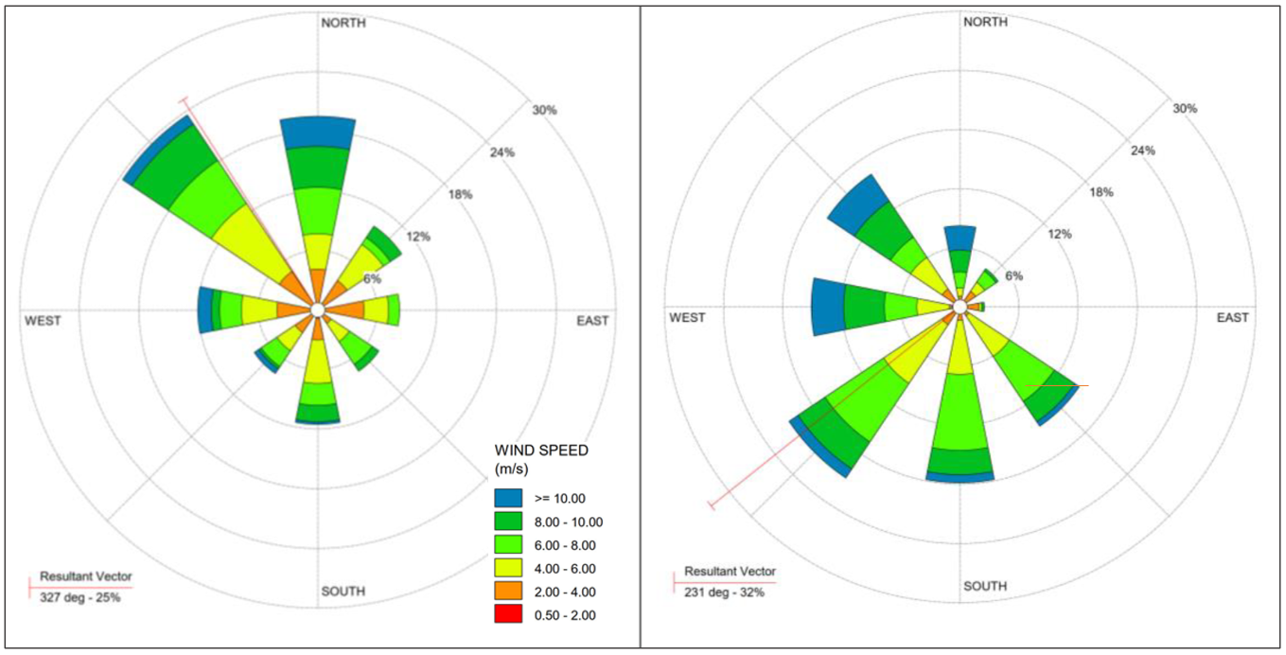

Figure . Wind rose at 9 am (left) and 3 pm (right) showing frequency of occurrence of wind speed and direction for the local project observations over 2018

#### Ambient air quality

There is no air quality monitoring data available in the project investigation area. Of the EPA Victoria monitoring stations across the Port Phillip and Latrobe Valley regions with continuous data, the monitoring station in Alphington (a suburb of Melbourne) was considered most representative of the air environment of the project site. This is because the Alphington site is located inland from the coast, when compared to the Geelong monitoring site, and is not heavily affected by industry or traffic, as is the case with EPA Victoria’s other monitoring stations.

There are no known activities in the investigation area that would generate respirable crystalline silica dust. As such, it is expected that concentrations of respirable crystalline silica are currently negligible at the quarry site.

Table 20.6 outlines the background levels for PM10, PM2.5, deposited dust and respirable crystalline silica used in the project air quality modelling for the meteorological case study year 2018. To determine these levels, the EPA Victoria Alphington monitoring station 70th percentile data was used to calculate the background 24-hour average PM10 and PM2.5 concentrations, and the 50th percentile data (i.e., medians) was used to estimate annual average background concentrations. The rationale for using these values can be found in Appendix L – *Air quality*.

Table . Background pollutant levels applied for project assessment

|  |  |  |  |
| --- | --- | --- | --- |
| Parameter | Averaging time | Background level | Notes |
| PM10 | 24 hours | 19.7 µg/m3 | 70th percentile from Alphington |
| Annual | 14.8 µg/m3 | 50th percentile from Alphington |
| PM2.5 | 24 hours | 8.0 µg/m3 | 70th percentile from Alphington |
| Annual | 6.4 µg/m3 | 50th percentile from Alphington |
| Respirable crystalline silica | Annual | 0 µg/m3 | No known sources of respirable crystalline silica in model region |
| Deposited dust | Monthly | 2.0 g/m2/month | Worst case estimate based on EPA Victoria Publication 1191 |

## Impact assessment

### Impact pathways

Air quality impacts can occur when air pollutant emissions from an industry or activity cause a deterioration in ambient (i.e., outdoor) air quality.

For the project quarry, air emissions during construction and operation would result from activities such as material handling, transport and processing, crushing and screening, drilling and blasting, and wind erosion of stockpiles and exposed areas. These activities would cause emissions of very small (inhalable) dust particles, known as airborne particulate matter. In addition to emissions of particulate matter there would also be gas emissions at the quarry site, primarily from the combustion of diesel and the blasting of explosives. These gases would include nitrogen oxides, carbon monoxide, volatile organic compounds and sulphur dioxide. Air emissions from the quarry site, which would be in use for at least 12 months and possibly up to 24 months, are expected to represent the most significant source of air quality impact for the project.

Key activities expected to affect air quality from the construction, operation and decommissioning of other (non-quarry related) project activities include:

* dust generated by:
  + civil works (including excavation works and material movement)
  + vehicles driving on unsealed roads
  + wind erosion of exposed areas and material stockpiles
  + operation of the concrete batching plants
* combustion engine emissions (nitrogen oxides, volatile organic compounds, fine particulates).

### Design mitigation

#### Sensitive areas

During the development of the project, a range of environmental, social and infrastructure constraints were considered as part of the planning and design process and in many cases, buffers were applied to known or modelled sensitive areas (including townships and dwellings) (refer to Chapter 4 – *Project alternatives and design development*). The purpose of incorporating these constraints and buffers into the planning process was to ensure that potential impacts could either be avoided or minimised. This approach aligns with the general environmental duty requirements, where the primary focus is to eliminate or avoid the risk where practicable.

#### Quarry

The quarry has been proposed in a part of the project site away from occupied dwellings. The closest occupied dwelling is 1.4 kilometres from the quarry boundary. This distance is greater than the minimum separation distance of 500 metres for quarries specified in EPA Victoria Publication 1518: *Recommended separation distances for industrial residual air emissions*.

Alternative locations were also considered but found to be less suitable for reasons unrelated to their proximity to dwellings, including their less suitable geology and proximity to environmental values. Owing to the low density of dwellings within and surrounding the project site, siting the quarry at a reasonable distance from occupied dwellings was not difficult.

#### Other project activities

The three temporary concrete batch plants have been located to provide convenient access to all wind turbines. The distance between concrete batch plants and sensitive receptors was an important consideration to minimise off-site impacts resulting from unintended, project-generated dust emissions. The closest sensitive receptor to any of the concrete batch plants is approximately 1.2 kilometres. This distance is significantly greater than the minimum separation distance of 100 metres for concrete plants specified in EPA Victoria Publication 1518: *Recommended separation distances for industrial residual air emissions*.

### Management controls

Under the general environmental duty, persons engaging in activities that involve air emissions are required to eliminate risks of harm to human health and the environment from those emissions, so far as reasonably practicable. Where this cannot be achieved, risks must be reduced (so far as reasonably practicable) and existing or proposed controls documented as to how they meet the requirement to minimise risks.

To address its general environmental duty relating to air quality, the project has included design measures (where feasible) to avoid potential air impacts for nearby sensitive receptors (see Section 20.7.2). To further minimise potential impacts to air quality, management controls would be implemented during the construction, operation and decommissioning of the project. Committed management measures are outlined in Table 20.7.

Table . Air quality management measures

| Air quality impact | Project phase | Management measures | Number |
| --- | --- | --- | --- |
| Dust from quarry site and other project activities impacts air quality | Construction, Operation | A Construction Environmental Management Plan will be developed and implemented, which would specifically address air emissions and mitigations. This document would be in accordance with the requirements of the new *Environment Protection Act 2017* and best practice guidance documents including, but not limited to:  EPA Victoria Publication 1823: *Mining and quarrying – Guide to preventing harm to people and the environment*  EPA Victoria Publication 1834: *Civil construction, building and demolition guide.*  A site-specific dust management plan (sub-plan of the Construction Environmental Management Plan) will identify potential and existing dust sources and outline best practice design controls and management practices to minimise dust. These measures would include, but not be limited to:  watering of unsealed roads to reduce wheel generated dust  use of water sprays to reduce wind erosion from material stockpiles and exposed areas  use of water sprays as required for material transfer operations and quarry activities (e.g., drilling rock, crushing and screening)  restricting vehicle speeds to 20 kilometres per hours near sensitive areas such as dwellings  site-specific dust control measures for dust producing activities  monitoring of forecast and real time local wind parameters (e.g., wind speed, wind direction) and adjustment of dust generating activities, as required, to reduce impact to sensitive receptors  sequencing of vegetation removal within the quarry work authority area where feasible to minimise the amount of disturbed land exposed to wind erosion  rehabilitation and revegetation of inactive stockpiles and disturbed areas to reduce wind erosion  selection of equipment, e.g., concrete batching plants, which have integrated best practice dust control features  regular visual monitoring of dust, with results recorded in a dust management database  regular monitoring of the effectiveness of dust control measures. If dust controls are found to be ineffective, these would be reviewed (internally and/or by an external dust specialist, if required) and amended as necessary  contingency measures where dust plumes are identified during visual monitoring and/ or the project receives dust related complaints  dust management training would be undertaken for construction workforce as part of the site-specific induction, outlining controls to be implemented during construction to manage potential air quality impacts  procedures for monitoring of weather (e.g., wind speed, wind direction) and triggers to adjust dust generating activities  complaint investigation and response plan  procedures for reporting the project’s performance against regulatory limits. | AQ01 |
| Dust from concrete batching plants impacts air quality | Construction and Operation | All project concrete batching plants will be designed and operated to adequately control dust emissions, as per guidelines set out in EPA Victoria Publication 1806: *Reducing risk in the premixed concrete industry*. | AQ02 |
| Dust from quarry site activities impacts air quality | Construction and Operation | A Quarry Work Plan will be developed in accordance with section 77G of the *Mineral Resources (Sustainable Development) Act 1990*. This plan will contain measures for the control of emissions of dust or other particulates, and the carriage and deposition of dust, silt and clay by vehicles existing the work authority area. These controls will be in accordance with best practice management standards including, but not limited to:  EPA Victoria Publication 1191: *Protocol for Environmental Management: Mining and Extractive Industries*  EPA Victoria Publication 1518: *Recommended separation distances for industrial residual air emissions*  National Environmental Protection (Ambient Air Quality) Measure. | AQ03 |

### Residual effects

#### Quarry – Construction and operation

##### Dust-generating activities

During quarry operation, the highest emission rates are attributed to dust that is generated by trucks hauling material over unsealed roads, followed by loading and unloading operations. Drilling and blasting activities are the smallest contributors to the total dust emissions. The calculated annual dust emission estimates (incorporating management control reductions) as Total Suspended Particulates, PM10 and PM2.5 for the quarry operation activities are summarised in Table 20.8.

Table . Estimated dust emissions from the quarry activities

| Quarry activity | Annual emissions (kilograms per year) | | |
| --- | --- | --- | --- |
| **Total Suspended Particulates** | **PM**10 | **PM**2.5 |
| Excavators loading overburden to trucks | 3,032 | 1,434 | 152 |
| Hauling overburden to dumps | 30,183 | 8,919 | 1,509 |
| Unloading overburden to dumps | 12,144 | 4,352 | 607 |
| Drilling rock | 1,328 | 698 | 66 |
| Blasting rock | 348 | 180 | 17 |
| Excavators loading shot rock to trucks | 1,798 | 850 | 90 |
| Hauling shot rock to raw product stockpiles | 17,895 | 5,288 | 895 |
| Loading raw product stockpiles | 1,200 | 510 | 60 |
| Loading shot rock to mobile crusher | 1,798 | 850 | 90 |
| Primary crushing | 3,000 | 1,200 | 150 |
| Secondary crushing | 9,000 | 3,600 | 450 |
| Screening | 9,000 | 3,600 | 450 |
| Loading crushed product to stockpiles via conveyor | 1,798 | 850 | 90 |
| Loading crushed product to trucks | 2,400 | 1,020 | 120 |
| Hauling crushed product off-site | 21,086 | 6,231 | 1,054 |
| Wind erosion from exposed areas/dumps | 10,862 | 5,431 | 815 |
| Wind erosion from active stockpiles | 3,329 | 1,664 | 250 |
| **TOTAL** | **130,200** | **46,078** | **6,865** |

##### Air dispersion modelling

Air dispersion modelling was undertaken using the emission estimates in Table 20.8 and meteorological data, as discussed in Section 20.4.2.

For the quarry area, modelling indicates that predicted ground-level concentrations near the quarry site boundary exceed the air quality standard for PM10, PM2.5, respirable crystalline silica and deposited dust during quarry operations. Of these particulate emissions, predicted PM10 concentrations for both the   
24-hour and annual average were modelled to have the greatest potential to impact ambient air quality, with elevated levels above the project standard (the most conservative standard taken from legislation) predicted up to 1,000 metres south beyond the quarry work authority boundary. The AERMOD contour maps for these particulate emissions for the quarry site and surrounds are shown in Figure 20.5 (maximum 24-hour PM10) and Figure 20.6 (annual average PM10). However, at the nearest sensitive receptor site (a participating landowner, 1.4 kilometres east), the predicted ground-level concentrations do not exceed the project standards for all air pollutants emitted from the quarry operations. As such, there is a low potential for air quality impacts at this site or other sites further away.

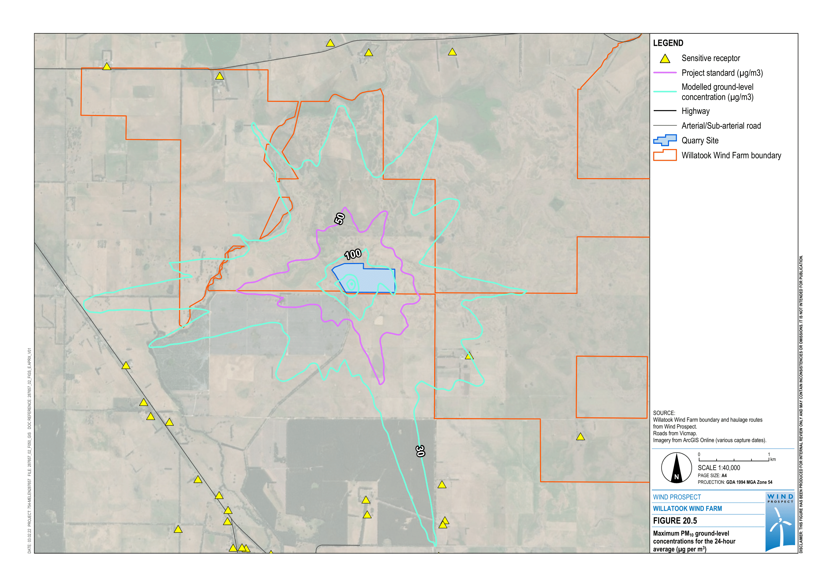

Figure 20.5 Maximum PM10 ground-level concentrations for the 24-hour average (µg per m3)

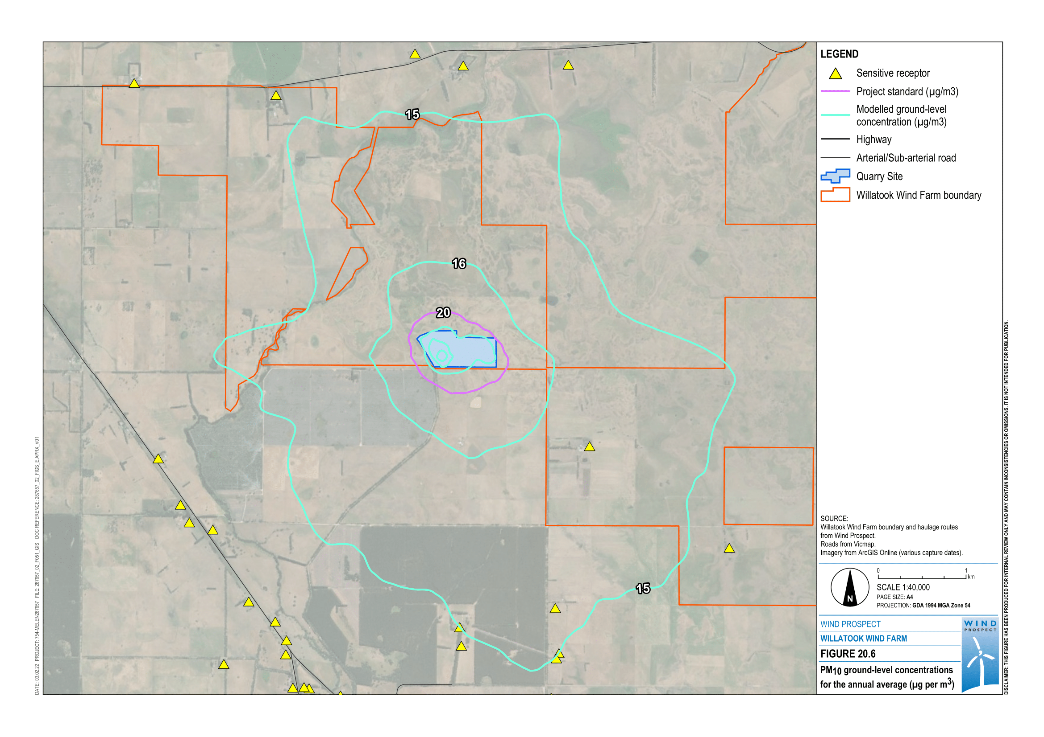

Figure 20.6 PM10 ground-level concentrations for the annual average (µg per m3)

A summary of the maximum predicted ambient ground-level concentrations for all grid points in the quarry model area and across all sensitive receptor sites is provided in Table 20.9 below.

Table . Summary of AERMOD model results

| Assessment parameter | Averaging time | Units | Project standard | Modelled result | |
| --- | --- | --- | --- | --- | --- |
| **Maximum grid ground-level concentrations** | **Maximum sensitive receptor ground-level concentrations\*** |
| PM10 | 24 hours | µg per m3 | 50 | 802 | 30 |
| Annual | µg per m3 | 20 | 161 | 15 |
| PM2.5 | 24 hours | µg per m3 | 25 | 112 | 9.7 |
| Annual | µg per m3 | 8 | 26 | 6.5 |
| Respirable crystalline silica | Annual | µg per m3 | 3 | 20 | 0.1 |
| Deposited dust | Monthly | g per m2 per month | 4 | 63 | 2.1 |

* For each model, the highest predicted ground-level concentration at a sensitive receptor occurs for the nearest receptor site located approximately 1.4 km south-east of the quarry site

##### Gas emissions

Due to the relatively small fleet of heavy moving equipment, mobile processing plants and light mobile equipment required for the project, and the short and periodic nature of the blasting operations, gas emissions from diesel combustion and blasting are expected to be insignificant for the project quarry site. As such, these emissions were not included in the modelling.

#### Other project activities – Construction, operation and decommissioning

##### Dust-generating activities

Construction dust emissions for each turbine foundation site are expected to be significantly less than those for the quarry and would occur over relatively short periods for each site. Similarly, the construction of the on-site substation, battery energy storage system and temporary construction offices would have significantly lower dust emissions compared to the quarry site and would be of short duration.

The closest concrete batch plant, used for the construction of the wind turbine sites, is approximately 1.2 kilometres from the nearest sensitive receptor. This distance is ten times greater than the minimum separation distance of 100 metres for concrete plants under the guideline *Recommended separation distances for industrial residual air emissions* (EPA Victoria, 2013), which is applied to minimise off-site air quality impacts arising from industrial activities including concrete batching. As such, activities at these sites are unlikely to have any significant impact to ambient air quality for sensitive receptors.

During project operation, light vehicles and small trucks would travel from the site office and maintenance yard to individual turbines and substation, mostly via internal unsealed roads. Larger vehicles may occasionally deliver large equipment. Dust generated from vehicle movements on unsealed roads during operation and decommissioning (outside of the quarry activities) are expected to be minor and of short duration. Overall, the emissions from the activities across the broader project site are not expected to be significant contributors to the dust impact of the project.

##### Gas emissions

As per dust emissions, combustion emissions during construction, operation and decommissioning (outside of the quarry activities) are expected to be minor and of short duration.

### Impact assessment summary

A summary of the air quality impact assessment is shown in Table 20.10 below, with the full assessment presented in Appendix L – *Air quality*.

Table . Air quality impact assessment summary

| Air quality values | Potential impact pathway | Project phase | Likely impact (magnitude, extent and duration) | Impact rating and justification |
| --- | --- | --- | --- | --- |
| Sensitive receptors | Particulate and dust emissions generated by quarry activities | Construction and Operation | During quarry operation (should it be used), the highest emission rates are attributed to dust that is generated by trucks hauling material over unsealed roads, followed by loading and unloading operations.  These emissions would occur for an extended period (with the quarry potentially operating for up to 24 months), would involve intensive material movement, and are expected to represent the most significant source of air quality impact for the project.  Modelling indicates that predicted ground-level concentrations at the nearest sensitive receptor site do not exceed air quality standards during quarry operations. | **Low**  The project is in a rural area with limited and isolated, sensitive receptor locations. Therefore, the potential for air quality impacts at sensitive receptor sites is low. |
| Gas emissions at the quarry site from combustion of diesel and blasting of explosives | Construction | Gas emissions from diesel combustion would mainly be nitrogen oxides, carbon monoxide and volatile organic compounds.  Emissions during the blasting operations would be nitrogen oxides, carbon monoxide and sulphur dioxide.  Impacts are anticipated to be short and periodic. | **Negligible**  Due to the relatively small fleet of equipment, and short and periodic nature of the blasting operations, these gas emissions are expected to be insignificant for the project quarry site. |
| Particulate and dust emissions generated by other project activities | Construction, Operation and Decommissioning | Dust emissions associated with the construction of turbine foundations, on-site substation, battery energy storage system and temporary construction offices would have significantly lower dust emissions compared to the quarry site. These impacts would occur over relatively short periods for each site.  Impacts from concrete batch plants are unlikely due to the distance to the nearest sensitive receptor.  Dust generated from vehicle movements on unsealed roads during operation and decommissioning other project activities (outside of the quarry activities) are expected to be minor and of short duration. | **Negligible**  Emissions from other project activities, outside of the quarry activities, are not expected to be significant contributors to the overall dust impact for the project. |
| Gas emissions generated by other project activities | Construction, Operation and Decommissioning | Combustion emissions during operation and decommissioning of other project activities (outside of the quarry activities) are expected to be minor and of short duration. | **Negligible**  Emissions from other project activities, outside of the quarry activities, are not expected to be significant contributors to the overall dust impact for the project. |

## Conclusions

Air pollutant emission modelling for quarry operation activities indicates that ground-level concentrations surrounding the quarry site exceed the air quality standard for PM10, PM2.5, respirable crystalline silica and deposited dust. The final Quarry Work Plan, as required under the *Mineral Resources (Sustainable Development) Act 1990*, would contain measures for the control of emissions of dust or other particulates from the quarry work authority area during construction and operation of the quarry. No exceedances of the project air quality standards are predicted at any of the sensitive receptors in the vicinity of the quarry.

Gas emissions from diesel combustion and blasting operations associated with quarry activities are anticipated to be short and periodic and were assessed to be insignificant for the project quarry site.

Gas and particulate (dust) emissions from other project activities, outside of the quarry activities, are not expected to be significant contributors to the overall dust impact for the project and would be effectively managed using dust management measures targeted for each specific activity. The project would develop and implement a dust management plan, outlining best practice design controls and management practices to minimise potential dust emissions and air quality impacts. This site-specific dust management plan would also contain a monitoring procedure for the generation of dust and contingency measures to be implemented if dust plumes are observed and/or credible dust related complaints are received.

To address its general environmental duty relating to air quality, the project would put in place reasonably practicable measures to reduce the risks of harm to people and the environment from air pollution where they cannot be eliminated. The approach has been to first avoid or limit potential impacts by creating appropriate separation distances between proposed project infrastructure (such as the quarry, concrete batching plants and the wind turbines) and sensitive receptors. The air quality impact assessment (Appendix L) has identified the potential impacts to air quality caused by project activities and provided management controls to mitigate against the risk of air pollution impacts. These take a proactive approach to avoid the generation of dust through the application of dust prevention measures and the monitoring of weather conditions to guide what construction activities can take place, and if additional dust suppression measures (e.g., additional water spraying) are required to permit the activities to continue.

The project would also monitor for the generation of dust, and if identified, implement contingency measures to supress further dust generation and ensure that dust effects are minimised. The project environmental management plan would include requirements for the project to provide information, instruction, supervision and training to people engaged in activities to enable them to comply with the general environmental duty.

With the implementation of recommended management measures, the potential impact to air quality for nearby sensitive receptors is considered to be low.

1. Year 2019 background data was not selected as this year was characterised by two major bushfires in Victoria, resulting in high levels of PM2.5 and higher than typical PM10 levels, as well as lower than average rainfall. Additionally, the PM2.5 dataset for this year was incomplete due to errors in the monitoring equipment.

   Published background data for 2020 was not available at the time of the air quality impact assessment.