Brolga

Overview
This chapter describes the assessment of potential impacts from the construction, operation and decommissioning of the project on Brolga, and measures taken to avoid and minimise these impacts in accordance with the Interim Guidelines for the Assessment, Avoidance, Mitigation and Offsetting of Potential Wind Farm Impacts on the Victorian Brolga Population (DSE, 2012) (Interim Brolga Guidelines).
This chapter is based on the findings of the Brolga impact assessment (Appendix C1) prepared by Nature Advisory. Due to the required methods of assessment, potential impacts on Brolga have been presented separately from the broader flora and fauna impact assessment (Chapter 12 – Biodiversity and habitat).
The Brolga is an iconic wetland bird that is listed as endangered in Victoria. The southern portion of the population has experienced significant decline since European settlement attributed to habitat loss from agriculture and wetland drainage, predation from foxes, and collisions with fences and powerlines. While Brolga collisions with wind turbines have not been reported, the Victorian Government have issued guidelines with the goal of zero net impact to the species as a precautionary measure due to the potential interaction with wind farms in their range.
Over the last decade significant efforts have been made to assess Brolga activity and suitable habitat at the project site and surrounding area. The assessment included a review of existing Victorian Government database records, consultation with project and surrounding landowners, aerial surveys, roaming observational field surveys to record Brolga activity, as well as a combination of field surveys and hydrological modelling to assess wetland suitability as Brolga breeding habitat.
A total of 28 Brolga breeding sites were identified within approximately 10 kilometres of the project site and of these 23 could be attributed to a functional wetland and defined as a possible Brolga breeding site. Six of these sites are within 3 kilometres of the project. One pair of Brolga were repeatedly observed nesting within the Cockatoo Swamp wetland complex during roaming field surveys conducted for the project between 2010 and 2021.
Additional investigations were conducted to predict wetlands that met hydrological criteria required for Brolga breeding, since a large proportion of DELWP Victorian Wetland Inventory wetlands were inaccurate in their extent and location. Hydrological modelling combined with field assessments predict that 11 seasonal wetlands and 3 farm dams within 3 kilometres of the project can provide suitable Brolga habitat, including the six sites with historical Brolga breeding records associated within them.
To minimise the impact of the project on the Victorian Brolga population, turbine free buffers have been developed around breeding wetlands to exclude wind turbines and limit disturbance. This area incorporates functional wetlands assessed as capable of providing habitat that could be used for foraging, breeding and night roosting, non-wetland areas around these wetlands and movement corridors between them. A buffer zone (2,658 hectares in size) was established around the Cockatoo Swamp complex, where five breeding wetlands are located. The area contains five defined Brolga home range areas, each significantly (>28%) greater than the largest recorded Brolga home ranges from independent research.
The establishment of this buffer resulted in significant design changes, with 23 proposed wind turbines from the layout either removed or relocated. The turbine free buffer is similar to or larger than those used for other approved or operating wind farms in the Victorian range of the Brolga, such as Dundonnell, Golden Plains and Stockyard Hill wind farms.
A Brolga turbine collision risk model was applied in accordance with the Interim Brolga Guidelines. It was assumed that a Brolga pair would nest each year at one of the five Brolga breeding sites in the central buffer zone around Cockatoo Swamp and one additional pair was assumed to use one of the isolated wetlands to the east of the wind farm three out of ten years. The model assumes that a proportion of these Brolga’s flights would be at a height and distance where turbine interaction is possible. Wind turbine avoidance rates were calculated using observations of Brolga and international studies of crane species. The model predicts that under the most conservative turbine avoidance scenario where Brolga avoid wind turbines 90% of the time, there would be 0.07 flights at risk of collision per year on average, or 1.7 flights at risk of collision over the 25-year life of the project. Statistically, there is a 95% chance of between zero and five collisions over 25 years.
A Population Viability Assessment (PVA) was also completed to assess the impact to the Victorian Brolga population. The assessment predicted the population size would be reduced by between 0.1 and 0.8 birds over the project life compared with baseline conditions, or 0.1% of the Victorian Brolga population.
The Interim Brolga Guidelines require that the impacts on the Victorian Brolga population are ‘fully offset’ through the implementation of a Brolga compensation plan. The aim of the plan will be to replace the worst-case estimate of the number of Brolga affected by the project (5 individuals over 25 years) through the restoration of lost breeding habitat so that additional breeding pairs can produce increased numbers of young that survive to become breeding adults. In this way, the impact on the population predicted by the PVA will be offset, meeting the policy objective of zero net impact on the Victorian Brolga population.

EES objectives and key issues
The EES scoping requirements specify the following draft evaluation objective and key issues, outlined in Table 11.1, relevant to Brolga that have guided this assessment.
Table 11.1 EES draft evaluation objective and key issues
Draft evaluation objective
Biodiversity and habitat: To avoid or minimise potential adverse effects on biodiversity values within and near the site including native vegetation, listed threatened species and ecological communities, and habitat for these species. Where relevant, offset requirements are to be addressed consistent with state and Commonwealth policies.
Key issues | Disturbance and/or degradation of adjacent or nearby habitat that may support listed species or other protected flora, fauna or ecological communities.  Disturbance and/or individual to population level loss of flora and fauna species listed as threatened under the EPBC Act, FFG Act and/or DELWP advisory lists.  Indirect habitat loss or degradation resulting from other effects, such as edge effects, surface hydrological changes, groundwater drawdown, noise, vibration, light or the introduction of weeds/pathogens.  Potential collision risk for protected bird and bat species with project infrastructure, including with wind turbine blades.

Legislation, policy and guidelines
Legislation, policies and guidelines relevant to the Brolga assessment are summarised in Table 11.2 below.
Table 11.2 Relevant legislation, policies and guidelines
Legislation, policy and guidelines | Description | Relevance to Project
Victorian Flora and Fauna Guarantee Act 1988 (FFG Act) | The FFG Act lists threatened and protected species in the State of Victoria. | Brolga is listed as threatened species which occurs in the broader region around the project in south-west Victoria.
Planning and Environment Act 1987 | The purpose of the Planning and Environment Act 1987 is to establish a framework for planning the use, development and protection of land in Victoria. This Act sets out the process for obtaining permits under schemes, settling disputes, enforcing compliance with planning schemes and permits, and other administrative procedures. | The Moyne Planning Scheme is relevant to the project and is administered by the Moyne Shire Council.
 | Planning Policy Framework and Municipal Strategic Statement | The following clauses of the Planning Policy Framework and Municipal Strategic Statement contained within the Moyne Planning Scheme are relevant to biodiversity for the project:  12.01-1S Protection of biodiversity objective is “to assist the protection and conservation of Victoria’s biodiversity.”  12.01-2S Native vegetation management objective is “to ensure that there is no net loss to biodiversity as a result of the removal, destruction or lopping of native vegetation.”  21.06 Environment objectives include:  reduce the impact of pest plants and animals on the Shire’s resources and production  protect and enhance the region’s indigenous genetic biodiversity.  22.02 Environment key clauses include:  22.02-2 Rare and threatened species (objective: “to maintain and enhance the habitat, particularly the critical habitat, of Victorian Rare and Threatened Flora and Fauna species”).
 | Particular provisions | 52.32 Wind Energy Facility: this clause facilitates the establishment and expansion of wind energy facilities, in appropriate locations, with minimal impact on amenity of the area. It requires that impacts of wind energy facilities on FFG Act listed species be assessed.
FFG Act Action Statement No.119 2003 – Brolga | An Action Statement developed for the Brolga species. | Details species distribution, ecology and key threats.
Planning and Policy Guidelines for Development of Wind Energy Facilities in Victoria (Policy and Planning Guidelines) (DELWP, 2021f) | The Guideline provides advice to inform planning decisions about a wind energy facility proposal. | The Guidelines require that impacts of wind farms on FFG Act listed species be assessed.
Interim Guidelines for the Assessment, Avoidance, Mitigation and Offsetting of Potential Wind Farm Impacts on the Victorian Brolga Population (DSE, 2012) | The Interim Brolga Guideline responds to the perceived risk posed to Brolga by the wind industry by outlining an approach to achieving a zero net impact to the Victorian Brolga population. | The project has been assessed in accordance with the Interim Brolga Guidelines.
It is noted that Victorian Brolga Assessment and Mitigation Standards are currently in draft as of May 2022. These have been exhibited for comment but have not been finalised. Due to uncertainty as to their final form, and the extensive work that was conducted for the project in accordance with the Interim Brolga Guidelines, the draft Brolga Assessment and Mitigation Standard has not been adopted by the project. This is consistent with the proposed ‘transitional provisions’ in the proposed draft standards.

Method
The potential impact of wind farms on Victoria’s Brolga population is seen as a key environmental issue for the wind industry in south-west Victoria. This is because a significant proportion of the Victorian Brolga population’s range occurs in areas proposed for wind farm development. To provide certainty, the Victorian Government issued the Interim Guidelines for the Assessment, Avoidance, Mitigation and Offsetting of Potential Wind Farm Impacts on the Victorian Brolga Population (DSE, 2012). These guidelines outline a standard approach to assessing a wind farm project’s impact and achieving a zero net impact on the Victorian Brolga population.
The Interim Brolga Guidelines detail three levels of progressively more detailed investigations required to assess impacts and design mitigation strategies.

Level of assessment triggers
The Interim Brolga Guideline assessment framework is broken into the steps:
- design the wind farm including all infrastructure to avoid and mitigate potential effects, to the extent that is practicable
- estimate any remaining and unavoidable risk using tools such as collision risk modelling and population viability analysis, to ascertain likely effects on the population
- determine appropriate compensatory measures to, at a minimum, completely offset unavoidable effects.
If all potential risks cannot be removed by the first step, then steps two and three apply. Triggers for the level of Brolga assessment required, along with their applicability to the project, are described in Table 11.3.
Table 11.3 Interim Brolga guidelines level of assessment triggers
Triggers | Applicable to project? | Comments
Level 1 – Assessment aims to identify the potential presence, number and location of any Brolgas or potential Brolga habitat within the radius of investigation for a proposed wind farm.
The proposed wind farm site is situated within the Victorian range of the Brolga. |  | The proposed wind farm site is situated within the Victorian range of the Brolga.
The presence of Brolga within the radius of investigation (i.e., within 10 km of the proposed wind farm boundary). |  | Brolga are known to occur within 10 kilometres of the project site.
The presence of potential Brolga habitat within the radius of investigation. |  | There is potential Brolga breeding habitat within the radius of investigation (i.e., within 10 kilometres of the project site).
The location of the proposed development is within an area that may be used by Brolga during seasonal movements between breeding and flocking habitats. |  | As Brolga are known to nest within and around the project site there is the possibility that the area is used for seasonal movements.
Level 2 – Assessment seeks to provide a comprehensive record of the location, nature and extent of Brolga habitats within the wind farm radius of investigation and to assess the potential for impacts arising from collision risk, indirect disturbance and barrier effects.
Records of breeding or flocking habitat within the radius of investigation. |  | There are records of breeding within 10 kilometres of the project site; however, no flocking sites are known to occur in this area.
The proposed development is in an area which may be used by Brolga moving seasonally between breeding and foraging sites, and may potentially create a barrier reducing movements between these habitats. |  | As Brolga are known to nest within and around the project site there is the possibility that the area is used for seasonal movements.
The proposed development is located in an area which may be used by Brolgas for diurnal movements between foraging and roosting site. |  | As Brolga are known to nest within and around the project site there is the possibility that the area is used for diurnal movements between foraging and roosting site.
The proposed location of new powerlines associated with the development may create new collision risks for Brolga. |  | The project design has largely removed the collision risk associated with new powerlines. Required overhead transmission lines are immediately adjacent to existing transmission lines.
Level 3 – Assessment has the objective of using site design and turbine placement to avoid significant impacts on breeding and non-breeding habitats and to then quantify the residual ‘unavoidable’ risk posed to Brolgas by the proposed wind farm and offsetting that measured risk to achieve a zero net impact.
Qualitative risk assessment (AusWEA, 2005) of project following site design is greater than “low”. |  | Noting the potential presence of Brolga within the site, a precautionary approach was followed and a level 3 assessment was completed.

Survey and assessment methods
There has been significant effort undertaken to survey and document the presence of Brolga and assess habitat suitability within 10 kilometres of the project site over the last decade. Details of the survey and assessment methods, along with their alignment with the three levels of assessment within the Interim Brolga Guidelines assessment framework, are provided in Table 11.4.
Table 11.4 Interim Brolga Guidelines recommended assessment methods
Steps | Guideline requirements | Project investigations
Level 1 – Assessment aims to identify the potential presence, number and location of any Brolgas or potential Brolga habitat within the radius of investigation for a proposed wind farm.
Step 1 | Undertake desktop studies into known and potential habitat areas for Brolga. | A comprehensive desktop review was conducted of all available historical and contemporary Brolga records within the 10-kilometre radius of the project.
Step 2 | Initial field inspection and local community consultation. | Initial field inspections were completed to identify potential Brolga breeding habitat of the project site. Initially a 20-kilometre search radius around the project site was used, which was subsequently reduced to 10 kilometres following the Interim Brolga Guidelines recommendation. Landowner and community consultation commenced in 2009 to identify potential Brolga flocking and breeding sites that may not be recorded in the available databases or accessible during field studies.
Level 2 – Assessment seeks to provide a comprehensive record of the location, nature and extent of Brolga habitats within the wind farm radius of investigation and to assess the potential for impacts arising from collision risk, indirect disturbance and barrier effects.
Step 1 | Aerial surveys can be used to identify Brolga breeding sites. | In October 2010, an aerial survey was conducted to record potential Brolga nests within 20 kilometres of the project. Nest locations were recorded and visited on the ground where possible.  A second aerial survey of wetlands was undertaken in October 2018. The aerial survey enabled an assessment of all wetlands within 10 kilometres of the project not visible from public roads.
Step 2 | Detailed community consultation. | In December 2018, community consultation was conducted by Nature Advisory involving face-to-face and telephone interviews with landowners and special interest groups.  All landowners within 10 kilometres were invited to participate via a mailout with further attempts to contact all landowners within 5 kilometres of the project site by telephone. In addition to farming landowners, representatives from Australian Blue Gum Plantations who have plantations to the west and south-west of the project site, and Pallisters Reserve which is also an area south-west of the project site were interviewed, along with Trust for Nature and Basalt to Bay Landcare Network.  A total of 38 landowners and organisation representatives participated in the interviews, building upon previous information gained from community consultations conducted in 2010.
Step 3 | Roaming surveys are a good method to detect Brolga which typically occur at low densities. Roaming surveys in winter and spring should search all potential breeding habitat, and in December to June should search potential flocking roosts at dawn and dusk and potential foraging areas during the day. | Site-specific field investigations have been undertaken during breeding and non-breeding periods in 2009, 2010, 2011, 2013, 2018, 2019, 2020 and 2021 to document the extent of Brolga activity as well as current and historical spatial patterns of activity in the radius of investigation. The roaming field surveys occurred during various weather conditions, including high and low rainfall seasons.  Field surveys were undertaken monthly during the non-breeding seasons in 2018, 2019 and 2020 by Nature Advisory to identify any wetland or waterbodies used for flocking within 10 kilometres of the project. A total of 15 survey events (totalling 48 days of survey effort) were conducted during the non-breeding (flocking) period.  In the 2012/2013 Brolga breeding season searches of five wetland areas within 2 kilometres of the project site were undertaken to identify Brolga breeding nests.  Roaming field surveys were undertaken over several days in each month of the Brolga breeding seasons of 2018, 2019 and 2020. A single survey was completed in 2021. A total of 18 survey events (totalling 67 days of survey effort) were conducted during the breeding season between 2018 and 2021. The roaming field surveys focused on wetlands within 5 kilometres of the project site. A total of 112 wetlands were surveyed for active Brolga breeding and for suitability as breeding habitat.
Step 4 | Wetland habitat assessment | All wetlands mapped within the DELWP Victorian Wetland Inventory (‘current wetlands’) layer within 10 kilometres of the project site were assessed by Nature Advisory. Each of these wetlands were assessed for their suitability to support Brolga reproduction focussing on vegetation presence, physical attributes and their condition.  To predict potential Brolga breeding habitat more accurately, hydrology investigations were undertaken by Water Technology to develop a surface water model to accurately assess which wetlands can hold water for a 120–day period once every ten years, which is the period of wetland inundation Brolga require to breed successfully. Hydraulic modelling simulated runoff generated from local rainfall and site topography. Identified suitable wetland areas then underwent a more detailed hydrological assessment, which involved water balance modelling of each wetland individually or as a series of connected wetlands.  Further ecological field surveys of these wetlands were completed to also assess other features that are known to be of importance to Brolga including the presence of aquatic or semi aquatic vegetation.  Hydrological modelling combined with field assessment identified areas capable of supporting Brolga breeding.
Step 5 | Flight behaviour studies aim to describe Brolga flight paths and movement patterns to determine buffer location and design and for use in a collision risk model. | Flight behaviour and movement data was gathered for two breeding pairs within 10 kilometres of the project site during the 2018 breeding season. Due to the limited number of breeding nests, the data gathered was not considered statistically robust enough to inform buffer location and design. Observations of flight movements of Brolga around Victorian breeding sites from past studies undertaken by Nature Advisory were used as a basis for determining movement patterns of Brolga.
Level 3 – Assessment has the objective of using site design and turbine placement to avoid significant impacts on breeding and non-breeding habitats and to then quantify the residual ‘unavoidable’ risk posed to Brolgas by the proposed wind farm and offsetting that measured risk to achieve a zero net impact.
Step 1 | Avoid or mitigate all potential impacts to Brolga breeding and flocking home ranges within the radius of investigation with turbine-free buffer areas. | Turbine free buffers were developed using Nature Advisory’s observational flight movements of Brolga, Brolga home range mapping published at other wind farm projects as well as recent published research.
Step 2 | Develop a site-specific collision risk model for Brolga utilising or moving through the radius of investigation. | A site-specific collision risk model for Brolga was developed to estimate turbine collision risk for the life of the project based on findings of earlier field and desktop studies.
Step 3 | Use DELWP (Melbourne University) Brolga Population Viability Assessment to estimate the impact of the proposed development on the population. | Melbourne University Brolga Population Viability Assessment was used to estimate the impact of the proposed development on the population.
Step 4 | Identify appropriate compensation strategies to ensure a zero net impact on the Victorian Brolga Population. | A framework for the proposed Brolga compensation was developed with the aim of replacing the estimated number of Brolga affected by the project (worst case 4 individuals over 25 years). This would be achieved through the restoration of Brolga nesting habitat so that additional breeding pairs can produce increased numbers of young that survive to become breeding adults.
A summary is provided below (Figure 11.1) of how the different methods described above were used to determine Brolga breeding wetlands and other functional wetland habitat. These wetlands then formed the basis for turbine free buffers zones and the final project design.
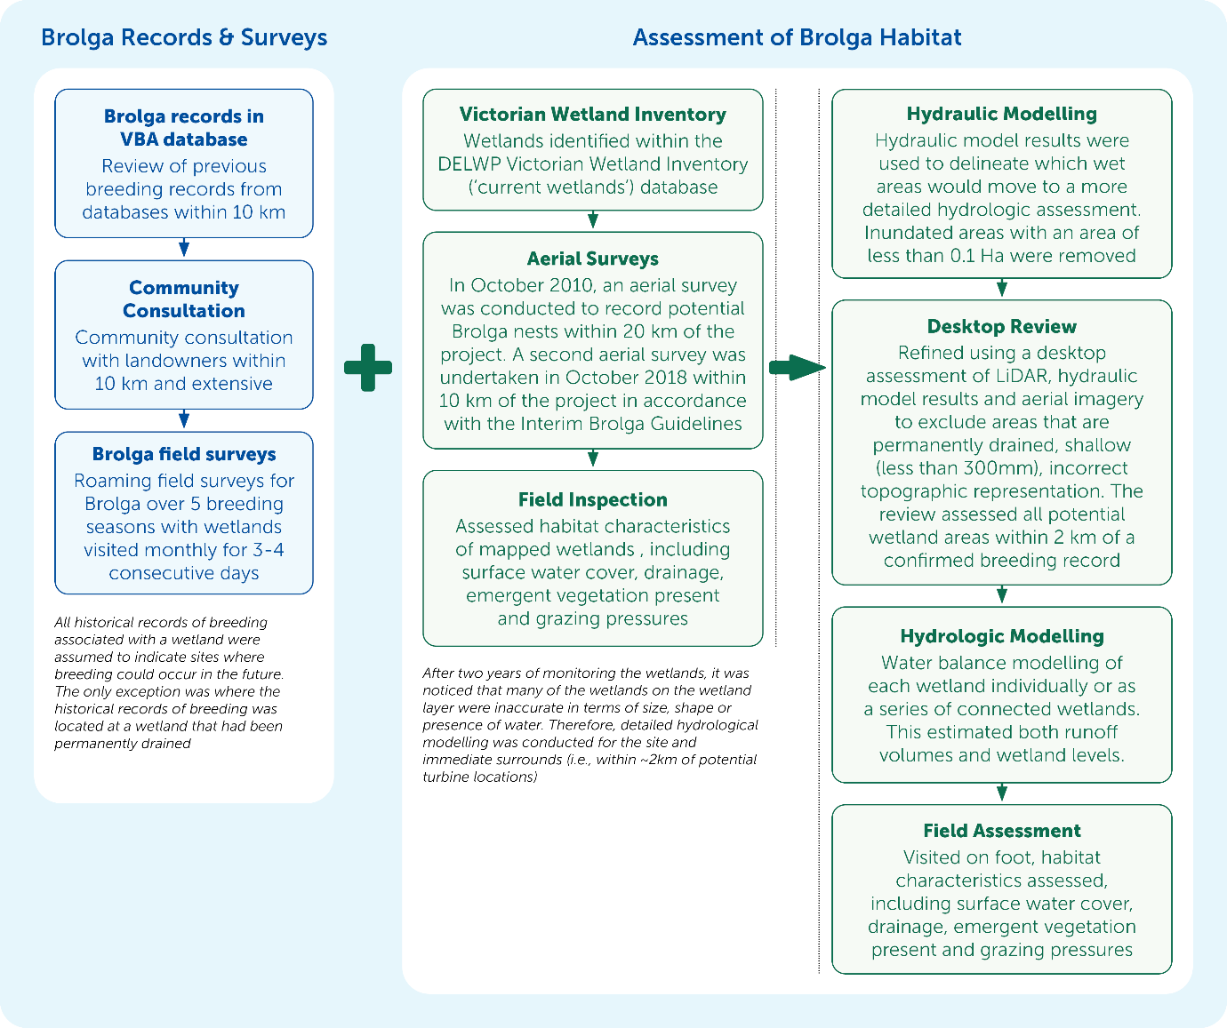
Figure 11.1 Brolga assessment methods

Existing conditions

Life history and reproduction
Brolga (Antigone rubicunda) are large, iconic wetland birds known for their elaborate courtship dance. Brolga belong to the crane family (Gruidae), of which two species (including the Brolga) occur in Australia. Adult birds range in weight between four and eight kilograms and stand up to 1.8 metres with a wingspan of 2 metres. During the non-breeding season, Brolga form large flocks occasionally as large as 200 birds but are typically in groups of around 10 to 20 individuals. Breeding pairs form long-term bonds and if one of the pair dies, the remaining individual can take several seasons to find another mate.
Brolga breed once a year and pairs typically produce one or two offspring. The Brolga’s behaviour and distribution differs between the breeding period and non-breeding or flocking period. The breeding period occurs between July to December, during the which territorial pairs nest in shallow freshwater wetlands that are often ephemeral, holding water only in winter and spring. During this period, they use stems, flowers and leaves to build nests above the water line, and this provides a food source (e.g., tubers) and habitat for vertebrate and invertebrate food sources. The non-breeding (or flocking) period is between January to June, when Brolga disperse from drying breeding wetlands to larger, often permanent wetlands to congregate with others to form flocks that roost at the wetland and move out to forage in adjacent terrestrial and wetland habitats (DSE, 2012). In between the breeding and flocking seasons, Brolga move between breeding and flocking sites or vice versa during two migration periods that can overlap with the months above.

Population size and distribution
The Brolga is not considered as a threatened species nationally, with an estimated population of between 20,000 to 100,000 birds in northern Australia (Marchant and Higgins, 1993). In Victoria, the population of Brolga has declined since European settlement because of habitat loss from agriculture and wetland drainage, predation from foxes and collisions with fences and powerlines (DuGuesclin, 2003). The Brolga is listed as endangered in Victoria under the FFG Act Threats include ongoing habitat loss, wetland drainage and alteration of flooding regimes, habitat degradation from stock grazing, and collisions with fences and powerlines. Predation on eggs and chicks by the Red Fox is also thought to be a cause of nest failure (DSE, 2003).
The most recent census of the Brolga population in southwest Victoria occurred in 2019 (SWIFFT, 2021). The population was estimated to be at least 635 individuals. This is similar to the estimate from 1984 of between 550 and 600 individuals.
The populations in Victoria and South Australia may now be isolated from the northern populations as there appear to be only scattered birds in New South Wales (DSE, 2003).
Brolgas generally return to traditional flocking sites each year, and numbers at flocking sites have declined significantly over the past century. Consistent flocking sites in southwest Victoria account for a significant proportion of the southern population. These sites include:
- The Grampians region
- Strathdownie
- Cressy
- Streatham (mainly on Lake Wongan and the Skipton area)
- Hamilton, Dunkeld and Penshurst areas
- Edenhope area
- Toolondo
- Willaura and Stavely areas
- Darlington.
A review of existing databases for records of Brolga breeding, flocking and sighting records were analysed by Nature Advisory. Information provided by local landowners and land managers (not recorded in databases) was also considered and incorporated into the assessment.
The desktop review found no historical Brolga flocking sites within 10 kilometres of the project site. Based on consultation with more than 40 landowners and representatives from Birdlife Australia, Friends of Pallisters Reserve Inc, Trust for Nature and Basalt to Bay Landcare Network, there were no reported sightings of Brolga in numbers that would indicate flocking activity within 10 kilometres of the project.
The project is located in an area of relatively few, scattered Brolga records. Higher densities of Brolga records occur to the north, northeast, northwest and to a lesser extent, west of the project (Figure 11.2).
A total of 28 Brolga breeding records were identified within 10 kilometres of the project site and 23 of these could be attributed a functioning wetland (Figure 11.3). Breeding sites documented included five locations within or nearby the Cockatoo Swamp complex adjacent to the project site, multiple locations near the Macarthur Wind Farm to the north and Pallisters Reserve to the southwest between 5 and 10 kilometres from the project site. In addition, there were records to the west of the site extending from Bessiebelle southwards, including Broadwater and Orford to St. Helens. Three records occurred to the north-east and east of the site.

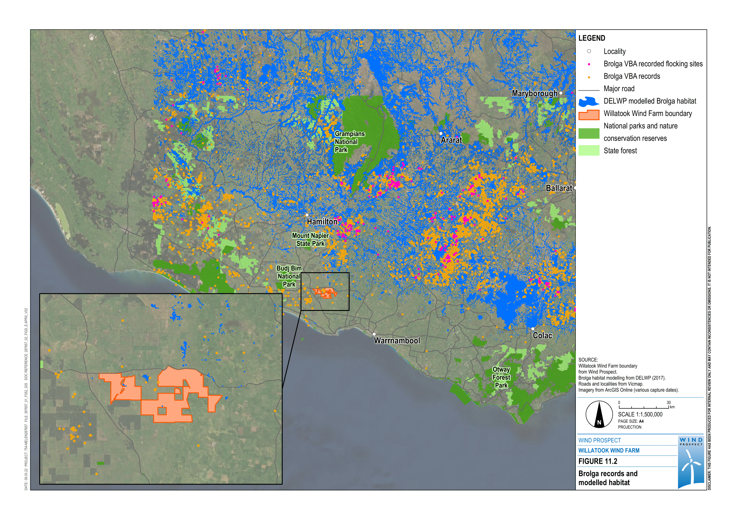
Figure 11.2 Brolga records and modelled habitat

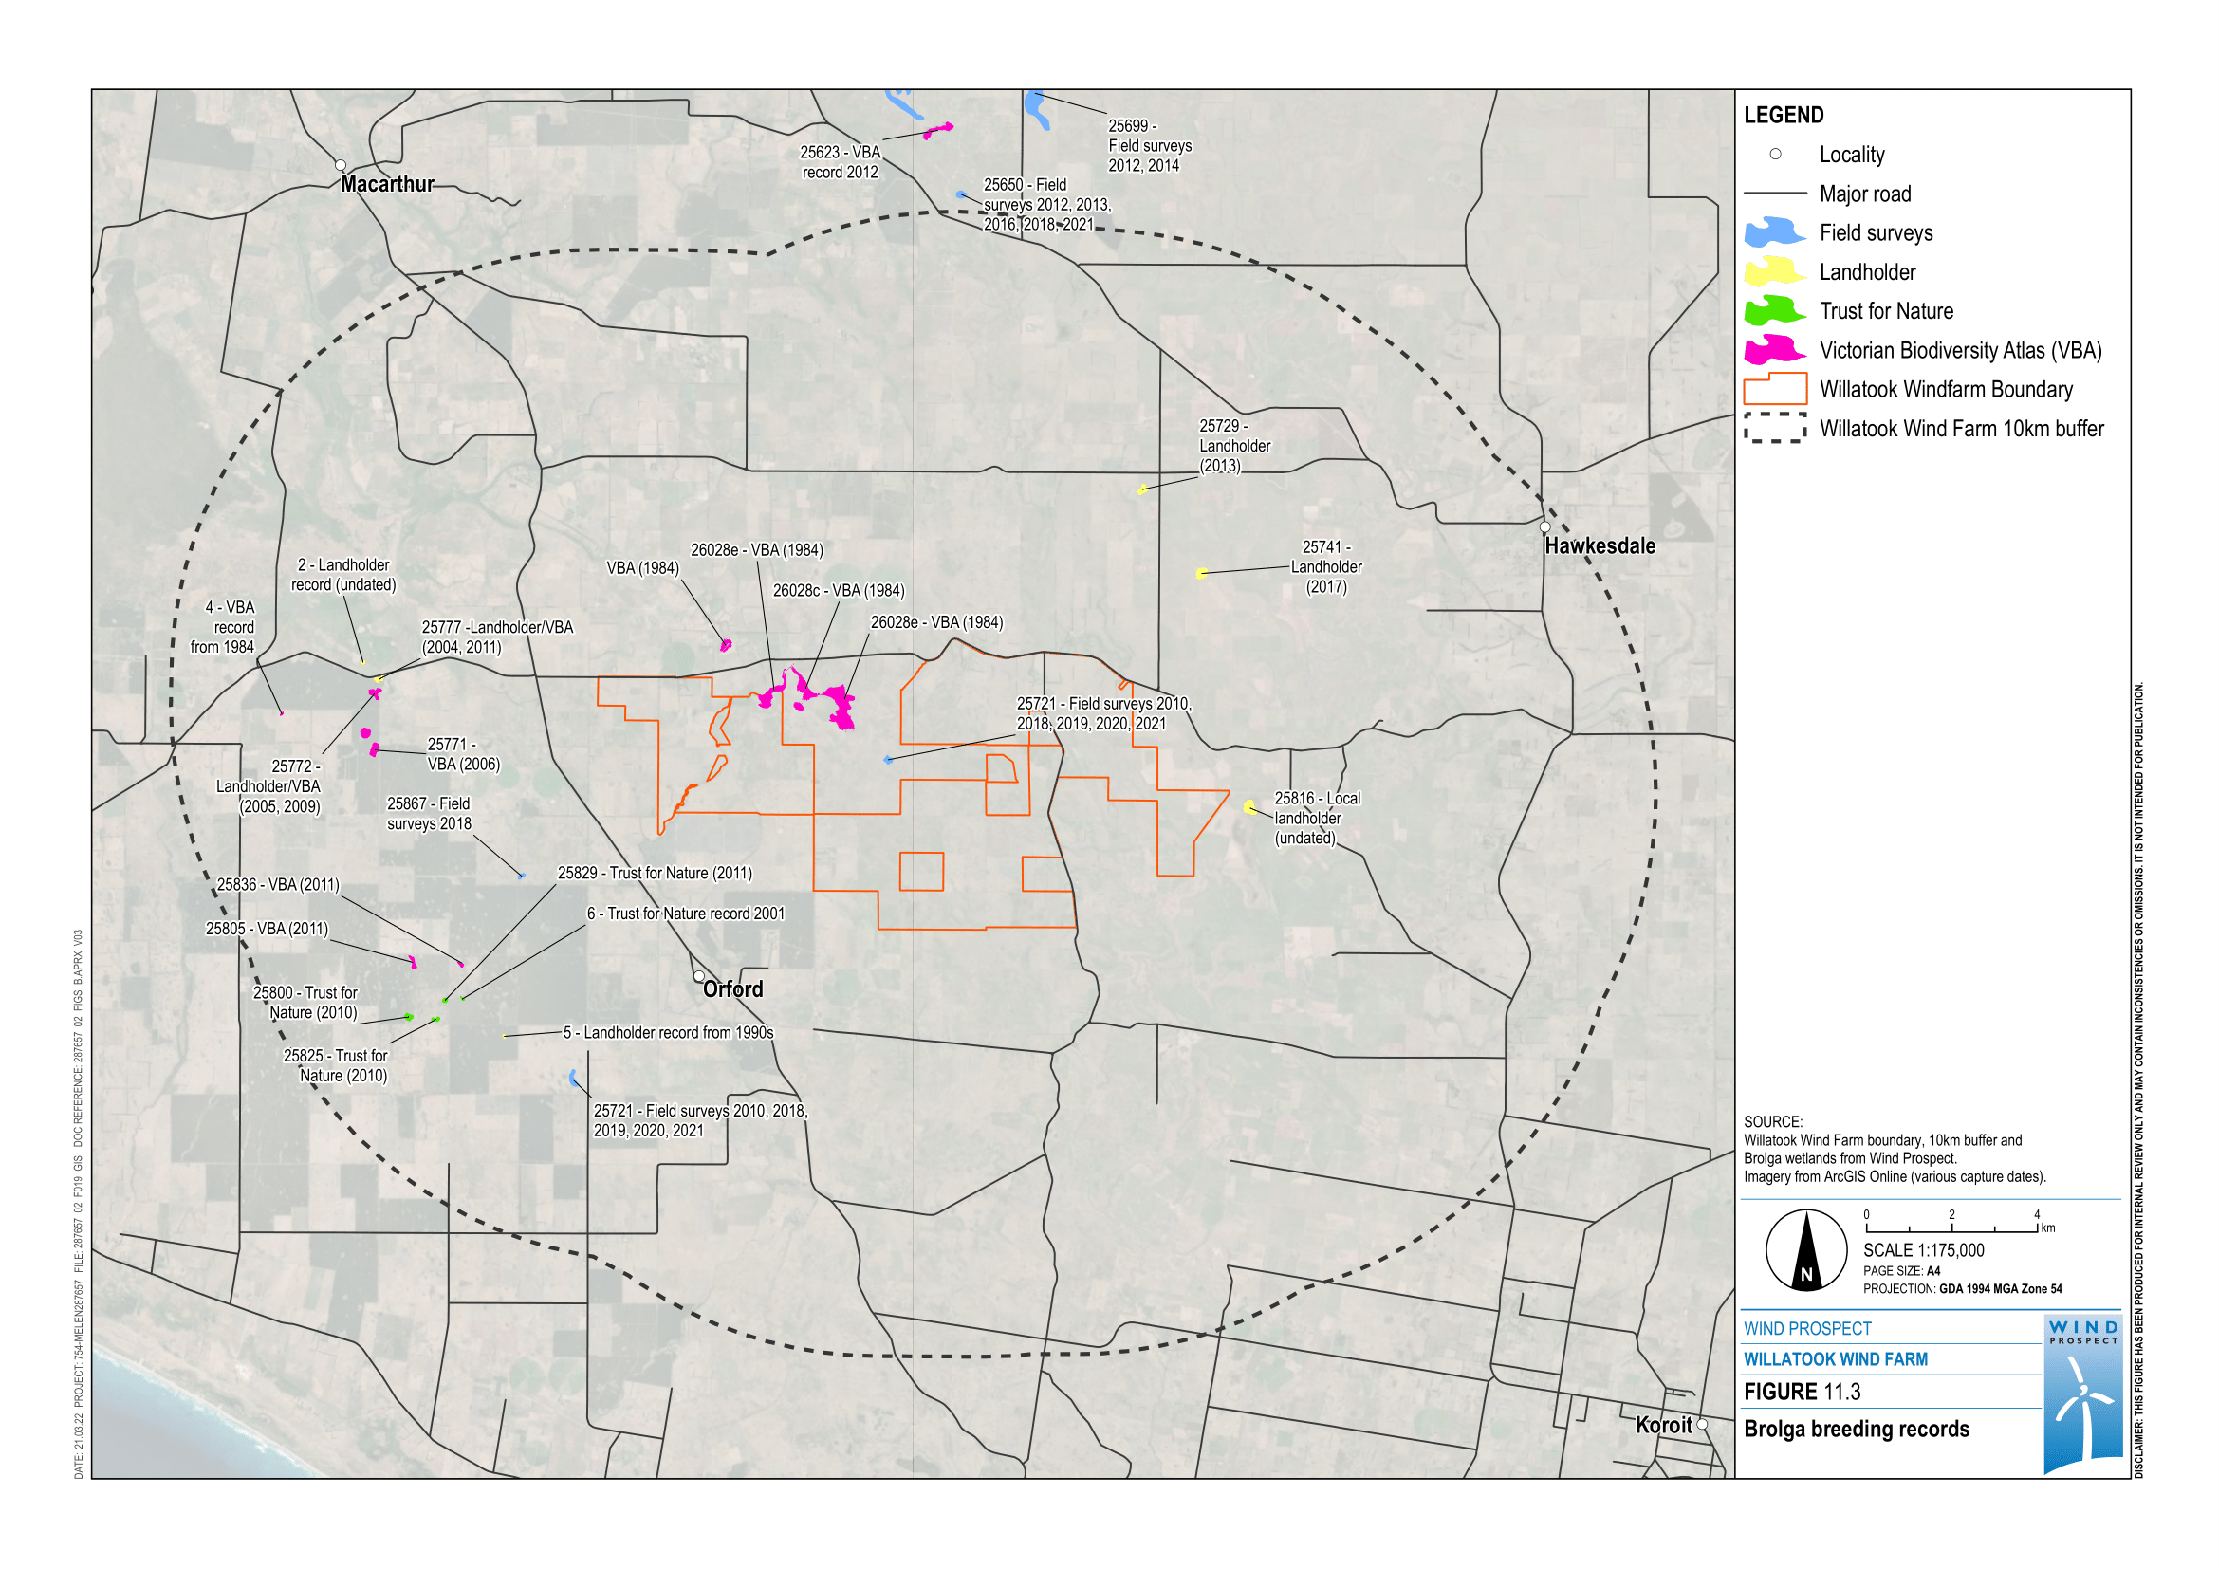
Figure 11.3 Brolga breeding records

Roaming field surveys were conducted for the project between 2010 and 2021. These observed five pairs of Brolga breeding within 10 kilometres of the project site. One pair of Brolga were repeatedly recorded nesting at one wetland within the Cockatoo Swamp complex (wetland 4; DELWP wetland 25721)
(Figure 11.5). Brolga nesting was also observed at Macarthur Wind Farm (wetland 25650), a felled plantation area (wetland 25867) and at St Helens (wetland 25894). Pairs of Brolga were also observed in the areas of Pallisters Reserve. A summary of the survey results is provided in Table 11.5.
Table 11.5 Summary of Brolga roaming surveys
Year | Field survey Brolga observations | Community observations
2009–2017 | One Brolga pair was observed nesting at wetland (wetland 4) (DELWP wetland 25721) in the Cockatoo Swamp complex in 2010. | Information provided on the location of regular Brolga sightings including observed Brolga with chicks and potential nesting wetlands along Muddy Dam Road, Broadwater.
2018 | One Brolga pair was observed nesting at wetland 4 (DELWP wetland 25721) in the Cockatoo Swamp complex. Nesting was abandoned due to the flooding of the nest.  One pair nested at Macarthur wind farm wetland 25650 and successfully raised a chick.  One pair nested at a felled Blue Gum plantation in wetland 25867 during 2018 where they successfully raised a chick. | Local landowners advised of historical Brolga breeding locations at wetland 25741 east of Nagorckas Road and wetland 2 approximately 6 kilometres west of the project site just north of the Woolsthorpe-Heywood Road.
2019 | One Brolga pair was observed nesting at wetland 4 (DELWP wetland 25721; Figure 11.4). Two chicks hatched and assumed to have fledged.  One pair observed at Macarthur wind farm wetland 25650 later in the breeding season and assumed to have nested nearby.  One pair of Brolga seen foraging at wetland 25841 near Mt Misery Road in August and November. | A pair of Brolga were regularly seen in the St. Helens area. Residents reported seeing a chick.  A pair of Brolga were seen foraging at wetlands (25784 and 25788) on Muddy Dam Road, Broadwater on two occasions.  A single Brolga was reported by a local landholder at wetland 25906 in July. No Brolga were observed here for the rest of the year.  A pair of Brolga were observed by a local landholder foraging in the floodplain of the Moyne River early in the breeding season. No breeding activity was reported.  Five Statutory Declaration were submitted in 2019. Four stated observing Brolga breeding, at wetlands 25729, 25741, 25932 and Wild Dog Swamp 25816. The fifth Statutory Declaration stated historically observing Brolga on a property previously owned within the project site.
2020 | One Brolga pair was observed nesting at wetland 4 (DELWP wetland 25721). They were observed foraging at W12w and W12e prior to nesting. Chicks hatched and assumed to have fledged. A pair was observed in the Pallisters Reserve area, although nesting was not confirmed.  A pair of Brolga with young chick observed in December in the St Helens area near wetland 25913. Breeding site was not confirmed.  A pair of Brolga were observed foraging at Wild Dog Swamp (wetland 25816) at Willatook on one occasion in 2020.  A pair was observed foraging at wetland 25797 along Muddy Dam Road in June, but no breeding activity was observed.  A pair was observed foraging at wetland 25698 along the Tarrone North Road in July, but no breeding activity observed.  A pair was observed foraging near wetland 25868 near Mt Misery Road in July, but no breeding activity observed. | Local landowners also reported a pair of Brolga foraging in the floodplain of the Moyne River south of Wild Dog Swamp prior to 2020.
2021 | One Brolga pair was observed nesting at wetland 4 (DELWP wetland 25721).  One pair observed at Macarthur wind farm wetland 25650 incubating eggs on a nest.  Brolga pair observed nesting in wetland 25894 at St Helens. | A landowner observed a pair of Brolga foraging on their property south of Riordans Road in June. This pair was likely to be the same pair breeding at Wetland W4.
Wetlands with verified breeding records were assumed to indicate future breeding wetlands. The exception to this is where wetlands did not meet suitable habitat criteria and had been drained, as identified from the high-resolution digital terrain model, hydrological modelling and verified by field visits. Two wetlands (wetland 1 and 25932) were excluded as Brolga breeding sites due to being permanently drained based on both field investigation and hydrological modelling of these sites.

Brolga habitat
Several features influence the suitability of wetland habitat for Brolga breeding. These include the:
- type and cover of vegetation and biological productivity
- hydrological features such as rainfall inflow and outflow features including deep seepage to groundwater, as well as inundation depth and duration (i.e., how long the wetland retains water)
- physical features of wetlands including the size and bank steepness.
The Victorian Brolga population occupies different habitats during the non-breeding season (January to June) and breeding season (July to December). In the non-breeding season habitat comprises deep freshwater marshes, vegetated areas in permanent open water, and feeding areas in pasture, seed and stubble crops. Since no flocking sites were assessed to occur within 10 kilometres of the project (see Appendix C1 – Brolga), the remainder of this chapter focusses on potential Brolga breeding habitats.
Suitable breeding wetlands consist of shallow freshwater marshes and meadows, with emergent vegetation that provides Brolga with vegetation with which to build a nest, and plants, amphibians, sometimes small fish, and a wide range of invertebrates on which to feed (SWIFFT, 2021). Suitable breeding habitat is dominated by aquatic vegetation including sedges, rushes, annual herbs, Tussock Grass (Poa sp.), Sweet Grass (Glyceria sp.), Spike Rush (Elocharis sp.) or Common Sword Sedge (Gahnia) (Marchant and Higgins, 1993). Brolga construct nests within the shallows of wetlands from a variety of plant matter where a platform of vegetation is constructed approximately 1.5-metre wide (White, 1987; Figure 11.5). Veltheim et al., (2019) note that individual wetland condition and quality is thus most likely to be the most important habitat feature for brolga breeding success.
Brolga require shallow wetlands to breed in water about 0.3 metres deep (e.g., see Figure 11.6). The Brolga breeding cycle involves a 30-day incubation period followed by a 95-day chick raising period. Therefore, an individual wetland needs to remain suitable for Brolga for at least 4 months to support a successful breeding attempt. This is the minimum duration required for Brolga to build a nest, lay eggs, incubate the eggs, and for chicks to grow to an age where they can walk to nearby wetlands and to avoid predation, particularly from foxes. Brolga are also unlikely to breed in drainage lines flowing into and out of wetlands as they prefer larger expanses of water to protect them from ground predators. Brolga are known to avoid flowing creeks and rivers (Veltheim et al., 2019).
Brolga are also unlikely to breed successfully in wetlands that are less than 0.6 hectares. Nature Advisory reviewed sizes of published and unpublished Brolga breeding sites and concluded that the smallest size wetland used by Brolga was 0.6 hectares used for night roosting (Veltheim et al., 2019), or 1.3 hectares for confirmed breeding (Sheldon, 2005).
Veltheim et al., (2019) identified that wetlands also act as night roosts, particularly once the adults and chicks have left the nest. These wetlands may or may not have been where the nest was originally constructed. Once nests are not used, these night roosts become the focus of activity for Brolga families.
Figure 11.4  Wetland 4 with nesting Brolgas and Black Swans with the Tarrone Terminal Station in background | 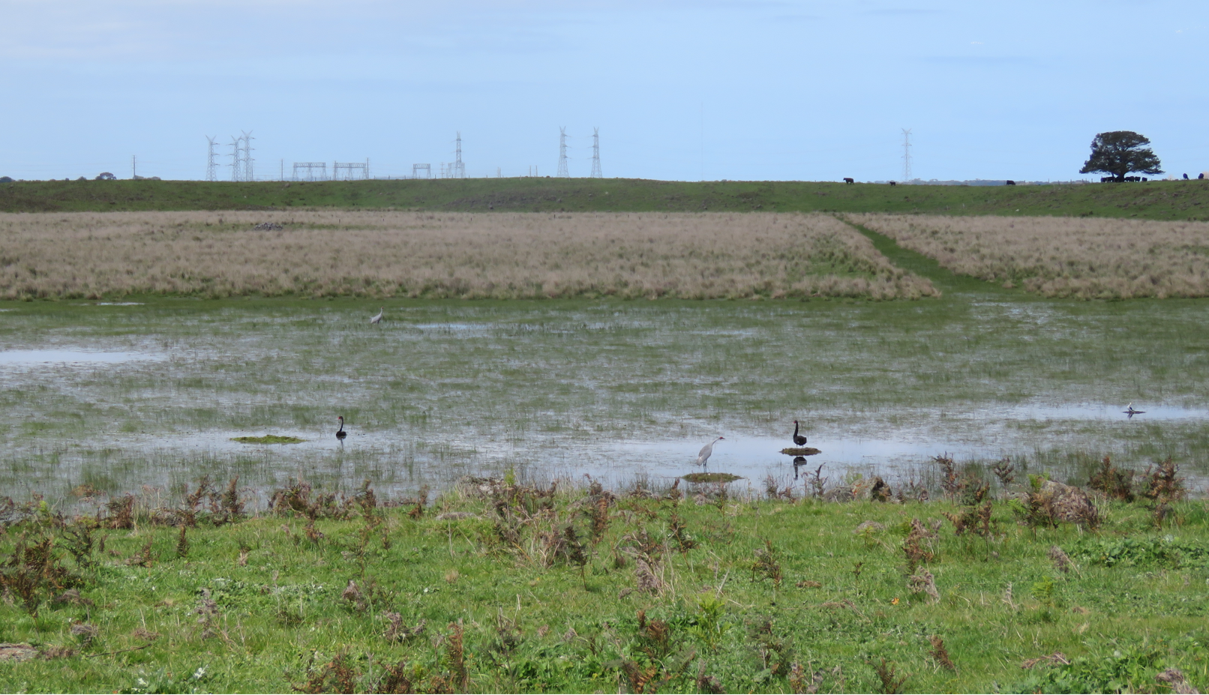
Figure 11.5  Nesting Brolga | 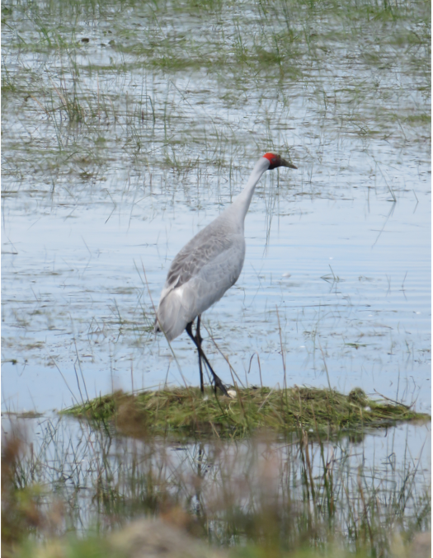
Figure 11.6  Aerial photograph of seasonal wetland in the Cockatoo Swamp complex | 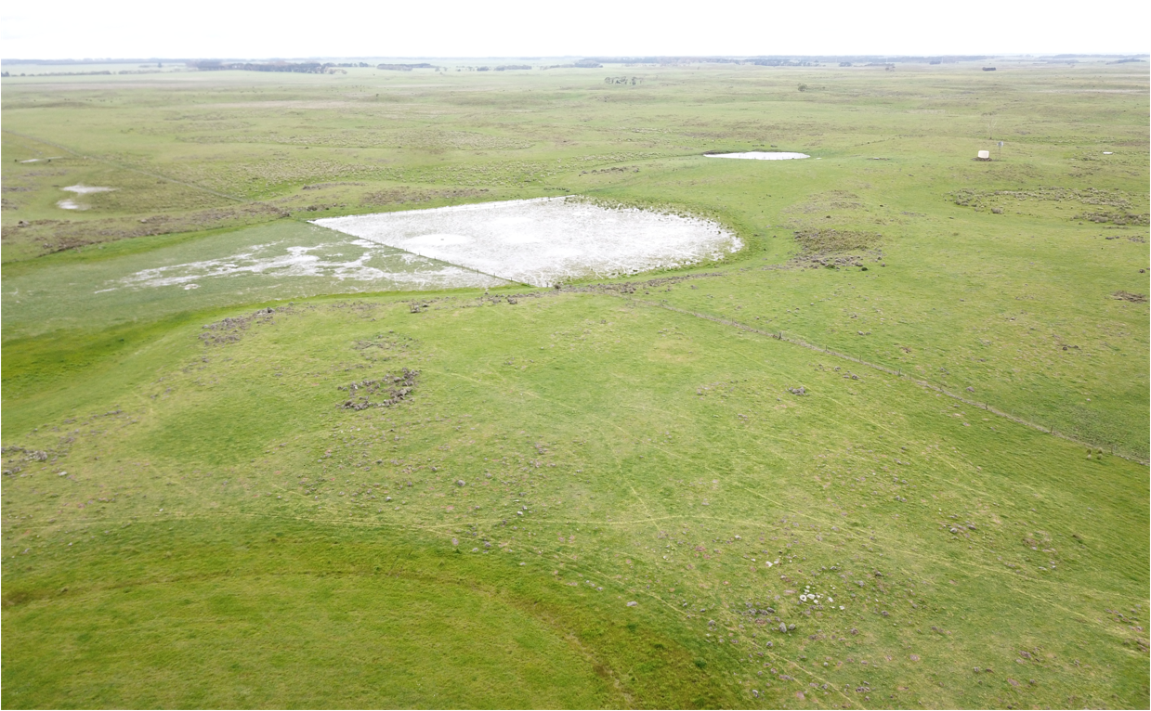
As described in Section 11.4.2, a variety of methods were used to accurately identify potential Brolga breeding and roosting habitat. Methods included examination of current and historical Brolga records, consultation with landowners and land managers, repeated field and aerial surveys for Brolga and potential wetland habitat, and specialised hydrological modelling.

Assessment Brolga habitat suitability using the Victorian Wetland Inventory
A total of 335 wetlands identified within the DELWP Victorian Wetland Inventory wetlands (‘current wetlands’) that are within 10 kilometres of the project site were assessed by Nature Advisory. Each of these wetlands were assessed for their suitability to support Brolga reproduction, focussing on vegetation presence, physical attributes (e.g., size, depth and steepness of banks) and their condition. Most (67.5%) of these wetlands were found to be unsuitable for breeding due to changes in hydrological regimes (i.e., they were drained and converted for agricultural use) or due to inaccurate wetland mapping by DELWP. A total of 109 wetlands (32.5%) were found to be functional hydrologically and had not been permanently drained, however, this did not consider the inundation period or depth, which are important determinants for Brolga breeding.

Refinement of potential Brolga breeding habitat using hydrological and field investigations
To predict potential Brolga breeding habitat more accurately, hydrology investigations were undertaken to develop a surface water model that accurately determines which wetlands can hold water at least once every ten years for 120–days or more, which is what the Brolga requires to breed successfully.
Hydraulic modelling simulated runoff generated from local rainfall and site topography. Modelling used high-resolution topographic mapping (LIDAR) and rainfall data from the past decade. This produced data on how wetlands and other depressions are filled, their maximum size and interconnectivity. The results were then used to remove potential wetlands that did not meet other Brolga breeding habitat requirements (e.g., wetlands had been permanently drained or were too small). The remaining wetland areas then underwent a more detailed hydrological assessment, which involved water balance modelling of each wetland individually or as a series of connected wetlands. This estimated both runoff volumes and wetland water levels.
Water levels for each wetland were modelled using a representative rainfall dataset from 2009 to 2019 to identify wetlands that met the inundation criteria for Brolga breeding and night roosting suitability. The assessment found that 17 wetlands met the inundation criteria (wetland 12/26028 was considered as a single wetland in this assessment) (see Figure 11.7).
Further ecological field surveys of these wetlands and farm dams were completed to assess other features that are known to be of importance to Brolga, including wetland size and the presence of aquatic or semi aquatic vegetation. Six wetlands (and 35 farm dams) were excluded because of their size (being less than 0.6 hectares), lack of suitable vegetation cover or in the case of farm dams their physical properties. Of the 38 farm dams and 17 wetlands that were assessed, three farm dams and 11 wetlands were assessed to provide suitable habitat for Brolga breeding or foraging based on the hydrological modelling and field assessments. These sites were defined as functional wetlands.
Functional wetlands were considered potential sources of food and habitat for the duration of Brolga breeding and chick rearing and are therefore likely to form part of the home range around the breeding wetland. Such wetlands were more likely than others to support a productive wetland ecosystem as post-filling ecological succession progresses through winter and spring, producing increased emergent plant and algal cover and associated fauna populations, including frogs (Appendix C1 – Brolga). Combined with their duration, these wetlands would therefore be disproportionately important sources of food and potentially alternate night time roosts as they are more likely to hold water.

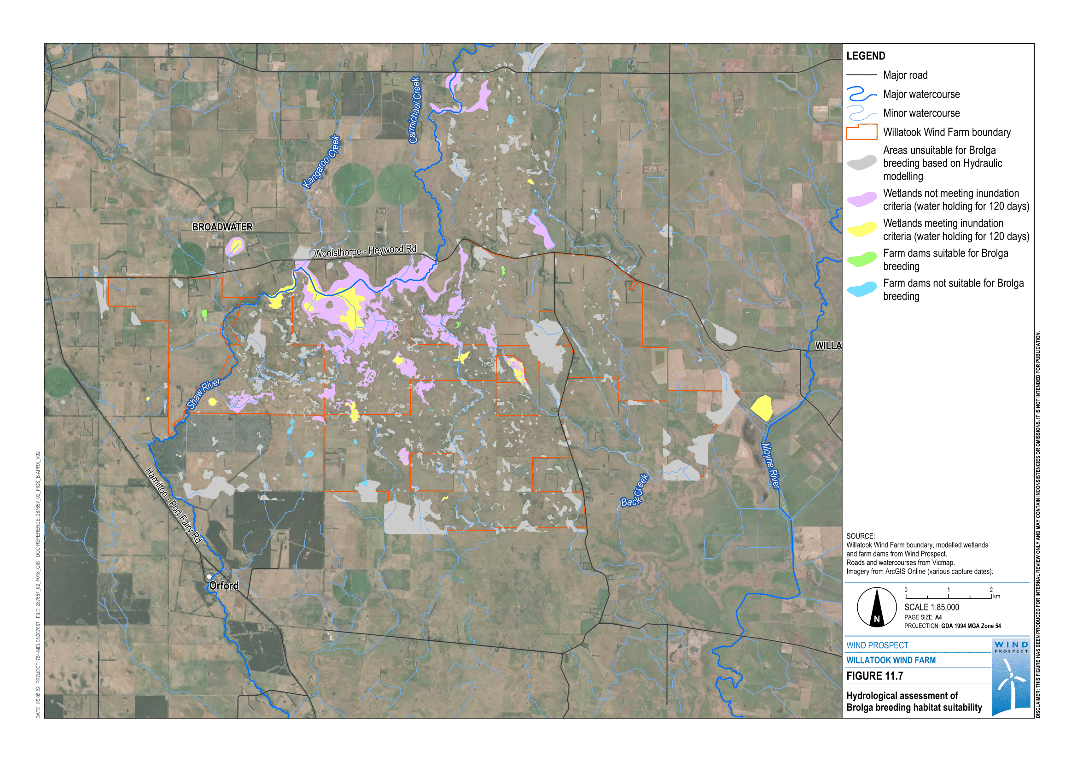
Figure 11.7 Hydrological assessment of Brolga breeding habitat suitability

Combining wetland assessments with records of Brolga breeding
Two types of habitats were defined based on the modelling undertaken and information collected or collated:
- Brolga breeding wetland that has had Brolga breeding either during the current investigations or in the past and is considered likely to provide Brolga breeding habitat in the future
- functional wetlands that are considered to provide Brolga breeding habitat in the future based on defined wetland criteria, but which do not have a breeding record.
A total of 28 sites associated with Brolga breeding records within the investigation area (i.e., around 10 kilometres from the site) were identified as possible breeding sites based on the review of previous breeding records from databases, community consultations and field surveys. Of these 23 were attributed to a functional wetland. All historical records of breeding associated with a wetland were assumed to indicate sites where breeding could occur in the future. The only exception was where a historical record of breeding was located at a wetland that had been permanently drained as demonstrated through hydrological modelling and/or field assessment. Six of these sites are within three kilometres of proposed wind turbines with five within an area described as the Cockatoo Swamp complex. Due to its large size and shape, wetland 12 (DELWP wetland 26028) was divided into three individual wetlands, W12w (western), W12c (central), and W12e (eastern). A further breeding wetland (25816) is situated to the east of the project.
Based on the wetland assessments (both hydrological modelling and field assessments) 11 seasonal wetland areas and 3 farm dams within 3 kilometres of the project were assessed to be suitable Brolga habitat, including the six sites defined as Brolga breeding wetlands. The remaining five wetlands and three farm dams met the Brolga wetland habitat criteria but have no previous breeding record associated with them, including when they have been suitable in the last 10 years of targeted project-related field surveys of the species.

Flight behaviour and movements
The behaviour of Brolga and how they move in the environment is important in predicting potential impacts from the project. Flight behaviour and movement data of nesting Brolga were recorded during the 2018 field surveys to gather site-specific data. However, due to only one breeding pair being located during this time, a statistically robust dataset could not be collected.
Flight behaviour data of Brolga has been gathered by Nature Advisory over a period of 15 years in southwest Victoria. Monitoring included observations of 24 breeding Brolga pairs taking 163 flights. For each breeding pair there was at least one12-hour period of continuous observation and three separate four hour observation periods. This mix of observation periods aimed to gather representative data on Brolga flights from breeding wetlands. Data was collected on:
- time spent in the breeding wetland
- flight times (outward and return)
- height flown
- distance flown
- destination habitat.
This data set was used to inform collision risk modelling and in particular the distance that Brolgas fly from breeding wetlands.
Monitoring found that 54% of Brolga flights were within 400 metres, 71% within 800 metres, and 86% within 1,600 metres of the breeding wetland. The remaining flights (14%) were between 1,600 and 3,200 metres. The distribution of flights by distance is shown in Figure 11.8.
Estimates of maximum flight heights were also recorded. These showed that approximately 50% of Brolga flights during the breeding season were 10 metres or less. Approximately 70% of Brolga flights during this period were 20 metres or less and 91% were 30 metres or less. Remaining flights were at or above 40 metres in height (Figure 11.9).
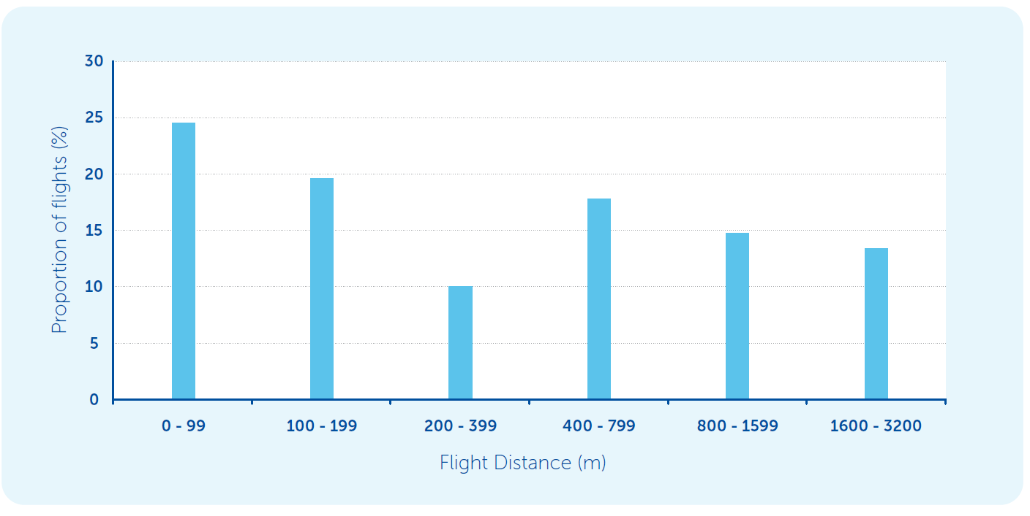
Figure 11.8 Flight distances from Brolga nest
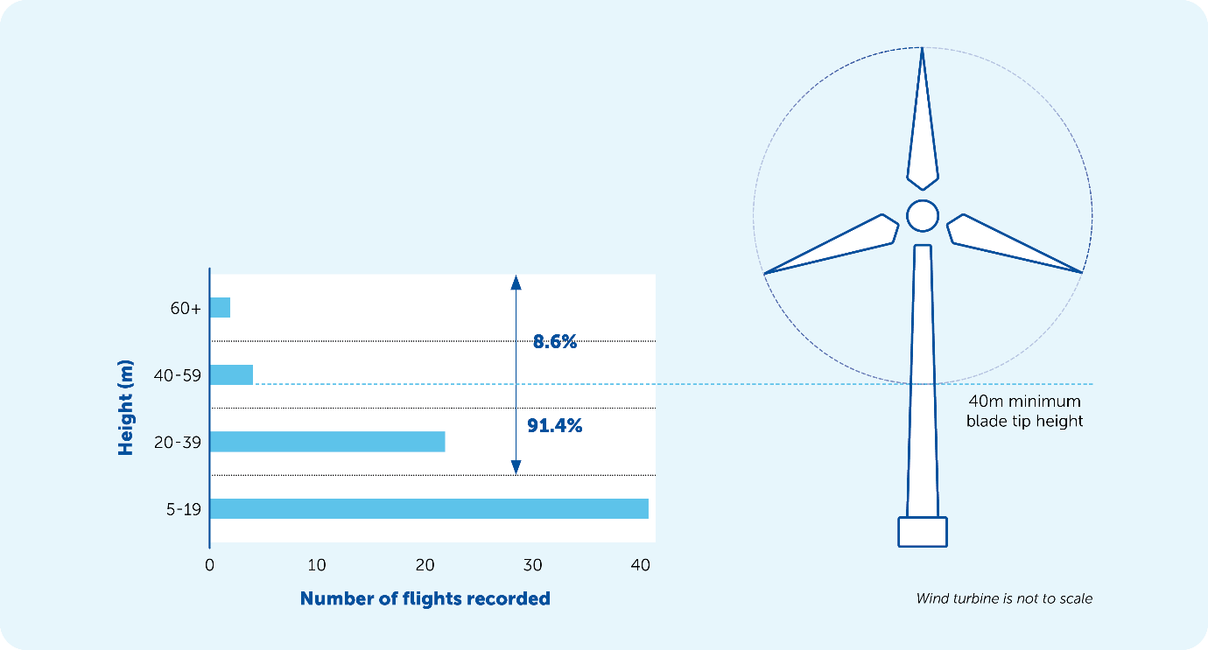
Figure 11.9 Brolga flight observations
Nature Advisory also recorded the habitat where Brolgas landed. This showed that Brolgas had no preference for a particular habitat when flying up to 400 metres from their breeding site. However, where Brolgas flew more than 400 metres from the breeding wetland the Brolga were significantly more likely to fly to a neighbouring wetland compared to other non-wetland habitats (e.g., pasture, grassland etc) (Appendix C1 – Brolga). The preference became stronger with increasing distance from the breeding site. Nature Advisory concluded that during the breeding season, Brolgas spend the majority of time foraging within the nesting site wetland and the immediately adjacent pasture. The longer distance flights observed of more than 400 metres showed a preference for wetland habitat.
Home range is a biological concept the area in which an animal lives and moves in space and time. Home ranges can be predicted using a number of statistical methods such as utilisation distributions.
Utilisation distribution is estimated from data sampling the location of an individual or individuals in space over a period of time using, for example, GPS tracking methods. It results in a probability distribution that an animal is found at a given point in space.
The spatial distribution and home ranges of Brolga was recently investigated by Veltheim et al. (2019). GPS transmitters were fitted to eleven pre-fledged Brolga chicks at breeding sites in Victoria. Brolga families roost and forage together, so the data were considered representative of the adult breeding pair and chick movements (on the ground). Satellite tags recorded four GPS fixes per day: morning (8:00), midday (12:00), late afternoon (16:00) and evening (23:00). It is important to note that this research is based on the location of Brolga chicks, which are largely ground based until they are close to fledging age.
Veltheim et al. (2019) found that Brolgas used either single or multiple wetlands depending on the habitat available. Those birds using multiple wetlands either switched between them or relocated permanently. Brolga chicks moved on average 442 metres to and from night roost wetlands measured as a radius from the roost site within the wetland (range: 0 to 1,964 m). The mean breeding home range calculated as the 95% utilisation distribution was 232 hectares, but this varied between from 70 hectares to 523 hectares.

Impact assessment

Impact pathways

Construction impact pathways
Construction impact pathways can be grouped into three types:
- direct habitat loss from vegetation clearance, earthworks and physical disturbance
- habitat degradation from direct and indirect pathways including surface water changes and groundwater drawdown
- disturbance (through project-related activity such as noise, vibration and lighting) disrupting the behaviour of fauna and potentially reducing reproductive success.
The project will result in physical disturbance that includes vegetation clearance, excavation, trenching and earthworks such as stockpiling, or cut-and-fill material movements required to construct project infrastructure. Physical disturbance will mostly occur during construction, although physical disturbance is also expected during decommissioning.
Wind farms are constructed progressively so construction activities in any location would be temporary. These activities would occur over several weeks with the exception of the quarry, substation and battery areas, concrete batching plants, and construction site compounds, which would experience regular activity over the construction phase.
During wind farm construction there will be heavy vehicle movements and activity, as well as human activity on the site, resulting in noise. There will also be noise from the operation of the on-site quarry, including blasting about twice a month. This noise and vibration have the potential to disturb breeding Brolga.
The construction of roads and larger infrastructure has the potential to alter existing drainage patterns if not accounted for during design. Prolonged changes to drainage patterns can lead to permanent changes to vegetation structure. Hydrological effects have the potential to occur over a large area, due to the nature of the shallow topographical relief of floodplain systems.

Operational impact pathways
Once the wind farm is operating the impacts to Brolga mostly relate to the interaction with wind turbines. The most obvious impact is due to death via collision with turning blades. Other causes include collision with stationary infrastructure such as transmission lines.
In addition to direct collision risk, Brolgas may modify their behaviour in response to the presence of the wind farm. They may be reluctant to fly through or over the wind farm (known as the ‘barrier effect’) or they may avoid areas adjacent to the turbines (called ‘alienation’). Either or both may restrict access to existing habitats. Other disturbance, such as human activity or vehicle/machinery movements during project operation, could impact on Brolga activity.
To date there have not been any Brolga collisions with wind turbines reported in Victoria. For example, Moloney et al., (2019) reviewed mortality records of birds at 15 Victorian wind farms between February 2003 and February 2018. They recorded at least 58 species of birds that had been killed by turbine collisions, but there were no records of Brolga. Brolga collisions with powerlines have been reported in Victoria (Goldstraw and Du Guesclin, 1991; Herring, 2005). While wind turbines have not been shown to be a key threat to the Victorian Brolga population, the Interim Brolga Guidelines (DSE, 2012) notes that Brolga may be vulnerable to collision due to their large size and relatively low aerial mobility.
Information on the impacts of wind turbines on Brolga behaviour is provided in Wood (2014, 2017), Veltheim et al. (2019) and in the Brolga assessment (Appendix C1). Nature Advisory surveys in 2018, 2019 and 2021 recorded nesting Brolgas at the Macarthur Wind Farm at wetland 25640, which is approximately 7 kilometres north of the project site. The same nest, and presumably the same pair, were again observed in all three years breeding within 400 metres of operating wind turbines. During the 2018 breeding season Nature Advisory monitored the adult pair and plotted their location as they moved across their home range. The pair were observed as close as 150 metres from the base of operating turbines (see Figure 11.10).
Similar behaviours were observed from the Veltheim et al. (2019) study, that the pair foraged close to the breeding wetland early in the breeding season and later moved further distances to the north-west later in the breeding season. At another wetland adjacent to the Macarthur wind farm, a pair of Brolga were observed breeding at this wetland in 2013 and 2014 (Wood, 2014). This wetland has six turbines surrounding it and are located between 50 and 420 metres from the edge of the wetland. Observations were made in 2014 and the Brolga were observed foraging within as close as 50 metres from a turbine in the 2014 breeding season (Wood 2014) and within 90 metres of a turbine during the 2016 breeding season (Wood, 2017). This indicates that at the Macarthur Wind Farm, Brolga have bred, sometimes successfully raising chicks, within 400 metres of operating turbines for at least six out of the last ten years and that they will forage consistently within 100 metres of the base of operating turbines (Wood, 2014 and 2017, Appendix C1). Wood (2014, 2017) also observed Brolga flying low directly under an operating turbine on at least two occasions. Further observations were made by Biosis (2020) who monitored Brolga at the Morton’s Lane Wind Farm in 2013, 2014, 2015 and 2019. Observations of Brolgas since that wind farm became operational were of single birds within or adjacent to the wind farm in the spring of most years. They concluded that there was no evidence of any detrimental effect on the local population of Brolgas at that wind farm.

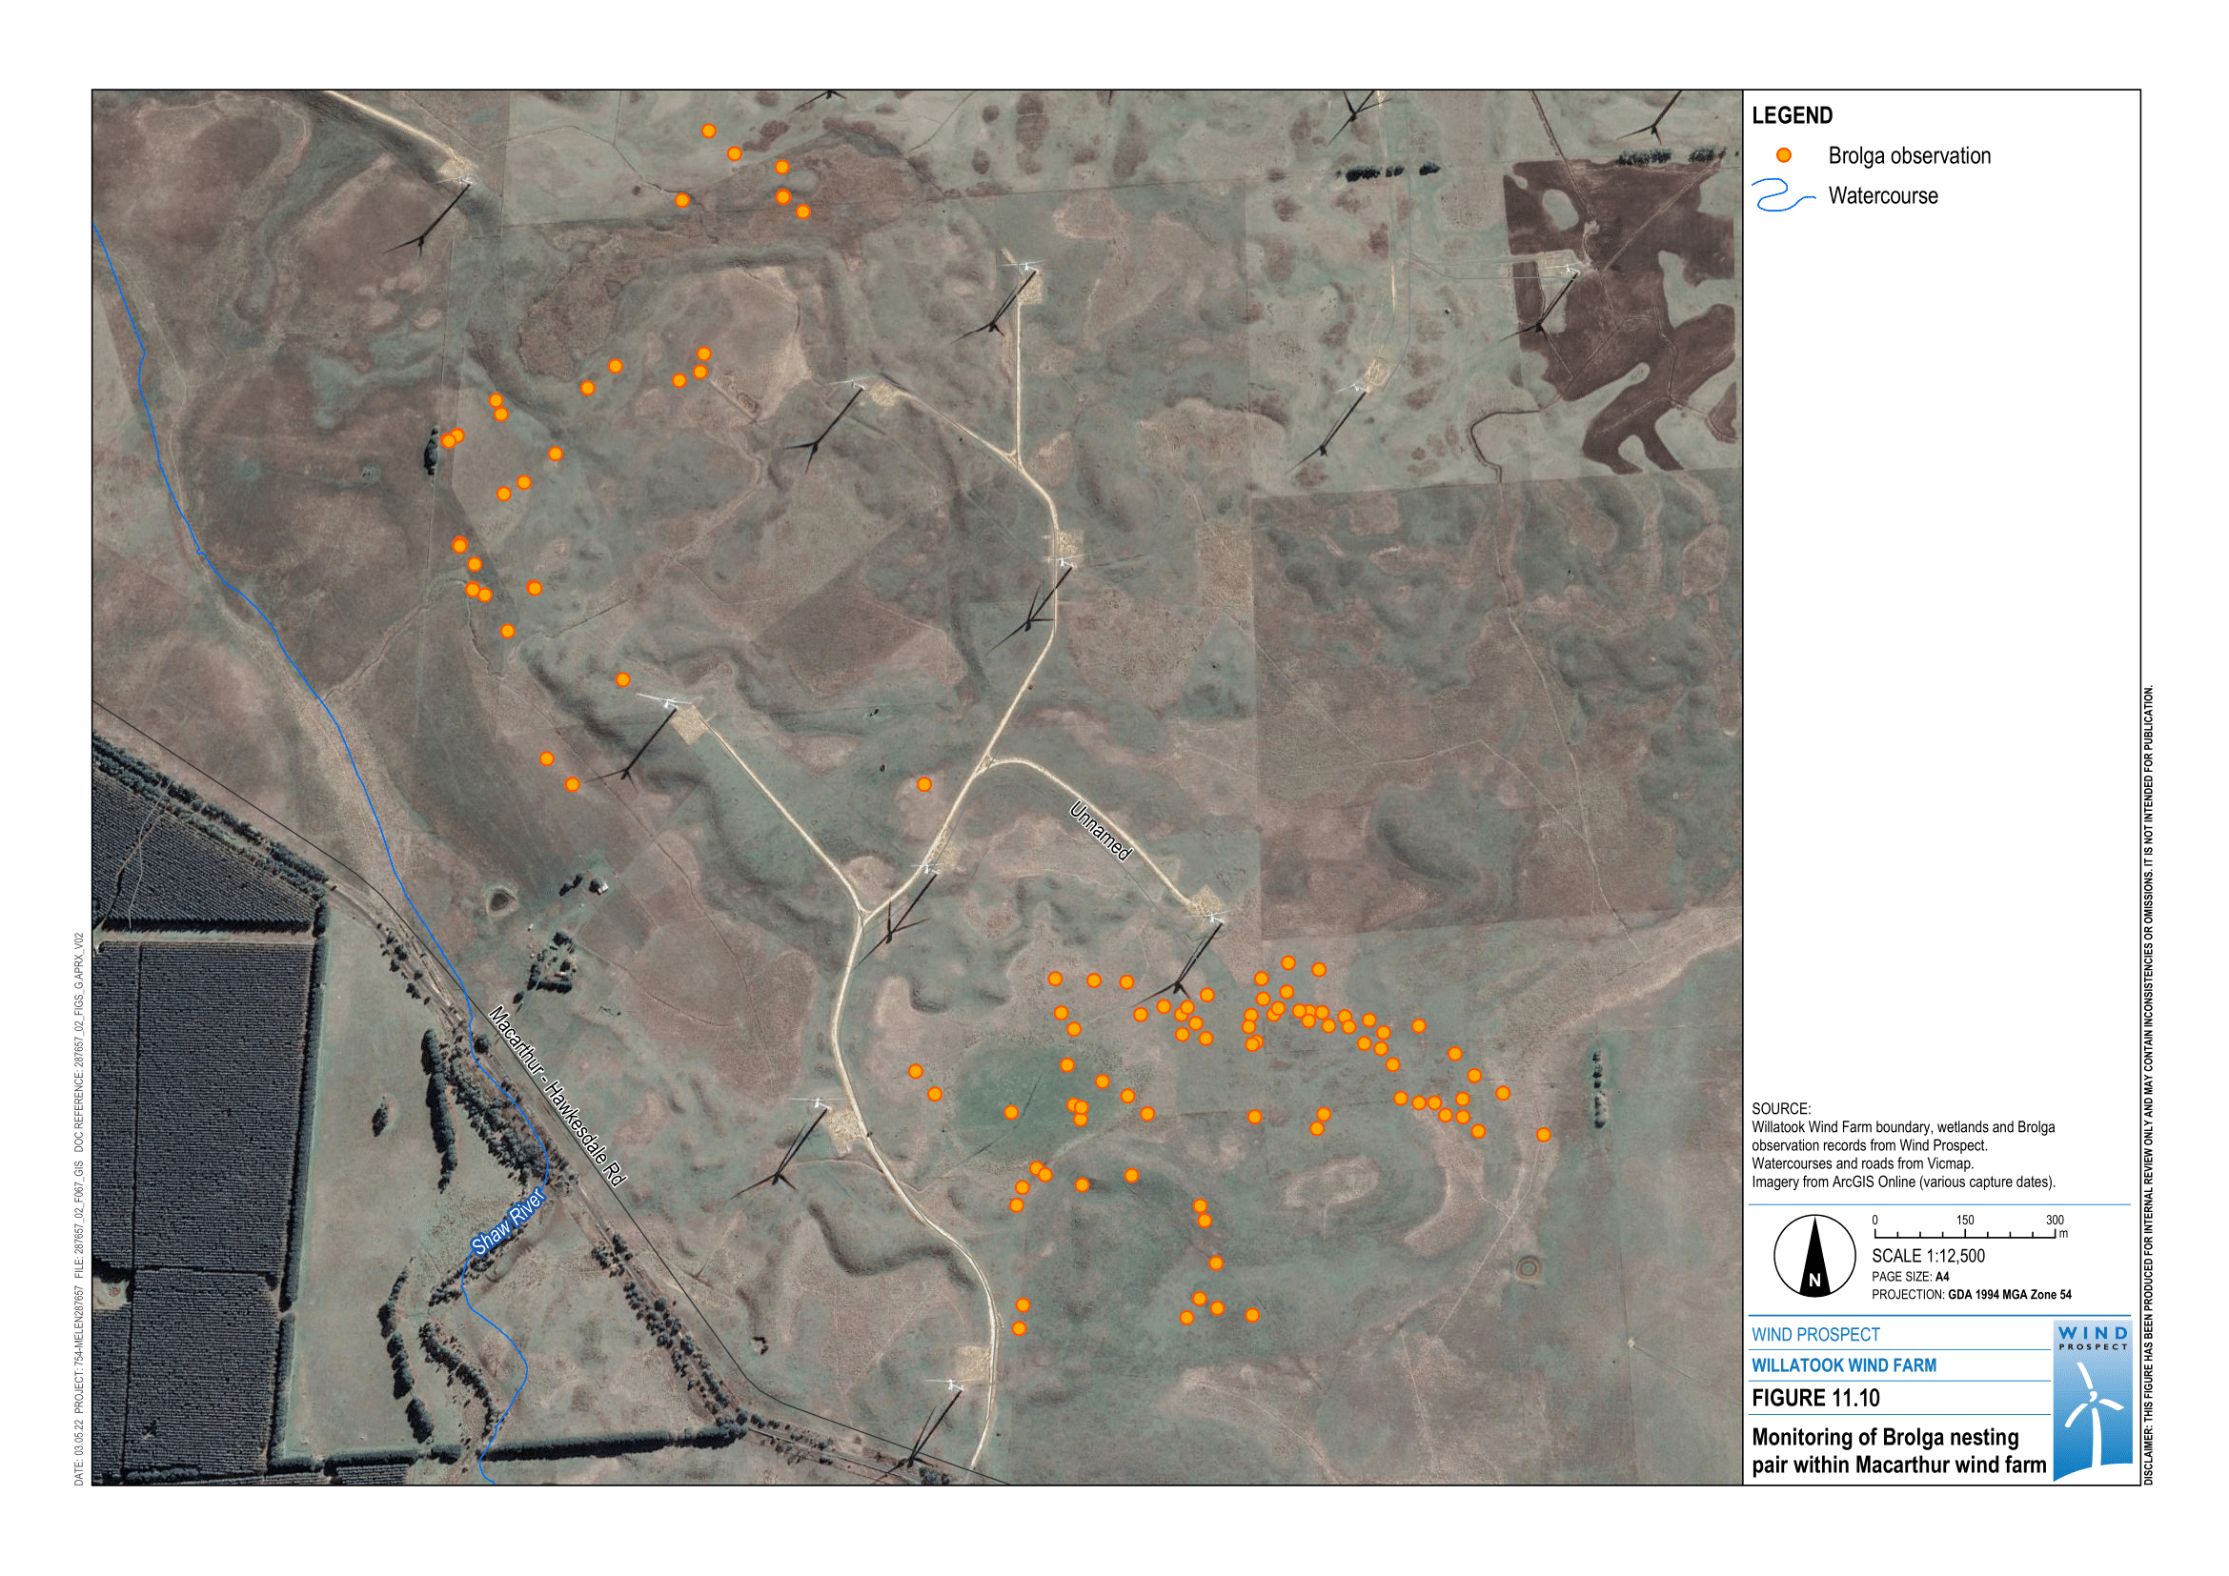
Figure 11.10 Monitoring of Brolga nesting pair within the Macarthur Wind Farm

In the absence of extensive and replicated observations on the interactions of flying Brolga with wind turbines, international research from closely related species was considered. The Brolga belongs to the crane family and wind turbine interactions have been observed for two other crane species: the European Common Crane (Grus grus) and the North American Sandhill Crane (G. canadensis).
Navarette and Griffis-Kyle (2016) documented two observed collisions of Sandhill Cranes with wind turbines. However, despite collisions being recorded there is extensive evidence that cranes will actively avoid colliding with operating wind turbines. For example, Nagy et al., (2013) documented 11,330 observed Sandhill Crane flights over, around and through an array of ten turbines in South Dakota with no collisions. Similarly, Derby et al., (2013) documented 26,468 Sandhill Crane flights during operation of five wind farms (with a total of 319 turbines) and found no crane collisions with wind turbines.

Decommissioning impact pathways
The eventual decommissioning of the project will involve the removal of wind farm infrastructure. During this process there are potential disturbance impacts because of noise, traffic and human presence, particularly during the breeding season. Activity associated with decommissioning is much less then that required during construction.

Design mitigation
In accordance with the Interim Brolga Guidelines, the mitigation hierarchy was adopted whereby:
- avoidance measures have been taken to avoid impacts, primarily through the development of turbine free buffers
- minimisation measures have been implemented to reduce the duration, intensity and/or extent of impacts that cannot be completely avoided, as far as is practically feasible, including committing to a 40-metre minimum blade height and limiting overhead transmission lines to the minimum required
- offset measures are taken to compensate for any residual, adverse impacts that cannot be avoided, minimised and/or rehabilitated or restored, in order to achieve no net loss or preferably a net gain of the Brolga population.
Early in the project’s development, a preliminary 1 kilometre buffer was adopted around Brolga breeding database locations within the original project site. Through the application of turbine free buffers described below, 23 wind turbines were removed or moved from the original project design near potential Brolga breeding wetlands.

Turbine free buffers
The main mitigation implemented during the project design to avoid or minimise impacts to the Victorian Brolga population has been the development of turbine free buffers around Brolga wetland habitat.
The turbine free buffer areas were designed to limit impacts to Brolga during construction (i.e., habitat destruction and/or disturbance) and operation (i.e., collision with wind turbines). Project-specific Brolga buffers were developed based on:
- extensive field surveys of the project site and surrounding areas
- consultation with landowners, land managers and special interest groups
- understanding of Brolga movements around breeding sites from observational studies by Nature Advisory over the last 15 years
- observations of the movements of Brolga breeding at the Macarthur Wind Farm since 2012
- the recent Brolga research undertaken by Veltheim et al. (2019).
The turbine free buffers proposed were developed by experienced consultants based on methods adopted at three wind farm projects in southwestern Victoria that have been issued with planning permits: Golden Plains, Dundonnell and Stockyard Hill. These methods were updated to reflect the research published by Dr Inka Veltheim (Veltheim et al. 2019) as well as incorporation of hydrological modelling to define suitable Brolga breeding sites and functional wetlands.
Turbine free buffers developed for the project consider three key habitats:
- seasonal wetlands used for the breeding (nesting and egg incubation), night roosting and foraging
- non-wetland areas around functional wetlands used for foraging and breeding
- movement corridors between breeding site wetlands and other functional wetlands.
Based on the satellite tracking of Brolga chicks, Veltheim et al. (2019) concluded that the most important consideration for breeding site protection and enhancement at wind farms was the inclusion of multiple wetlands within breeding home ranges within the turbine free buffers. They note that both breeding wetlands (including night roosts) and non-wetland habitat should be incorporated into turbine-free buffers enabling barrier-free movement between wetlands and non-wetland foraging areas.
Veltheim et al. (2019) concluded that a distance of 2,000 metres encompasses additional foraging habitat and movement corridors within the 95% utilisation distribution (i.e., a 95% probability that an animal is found at a given point in space based on a statistical model). Five seasonal wetland areas in proximity to the project are within 2,000 metres of each other and were therefore defined as the wetland complex.
Wetland 25816 is more than 2,000 metres from any other defined breeding wetlands and therefore does not form of a complex wetland. Considering this wetland is located more than 1.8 kilometres from the closest proposed wind turbine location and risks to Brolga nesting in this location are assessed to be low, further buffering of this wetland was not considered necessary.

Defining turbine free buffers
The following steps were completed to develop the Cockatoo Swamp complex turbine free buffer.
Based on the findings of Veltheim et al. (2019), all functional wetlands within two kilometres of confirmed breeding wetlands, were included in the initial home range. This was considered the most likely area in which nesting Brolga would move to forage or roost. Areas still functioning as wetlands (holding water for at least 120 days) can provide additional foraging areas for Brolga away from their breeding wetland. Brolga will move out to these wetlands particularly when young Brolga are getting larger and can move greater distances, and when resources at their breeding wetland become depleted.
The greatest risk to Brolga from wind farms is collision with turbines, which happens when Brolga are flying. To provide for Brolga movements around each functional wetland, a 400-metre buffer is provided that encompasses the majority of Brolga flights from nesting wetlands based on Nature Advisory movement data (also used for Brolga buffers of the Dundonnell and Golden Plains wind farms). Flight observations by Nature Advisory showed that Brolgas showed no preference for a particular habitat when flying up to 400 metres from their breeding site (see Section 11.5.4). For flights beyond 400 metres from the breeding site the Brolga showed a preference for wetland areas compared to other habitat (Appendix C1 – Brolga). The preference for wetland flight destinations became stronger with increasing distance from the breeding site.
To protect movement corridors for Brolga between each of the breeding wetlands and other functional wetlands, a home range boundary was drawn between the outer extent of each of the 400 metre buffer areas around functional wetlands within the Cockatoo Swamp wetland complex (see Figure 11.11). Home ranges encompass the zones between these buffered areas for wetlands that are 2,000 metres or less apart. This resulted in five overlapping home ranges of between 721 to 942 hectares as shown in Figure 11.12. These home range are between 28 to 45% larger than the largest Brolga breeding home range calculated by Veltheim et al. (2019), which was 523 hectares, and more than three times the mean area Brolga breeding home range of 232 hectares.

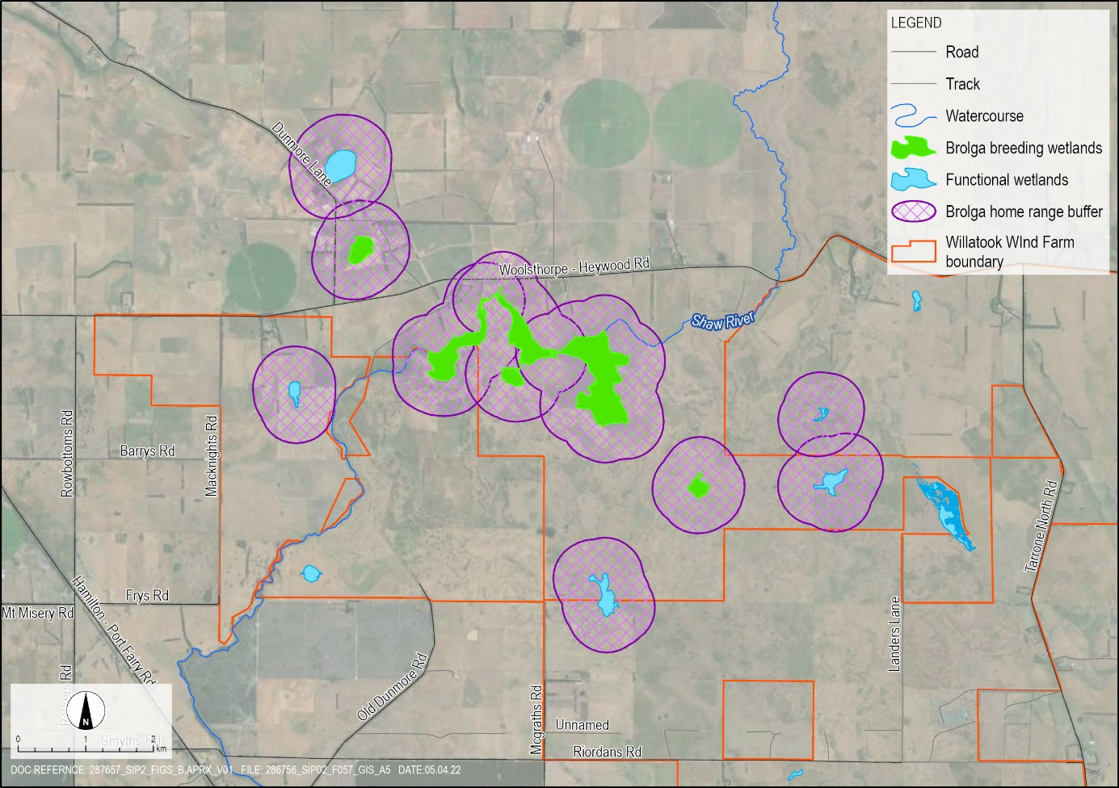
Figure 11.11 400 metre buffer of functional wetlands and Brolga breeding wetlands
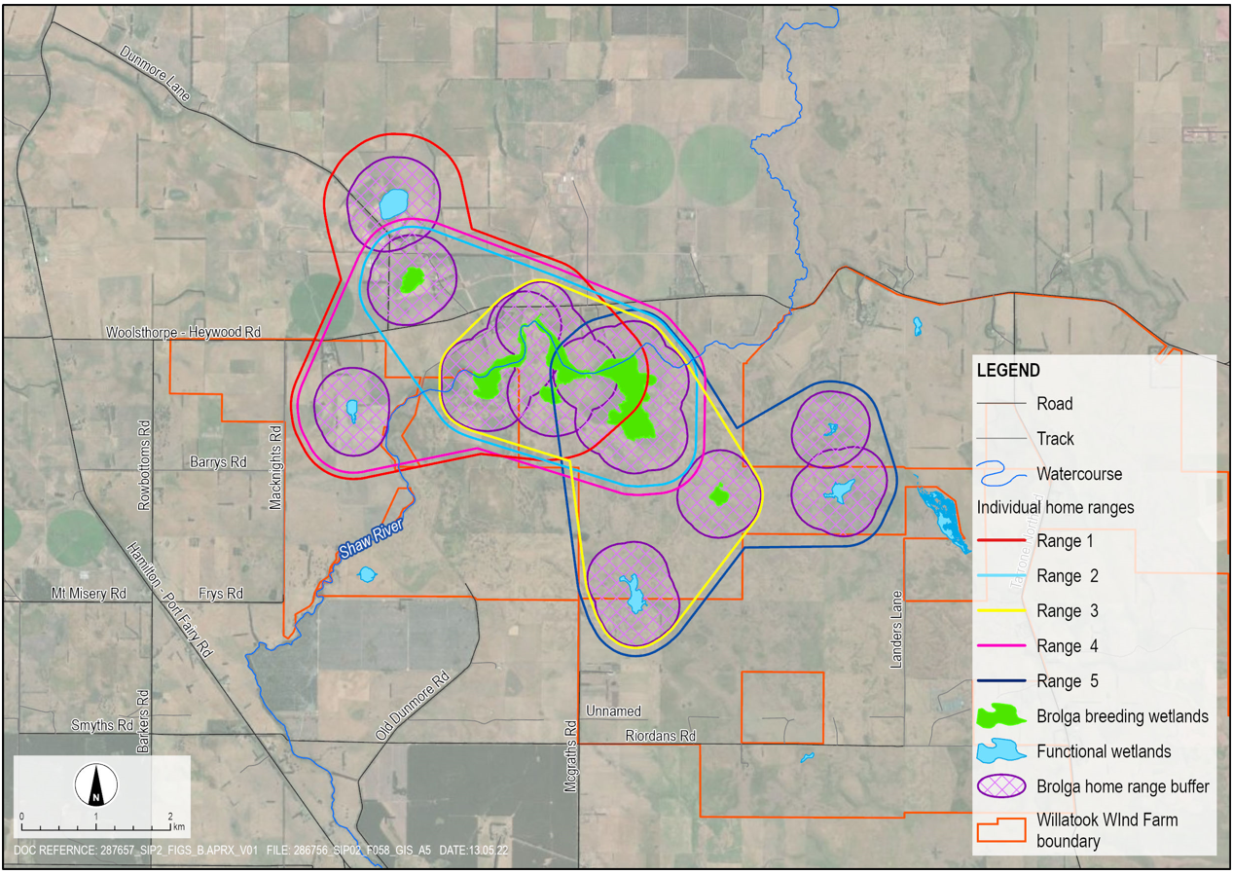
Figure 11.12 Brolga home ranges

The Interim Brolga guidelines acknowledge that home ranges are likely to vary with local habitat quality and extent and seasonal conditions (DSE, 2012). The home ranges defined by the project (see Appendix C1 – Brolga) have the following features:
- a minimum of four wetlands (average 4.2 wetlands) in each of the home ranges from the five Brolga possible breeding wetlands in the Cockatoo Swamp wetland complex. Veltheim et al. (2019) found that brolgas need three wetlands within the breeding distribution to breed successfully
- home ranges that are each significantly larger than any of the home ranges recorded in the Veltheim et al. (2019) or other studies.
A disturbance buffer of 300 metres was then applied around the perimeter of the home range boundary consistent with the recommendation of the Interim Brolga Guidelines. No project infrastructure (including tracks or cables) was placed within this buffer area. An additional 95 metres was added to the home range boundary to account for the maximum length turbine blades. The outer edge of these additional zones around the home range represents the turbine free buffer for Brolga breeding sites.
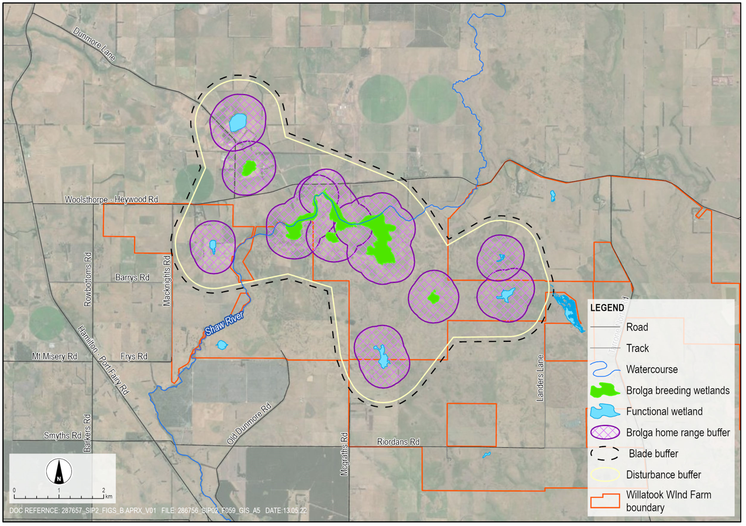
Figure 11.13 Final turbine free buffer around Cockatoo Swamp complex
The resulting turbine free buffer around Cockatoo Swamp complex is 2,658 hectares in size, encompassing five wetlands (W12e, W12c, W12w, 1 and 4). It includes a 795-metre turbine free buffer around the perimeter of known Brolga breeding wetlands and functional wetlands within 2,000 metres of those breeding wetlands. Based on flight observations by Nature Advisory this area would contain 71% of Brolga flights from observations of nesting Brolga pairs, noting that only a fraction (~8%) of all flights are at the height of wind turbines blades (refer to Figure 11.9). Records indicate this buffer protects the future breeding opportunities for the one pair of Brolga found using it.
The Veltheim et al. (2019) research acknowledge that Brolga home range variations make it challenging to apply generic buffers, based on average home range size or movement ability of pre-fledged chicks. They note that it is more appropriate to ensure that habitat elements including breeding site, night roost, foraging areas and potential movement corridors between these habitats are incorporated into buffers at each breeding site, based on their spatial arrangement in the landscape.
The current proposal includes the creation of a large complex wetland buffer area to avoid impacts to the pair of Brolga known to nest in the area. This would provide infrastructure free area almost ten times the mean home range size recorded by Veltheim et al. (2019) and is considered to avoid impacts on that pair effectively.

Minimum tip height
A minimum tip height of 40 metres for wind turbines has been adopted for the project (i.e., all wind turbine blades will be at least 40 metres from ground level). This limit was selected to minimise potential collision risk with Brolga (and other birds and bats). This was informed from flight behaviour data gathered by Nature Advisory over 15 years in southwest Victoria. These monitoring observations of 31 breeding Brolga pairs showed that there were approximately 8.6% of flights estimated to be at or above the minimum tip height of 40 metres (see Figure 11.9).

Hydrology
The construction of roads and hardstand areas has the potential to alter existing drainage patterns if not accounted for during design. Hydrological effects have the potential to occur over a larger area due to the nature of the shallow topographical relief of floodplain systems. The exclusion of wind turbines and other infrastructure from the entire Cockatoo Swamp ephemeral floodplain complex area will largely mitigate this potential impact. Furthermore, hydrological flood modelling was used to inform the placement of turbine locations outside of water flow paths. In areas where inundation is predicted, hardstands will be designed to ensure drainage flows away from wind turbine location. Hardstands will be slightly raised above surrounding ground level, and in several instances, foundations will be raised further to ensure floodwaters do not reach the base of the wind turbine in a 1% AEP event (refer to Chapter 10 – Surface water for a description of flooding terminology). Permanent surface structures, including the substation and the battery energy storage system, would be designed to maintain existing overland flow paths and not result in increased flood levels upstream of the sites.

Minimisation of overhead transmission lines
Brolgas are known to collide with powerlines (Goldstraw and Du Guesclin, 1991), so new powerlines associated with wind farms within Brolga habitats will pose a new collision risk.
The addition more land to the to the central part of the project in 2019 site enabled the proposed on-site substation to be relocated adjacent to the Tarrone Terminal Station area. This reduced the length of overhead transmission line between the on-site substation and the grid connection point at the Tarrone Terminal Station to be reduced from 5 kilometres to less than 300 metres. Biosis (Appendix C2 – Ecological peer review) note that the reduction of the proposed overhead transmission line is a significant measure that can be expected to reduce the probability of Brolgas colliding with the transmission line.
The on-site substation and overhead powerline have been located away from Brolga breeding wetlands and well outside the Brolga home range and buffer zones created for the project. All remaining electrical cabling required for the project will be placed underground and located outside the Brolga buffer zones.

Management controls
To minimise potential impacts to Brolga, the mitigation hierarchy was adopted whereby key avoidance and risk minimisation measures were applied during the design of the project. This included the development of turbine free buffers, committing to a 40-metre minimum blade height and limiting overhead transmission lines. To ensure project-related disturbance does not aversely effect Brolga breeding success, or that there are no unexpected turbine collisions the following management measures outlined in Table 11.6 have been proposed for the project.
Table 11.6 Measures to manage residual effects to Brolga
Brolga impact | Project phase | Management measures | Number
Turbine collision | Pre-construction | Before development starts, a bird and bat adaptive Management Plan is to be approved by DELWP, DAWE and the responsible authority. | BR01
Turbine collision | Pre-construction | Before development starts, a Brolga Compensation Plan is to be approved by DELWP and the responsible authority. | BR02
All | Pre-construction | As part of the bird and bat adaptive management plan develop a mortality monitoring program of at least three years’ duration that commences when the first turbine is commissioned. | BR03
Turbine collision, disturbance | Construction, operation | Monthly Brolga monitoring will be conducted between June and December for all wetlands within two kilometres of wind turbines locations.  Should breeding activity be observed then regular surveys will be conducted to collect the following information:  observations of breeding behaviour  observed flights, including start and end times, as well as flight path (mapped), height (including range), interaction with turbines and habitat and activity at destination (where observable)  the number of young successfully fledged. | BR04
Disturbance | Construction | If Brolga breeding activity is recorded within breeding wetlands identified in Section 11.5.3, the Blast Management Plan will trigger specific measures including:  conducting behavioural monitoring of Brolga coinciding with quarry blasts to determine whether there is a behavioural reaction  reducing the number, charge and size of blasts  using directional blast methods away from the breeding area. | BR05
Turbine collision | Operation | Monthly visual inspections for Brolga within a 120-metre radius of each wind turbine during the breeding season for three years of operation. Any observed adverse outcome of turbine interactions (collision, death, injury) will be described in detail and reported within two business days to DEWLP’s regional manager. | BR06
Brolga compensation monitoring | Operation | Observations of the number and age of birds within the chosen restoration site bi-monthly during breeding season. Observations of evidence of breeding activity, including:  stage of breeding (i.e., nest building, laying, incubation, parental care, fledging)  outcomes of breeding attempts  water level fluctuations, predation, disturbance. | BR07

Residual effects
Following the development of design measures and implementation of management controls, an assessment of residual effects and impacts was completed describing the likely effects to the Brolga population brought about by the construction, operation and eventual decommissioning of the project.

Wind turbine collision
Brolga collisions with powerlines have been reported in Victoria, however, no collisions with wind turbines have been reported to date. Brolgas spend significant portions of their time on the ground. They obtain their food on the ground and walking occupies a large part of their activity cycle. Flights are relatively infrequent and are undertaken primarily when moving between a breeding nest site and preferred foraging areas.
While the likelihood of collision with turbines was assessed to be low, based on their flight behaviour and the height of turbines, there remains a risk of collision with wind turbines. The Interim Brolga Guidelines state the objective of collision risk modelling is “to estimate the residual number of Brolga movements which have the potential to interact with wind turbines on the proposed site and from this estimate the annual collision risk”.
To quantify this risk, a collision risk model was developed in accordance with the Interim Brolga Guidelines. This model integrates spatial modelling of the probability of occurrence of the Brolga at the turbine blade height (40 to 250 metres). Model inputs have been developed from available information on the movements of Brolga around breeding sites elsewhere in its Victorian range. The model was based on conservative assumptions, including turbines operating 24 hours per day, 365 days per year. Further details of the collision risk model are provided in Appendix C1 – Brolga.
Eight wetlands (three of which are connected) were identified as potential Brolga breeding sites within proximity to the project (see Section 11.5.3). It was assumed that a single Brolga pair would nest each year at one of these wetlands (consistent with field observations over the last decade). One additional pair was assumed to use one of the three isolated wetlands to the east of the wind farm three out of ten years. The model assumes that each member of the breeding pair makes a flight around the breeding site once per day (a total of two outward and two inward flights per day) with a proportion of the flights at a height and distance where turbine interaction is possible. Wind turbine avoidance rates of wind turbines were modelled at 90%, 95% and 99% based on international research of cranes (Appendix C1 – Brolga).
To quantify the relative reduction of risk with the implementation of the turbine free buffers, the collision risk model was run on two wind farm layouts:
- the original layout referred to government agencies that included one-kilometre buffers around known Brolga breeding database locations
- the current layout that integrates the turbine free buffers (described in Section 11.5.2).
Under the 90% wind turbine avoidance scenario, the collision risk modelling predicts, on average, there will be 0.07 collisions per year, or 1.7 collisions over the 25-year life of the project. Statistically, there is a 95% chance that there would be between 0 and 5 collisions over the life of the project (see Table 11.7). This compares to 0.1 collisions per year under the same modelling scenario for the original referred layout, or 2.8 collisions (95% confidence interval of between 0 and 7 collisions) over the 25-year life of the project. This represents a reduction of collision risk by almost 50% through the adoption of the larger turbine free buffer. It is also significantly lower than the assessed risk of the recently approved Golden Plain’s Wind Farm (which ranged from <1 to <8 collisions) (Brett Lane and Associates, 2018).
Table 11.7 Results of collision risk modelling
 | Wind turbine avoidance rate | Collisions per year | Collisions over project life | 95% prediction interval¹ over project life
Original layout | 99% | 0.01 | 0.3 | 0 to 2 birds
 | 95% | 0.07 | 1.6 | 0 to 5 birds
 | 90% | 0.13 | 3.3 | 0 to 7 birds
Current layout | 99% | 0.01 | 0.2 | 0 to 1 bird
 | 95% | 0.03 | 0.9 | 0 to 3 birds
 | 90% | 0.07 | 1.7 | 0 to 5 birds
  - A prediction interval is an estimate of an interval in which a future observation will fall, with a certain probability, given what has already been observed.
Biosis (Appendix C2 – Ecological independent peer review) note that these are likely to over-estimate of potential collision risk to Brolga at Willatook since the results produce a measure of the number of flights-at risk of collision, not the number of birds at risk of collision. They conclude the results the collision risk and population viability analysis “indicate extremely low potential for impact on the population” and they “agree with that as an overall assessment”. They also note that there is “no documentary evidence for any Brolga collisions with turbines at operational wind farms, also suggests that this form of impact on the species is very unlikely to occur”.
To ensure predictions relating to Brolga outlined in this EES are accurate, a bird and bat adaptive management plan will be prepared to the satisfaction of DELWP that will detail a Brolga monitoring program. This would include both behavioural observations as well as a mortality monitoring to identify any unexpected turbine interactions (resulting in injury or death) as outlined in Section 11.6.3.
To assess the impact Victorian Brolga population under various collision risk modelling scenarios, a Population Viability Assessment was completed by Professor Michael McCarthy from the University of Melbourne (included in Appendix C1 – Brolga). This predicted that the population size would be reduced by between 0.3 and 0.8 birds compared with baseline conditions. Using the worst-case scenario collision impact rate, this represents a reduction of about 0.1% in the population.
The Interim Brolga Guidelines require that the worst-case scenario (i.e., the upper 95% confidence interval) be adopted and offset through the implementation of a Brolga Compensation Plan. Based on the collision risk model this results in an upper limit of five Brolga that may collide with wind turbines over the 25-year life of the project that require creation of a suitable offset through the restoration of breeding habitat so that additional breeding pairs can produce increased numbers of young that survive to become breeding adults. This will ensure that the expected minimum population size remains the same. A framework for this plan is outlined in Appendix C1 – Brolga along with an assessment of its feasibility.

Disturbance
The on-site quarry is proposed and would operate during the construction stage of the project. The proposed quarry is located approximately 2.1 kilometres from the closest Brolga breeding wetland. The sensitivity of Brolga to ground motions and low air blast and noise levels from distant blasts is unknown. Based on observations and presence of other bird species near regional quarries, it is likely that occasional blast events at the quarry would not cause disturbance to Brolgas nesting or foraging (as discussed in Appendix E4 – Quarry blasting). Blasting would occur about two times per month and would be of a similar intensity to thunder at the distance of the Brolga breeding wetlands and therefore would not be expected to result in significant disturbance. Based on monitoring of the effects of quarry blasting on wetland birds close to an operational basalt quarry in southern Victoria, Biosis concluded that they would not expect Brolgas to respond negatively to proposed quarry blasting operations at a distance of at least 2.1 kilometres (Appendix C2 – Ecological independent peer review).
To ensure project-related disturbance does not aversely effect Brolga breeding attempts, behavioural monitoring of Brolga will be conducted throughout the breeding season period. Measures to limit disturbance for recorded Brolga nesting, may include scheduling construction activities for those wind turbine locations closest to the breeding site to occur outside the breeding season or micrositing the closest turbine(s) further from the wetland.
Brolga monitoring at Macarthur Wind Farm indicates that Brolga have nested within 200 metres of constructed and operational wind turbines and they will forage consistently within 100 metres of the base of operating turbines (Appendix C1 – Brolga). Once construction of the project is complete, the lower level of vehicle traffic and human activity associated with operating the completed wind farm is considered unlikely to disturb fauna in adjacent habitats persistently.

Cumulative impacts
Potential cumulative impacts to the Victorian Brolga population are assessed in Chapter 24 – Cumulative effects.

Conclusions
Over the last decade there has been a significant effort to assess Brolga and their habitat for the project. A total of 28 Brolga breeding sites have been identified within the area of investigation, and of these, 23 were attributed to a functional wetland. Six of these sites are within 3 kilometres of a potential wind turbine location. Field surveys conducted for the project between 2010 and 2021, recorded five pairs of Brolga breeding within the 10 kilometres of the project site. One pair were repeatedly observed nesting within the Cockatoo Swamp complex area.
To minimise the impact of the project on the Victorian Brolga population, turbine free buffers were developed. These buffers incorporate wetlands used for the foraging, breeding (nest, egg incubation) and night roosting, non-wetland areas around breeding wetlands used for foraging, and movement corridors between foraging and breeding wetlands to other functional wetlands. A single turbine free buffer was created around Cockatoo Swamp that is 2,658 hectares in size. This incorporates five wetlands with a
795-metre buffer from the outer perimeter of both known Brolga breeding wetlands and other functional wetlands. This buffered area is similar to or larger than buffers developed for other operating wind farms in the Brolga’s range in Victoria.
In accordance with the Interim Brolga Guideline, a risk-based approach was applied to the project, whereby turbine collision risk was modelled. The model predicts that under the most conservative turbine avoidance scenario where Brolga avoid wind turbines 90% of the time, there would be 0.06 collisions per year on average, or 1.7 collisions over the 25-year life of the project. Statistically, there is a 95% chance of between zero and five collisions over 25 years. A Population Viability Assessment was also completed to assess the impact to the Victorian Brolga population. The assessment predicted the population size would be reduced by between 0.3 and 0.8 birds over the project life compared with baseline conditions, or 0.1% of the south-east Australian Brolga population.
Through the restoration of breeding habitat as part of a Brolga Compensation Plan additional breeding success is expected to increase the number of young that survive to become breeding adults.

The 120-day inundation period criterion was established with advice from DELWP early in the assessment.

